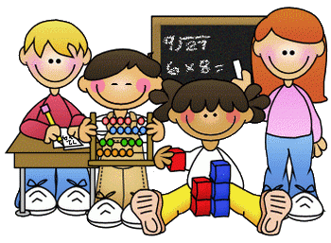

Primary 1 Homework – Week Beginning 26th October 2020



Literacy

Phonics

We have been learning the following sounds in class. Write each sound 3 times. Please use the formation sheets sent home previously to help.

**i**

Common Words

**me my**

make new flash cards for these new words to add to the ones that you already have. Use these to go read your words every night. Write your words out 3 times.

Name Writing

Write your name 3 times. Then try writing it again this time in rainbow colours.

Reading

Pick a book or magazine that you have at home and read it with an adult. Talk about your favourite part of the story.

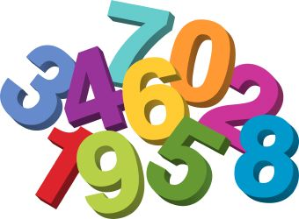

Maths

1. Count on and back to 20.
2. Practice writing the numbers from 0 to 10.
3. Complete the missing number patterns below.

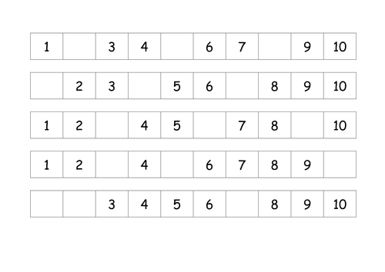



Health & Wellbeing

We have been learning about our feelings and reading the Colour Monster.

You can listen to the story again here.

<https://uk.video.search.yahoo.com/search/video;_ylt=AwrJQ5y3.GpfrlYA7CkM34lQ;_ylu=Y29sbwNpcjIEcG9zAzEEdnRpZANDMDQ1M18xBHNlYwNzYw--?p=the+colour+monster+story&fr=mcafee#id=1&vid=5ae20550e5ebc4b94b18477270b66575&action=view>

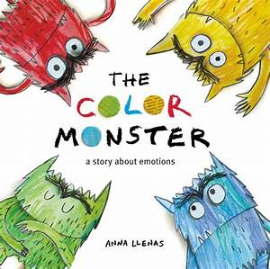

The calm monster is green- can you do an activity at home which helps you to feel calm?

C:\Program Files (x86)\Microsoft Office\MEDIA\CAGCAT10\j0305493.wmf 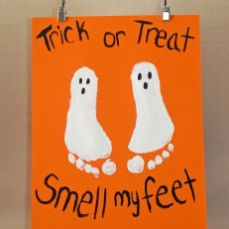 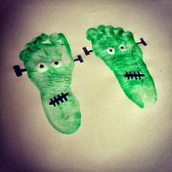

Halloween Craft!

Why not try some foot or hand painting for some Halloween fun!