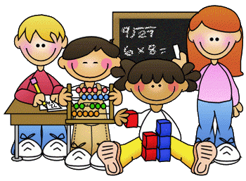
Primary 2 Homework – Week Beginning 5th October 2020

Literacy
Phonics
Revise the sounds ue (as in blue).
Write 3 words with each of your sounds in them.

Common Words
very fast took there
Write words 3 times each then pick one word and write it in a sentence.

Reading
Read a book or a magazine that you have at home. Talk about the story with an adult.

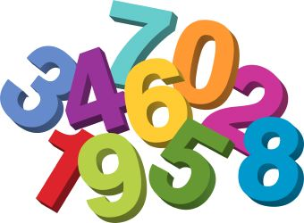
Maths
- Revise counting on and back within 30.
- Use Sumdog or Education City to play some number games.
- Complete the addition and subtraction sums below
10 + 6 =
8 – 4 =
5 + 4 =
10 + 3 =
7 – 5 =
12 + 6 =
11 – 2 =
16 – 4 =
9 + 5 =
15 – 9 =

Health & Wellbeing

We have been learning about the Colour Monster.
You can listen to the story again here.
https://uk.video.search.yahoo.com/search/video;_ylt=AwrJQ5y3.GpfrlYA7CkM34lQ;_ylu=Y29sbwNpcjIEcG9zAzEEdnRpZANDMDQ1M18xBHNlYwNzYw--?p=the+colour+monster+story&fr=mcafee#id=1&vid=5ae20550e5ebc4b94b18477270b66575&action=view

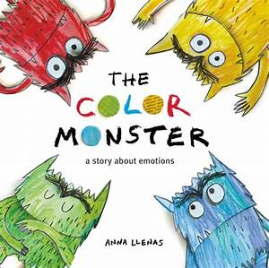

The Anger Monster is red. Can you draw something that makes you feel angry?

