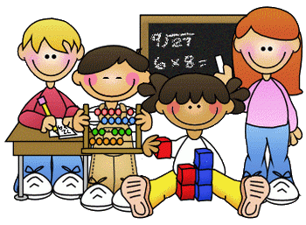
Primary 1 Homework – Week Beginning 5th October 2020

Literacy
Phonics
We have been learning the following sounds in class. Write each sound 3 times. Please use the formation sheets sent home previously to help.
n

Common Words
in it
make new flash cards for these 2 words to add to the ones that you already have. Use these to go read your words every night. Write your words out 3 times.

Name Writing
Write your name 3 times. Then try writing it again this time in bubble writing.

Reading
Pick a book or magazine that you have at home and read it with an adult. Talk about what happened in the story.

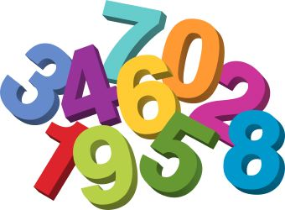
Maths
- Count on and back to 20.
- Practice writing the numbers from 0 to 10.
- Complete the missing number patterns below.

Missing Numbers to 10
1

3

5

7

9

10

8

6
5

3
2
1
1

6

4
3
7

9
10

Health & Wellbeing

We have been learning about our feelings and reading the Colour Monster.
You can listen to the story again here.
https://uk.video.search.yahoo.com/search/video;_ylt=AwrJQ5y3.GpfrlYA7CkM34lQ;_ylu=Y29sbwNpcjIEcG9zAzEEdnRpZANDMDQ1M18xBHNlYwNzYw--?p=the+colour+monster+story&fr=mcafee#id=1&vid=5ae20550e5ebc4b94b18477270b66575&action=view

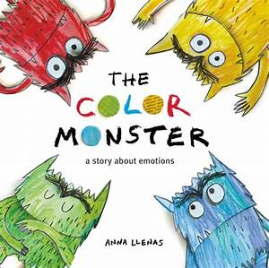
The Anger Monster is red. Can you draw something that makes you feel angry?

