Primary 2 Homework – Week Beginning 5th October 2020

Literacy
Phonics
Revise the sound ue (as in blue).
Write 3 words with each of your sounds in them.

Common Words
very fast took there
Write words 3 times each then pick one word and write it in a sentence.

Reading
Read a book or a magazine that you have at home. Talk about the story with an adult.

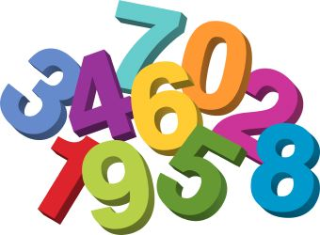
Maths
Revise counting on and back within 30.
Use Sumdog or Education City to play some number games.
Complete the addition and subtraction sums below
10 + 6 =
8 – 4 =
5 + 4 =
10 + 3 =
7 – 5 =
12 + 6 =
11 – 2 =
16 – 4 =
9 + 5 =
15 – 9 =

