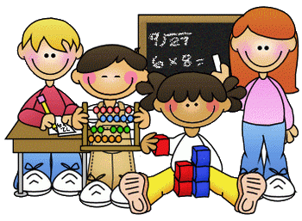
Primary 2 Homework – Week Beginning 28th September 2020

Literacy
Phonics
Revise the sounds ea (as in each) and ow (as in grow).
Write 3 words with each of your sounds in them.

Common Words
ask eat yellow again
Write words 3 times each then pick one word and write it in a sentence.

Reading
Read a book or a magazine that you have at home. Talk about the story with an adult.

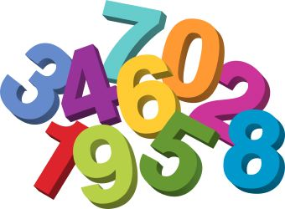
Maths
Revise counting on and back within 30.
Use Sumdog or Education City to play some number games.
Complete the subtraction sums below
10 – 5 =
8 – 6 =
9 – 4 =
10 – 3 =
7 – 4 =
10 – 6 =
9 – 2 =
5 – 3 =
8 – 5 =
10 – 9 =

