Primary 1 Homework – Week Beginning 28th September 2020

Literacy
Phonics
We have been learning the following sounds in class. Write each sound 3 times. Please use the formation sheet given home (previously) as a guide.
a t
Name Writing
Write your name 3 times and write your name using lots of colours like a rainbow!
Reading
Pick a book or magazine that you have at home and read it with an adult. Draw a picture of your favourite part of the story.
Maths
Count on and back to 20.
Practice writing the numbers from 0 to 10.
Dice Numbers
Get six items such as beads, marbles or even small toys.
Roll a dice then select that amount from your pile, e.g. if you roll a 4 on a dice, count out four items.
Then put them back into the pile and roll again.
To add challenge, roll two dice and count the total number of dots before counting out your items.

Science – Our Senses
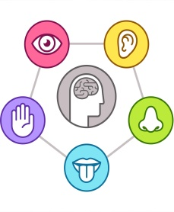
In Science we have been learning about our senses. Your homework this week is to investigate hearing!
The Water Xylophone (Adult Assistance Required)
Set five glasses in front you and filled each one with water- fill them at different levels.

Tap on each glass to listen for the different sounds produced.

Line them up in order by water level and play your water xylophone.
