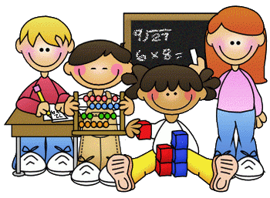
Primary 1 Homework – Week Beginning 14th September 2020

Literacy
Phonics
We have been learning the following sounds in class. Write each sound 3 times.
m c s p

Name Writing
Write your name 3 times.

Reading
Pick a book or magazine that you have at home and read it with an adult. Talk about what happened in the story.

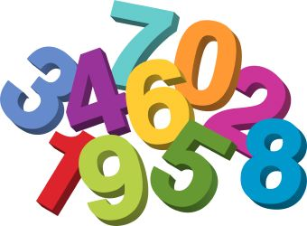
Maths
Count on and back to 20.
Practice writing the numbers from 0 to 10.
Go on a number hunt around your house to see where you can find numbers.

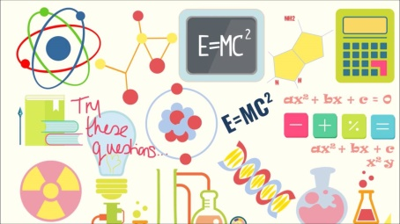
Science – Our Senses
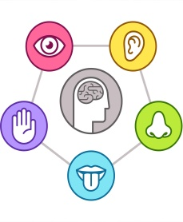
In Science we have been learning about our senses. Pick one of the 5 Senses and draw a picture of something that you do with it.
e.g. Taste - Eating Ice-Cream.

