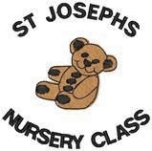
Nursery Return August 2020

Dear parents/carers,
We would like to thank you for your patience in receiving this information.

We are now able to share with you the final arrangements for our return to St. Joseph’s Nursey, on Wednesday, 12th of August 2020.
Support

We are delighted to be welcoming our children back to St. Joseph’s Nursery on August 12th 2020. Returning to nursery after such a long period or for the very first time will cause mixed emotions for some of our children. We recognise that some may feel anxious, especially with the current climate. As such, the health and wellbeing of all the children will be at the heart of all we do as we move forward into this new phase. We regret that our settling arrangements have had to change due to the current restrictions; however, our experienced staff team is committed to supporting our children and their families to meet their needs.
Please be assured that the safety, health and wellbeing of our children and staff is our key priority and we will adhere strictly to advice from the Scottish Government and WL Council to ensure that everyone is safe and well as we implement the following arrangements for a safe return.
Return Dates
Date | Arrangements
Tuesday 11th August 2020 | In-service day.  Staff only, attend
Wednesday 12th August 2020 | ELC/Nursery resumes  Morning Session: 8.00 am-12.45 pm  Afternoon Session: 1.15 pm- 6.00 pm  Full Day: 8.00 am- 6.00 pm
Travelling to Nursery
As far as it is safe to do so, children and parents/carers are encouraged to travel to nursery on foot, bike, scooter or park and stride. Parents should park in Gateside Road as there is no parking for parents in front of the school. Please do not park in the school grounds or staff car park as it presents a significant threat to the safety of our children and prevents school transport from moving safely within the grounds. There are designated parking bays for people with disabled permits.

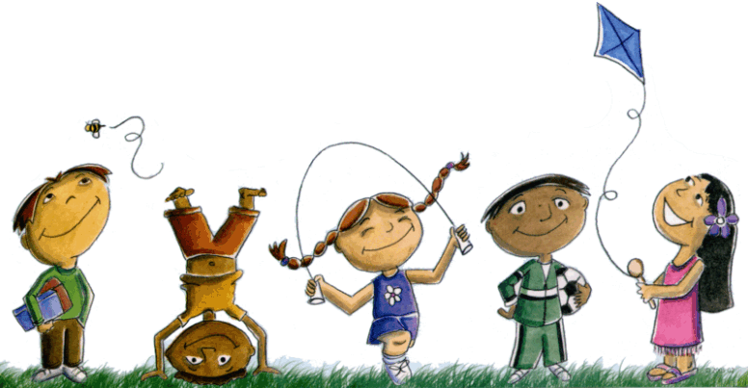
Arriving at Nursery
We will be operating our registration procedures and start our nursery day in the outdoor play area. As evidence suggests, the risk of transmission of Covid-19 is reduced outdoors, so, we plan to maximise the use of our outdoor space for learning experiences. We ask that children dress for the weather.
Please provide a waterproof jacket on the days it is required and wellies that can be labelled with your child’s name and remain in nursery to use as needed, As your child explores the many different areas of the nursery, there may be times when they get wet or dirty. Hence, your child would benefit from having a change of clothes in nursery that they can leave in their peg bags and use if needed. There is no requirement for indoor shoes at his time.
On sunny days, please apply sun cream before your child arrives at nursery, There is also a requirement for your child to have their own sun cream in nursery. This should be clearly labelled with your child’s name and a medical form for it will have to be completed.

The Nursery Day
Due to the current situation, we can no longer allow adults into the Nursery. Only one person may drop off/collect their child. This will allow us to maintain the required two metres distance from other adults, other adults and children, and to prevent congestion in around our entry and exit points.

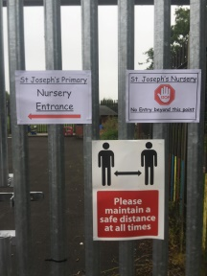
- Parents/carers should access the nursery in the usual way, via the gate on the footpath that runs adjacent to the Infant playground. There will be clear signage to direct you and staff will be available to assist.

Nursery Entrance

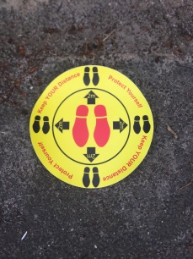
- Clear markers to indicate a safe 2M distance will be displayed. Parents are asked to remain at the markers until they are invited to come forward with their child.

Social Distancing Markers

- Staff will meet you and your child at the drop of time and will return your child to meet you at the gate at pick up time. Again, parents are asked to remain at the allocated markers, and one family at a time will be called forward.
- Please be mindful of other parents and children at drop off and pick up times, stepping back, to allow others to move freely.

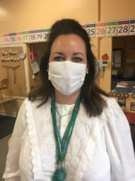
- You may see people wearing face coverings.
Face Coverings

Staggered Times
National guidance has advised to stagger our start and finish times to avoid congestion and allow for physical distancing. Please see below.

Morning Session  Morning Session – 8.00 am-12.45pm (Mon-Thurs) | AM Session Drop Off Pick Up  8.00 am-8.15am 12.00pm-12.15pm Blue Group Miss Gardner  8.15 am-8.30am 12.15pm -12.30pm Green Group Mrs Morton  8.30 am-8.45am 12.30pm- 12.45pm Red Group Miss Cairney
Afternoon Session  Afternoon Session 1.15pm -6.00 pm  (Mon-Thurs) | PM Session Drop Off  1.15 pm -1.30pm 5.15 pm 5.30pm Blue Group Miss Gardner  1.30 pm- 1.45pm 5.30 pm 5.45pm Green Group Mrs Morton  1.45 pm-2.00pm 5.45 pm 6.00pm Red Group Miss Cairney
Full Day  Full Day 8.00 am -6.00 pm  (on your child’s allocated days) | Full Day 8am -6pm (on your child’s allocated days)  Please follow the AM session drop off times for your child’s Key Group which will then determine pick up time.
Please speak to a member of staff if you have any queries about the staggered time arrangements.
Please adhere strictly to your drop off and pick up times and do not wait at the gates.
Eating Arrangements
Snack time in the nursery is regarded as one of the most important times of the day. Children develop valuable life and communication skills in a social setting. As far as it is safe to do so, we will try to keep our snack times as normal as possible. Children will continue to wash/sanitise their hands, before and after eating. Tables will be wiped down after each sitting.
Breakfast, mid-morning and afternoon snack is still being provided for the children attending full day or the AM, session.
Parents are reminded that, if you your child is staying for lunch, nuts and products containing nuts are not permitted in the nursery as they present a serious risk to children suffering from allergies.

Risk Assessments
As previously mentioned in our last update, robust Risk Assessments have been carried out for our safe return to nursery.
The new risk assessment will include essential public health measures such as:

· Enhanced hygiene and environmental cleaning arrangements;

· minimising contact with others and physical distancing for adults;

· Wearing appropriate personal protective equipment where necessary;

· A requirement that people who are ill stay at home;

· Active engagement with Test and Protect.
Please note that there is no requirement for children to wear a face covering or for physical distancing between children in a nursery.

Hygiene
Every effort has been made to limit the risk of infection and to ensure the highest level of cleanliness is maintained in and around the nursery.
Hand sanitisers have been installed at all main entrances to the building. In line with current government guidance, children will wash/sanitise their hands on entering and leaving the nursery building and at other regular intervals throughout the session. If you prefer your child to have their own sanitiser, you can, making sure the bottle of hand gel is clearly labelled with your child’s name.
Please do not allow your child to bring toys or other non -essential items to nursery
The nursery will be cleaned each day and frequently touched areas such as door handles and work surfaces and toys will be cleaned throughout the session. This cleaning schedule will not impact on your child’s learning experience.
Many new signs have been prepared to help remind our children about the importance of personal hygiene during this pandemic. This will be taught and reinforced, with the use of, videos, social stories, and songs.

Nursery Groups
Minimising contact with others and physical distancing for adults is a key priority. For that reason, children have been arranged into 3 Key groups with a designated member of staff. Additional staff will be present in the nursery to support our children during this time.
All staff will continue to plan and deliver the best experiences for our children.

Personal Protection
Please note that there is no requirement for children to wear a face covering or for physical distancing between children in a nursery. There is also not a requirement for parents to wear a mask at drop off/pick up times or for the staff to wear a mask in the nursery. However, the choice to do so is entirely up to the individual and decisions will be respected. At times, if staff members have to offer personal care to a child, full PPE will be used.

Knowing the Signs and Symptoms of Corona Virus
If your child develops any of the following symptoms;
- high temperature,
- new continuous cough
- loss of (or change in) sense of smell or taste
- or who has had contact with a family/community member with symptoms,
Then, please do not send your child to nursery. Keep them at home and follow NHS guidelines on Test and Protect and self- isolation.
If a child develops any of these symptoms when in nursery, they will be; isolated in a designated room with a member of staff, parents/emergency contact will be notified and arrangements will be made for the child to return home. Parents/carers will be advised to arrange to have their child tested. Information on Test and Protect procedures will be provided when the child is collected.
Information on groups of children within the nursery, and the adults that each child is in contact with is being collected to support Test and Protect procedures. This may mean the sharing of names with official public health contact tracers.

Medication
For those children who are required to take long or short term medication in nursery, parents/carers will be required to complete the relevant medical forms and bring the medication to nursery on your child’s first day. Medication will be collected and all appropriate paper work completed. Medication must be in its original packaging with a clear prescription label.

Thank you
Finally, the ELC team would like to thank you for your continued patience and support as we finalised our arrangements for a safe return. We look forward to seeing you all when we begin our new session, on, Wednesday, 12th of August, 2020. If you need to get in touch before then, please contact the school, on, 01501 740452.
Thank you and stay safe. The Nursery Team.

