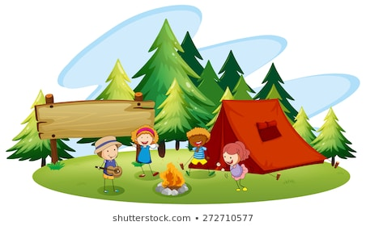
Hello Boys and Girls,
We have come to the end of our school term and next week will be the start of the summer holidays. I know that this has not been the year that we all expected to have but I am so proud of you all and I loved being your teacher this year. I thought it would be a nice way to finish the school year by taking a virtual trip as we can’t go on a real one. So this week we are going camping. As always you do not have to complete all of the tasks just do what you can. The most important things are that you have fun and you stay safe.
Mrs Warner
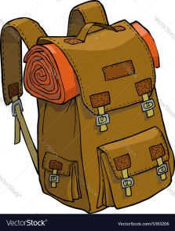
Activity 1 – Get Packed
It is nearly time to set off on our trip so we need to pack our bags. You can only take one bag with you and there can only be 10 things inside it. Draw a picture of your backpack with your 10 essential items inside it.

Activity 2 – Get Moving
Before we leave we need to learn our marching song. March on the spot or around your house chanting the Marching Song as you go. When you stop you will finally be at our camp. WELCOME!

https://www.youtube.com/watch?v=XrEE9LrLaQ4
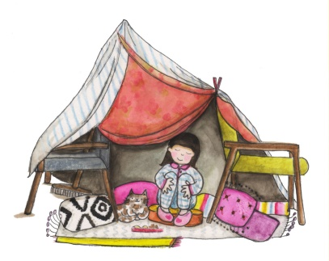
Activity 3 – Den Building
Now that we have reached camp we need to build ourselves a den that we can shelter in. Find the perfect spot in your house, even better if it’s somewhere that you can sleep. Make sure you make your den really comfortable and as sturdy as possible. Have a look at this website for some ideas of ideas of things that you could use to build your den.

https://www.noaandnani.co.uk/den-building-ideas-for-the-best-dens-ever-i43#Indoors

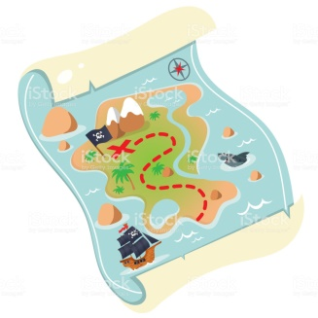
Activity 4 – Map Making
Now that you are settled in camp and have built your den you will need to tell all you family and friends how to get there. Draw a map to help them.

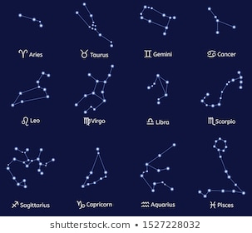
Activity 5 – Star Gazing
If it is a clear night go outside and look up at the sky. See if you can spot any stars, constellations, planets or satellites. You could download the app Sky View and use it to help you find anything interesting in the sky. Even if it is cloudy the app will still show you what is hidden behind the clouds. You could even take some blankets and hot chocolate out with you to keep you cosy.

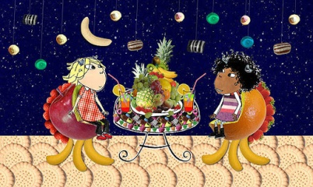
Activity 6 – Midnight Feast
Ask permission from an adult to gather some snacks for a midnight feast (remember it doesn’t have to be at midnight). Grab your favourite book and get cosy inside you den and enjoy your feast.

Activity 7 – Sock Challenge
When you are camping you need to wear lots of socks to keep your feet nice and warm. How many socks can you put on within 30 seconds? The world record is 28 socks. Can you beat this?

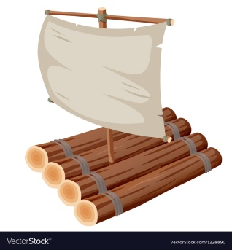
Activity 8 – Raft Making
Design and make a mini raft that will float. Look for materials around the house and in your garden that will float. You could maybe use lollypop sticks, sticks from the garden or an old milk carton. Once you have made your raft test it out. Fill the bath, sink or a container outside to see if your raft floats.

Activity 9 – Spooky Stories
Camping wouldn’t be camping without a spooky story. Write your own spooky story to tell the rest of your family. You could build a pretend campfire for you all to sit around and tell your stories.

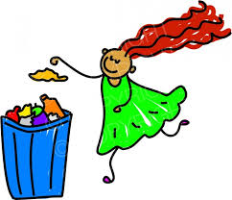
Activity 10 – Tidying Up
Sometimes the area around a campsite can have lots of rubbish. This is very dangerous for all of the wildlife. Can you design a poster to encourage people to put their rubbish in the bin? Remember to make it nice and bold. You could include pictures of some of the animals that need our help.

Activity 11 - Campfire S’mores
Can you follow a recipe and make some S’mores to snack on?
Ingredients

- 4 tea biscuits/ digestives
- 4 chunks of chocolate/chocolate spread
- 2 marshmallows
Method

- Cut out 2 squares of tinfoil big enough to wrap your treats in.
- Put 1 biscuit in each piece of foil and top with a chunk of chocolate or some chocolate spread and a marshmallow. Place another biscuit on top and wrap each parcel tightly.
- Put the S’mores on a warm barbeque (or in the oven) and warm through on each side for 2 mins, so that the chocolate and marshmallows are just melted.
- Remove and allow to cool slightly before carefully removing the foil.
Activity 12 – Scavenger Hunt
We are going to go on a Scavenger Hunt. You can either do your hunt around your house or garden or do it on your daily walk. The items you need to find are listed below.

Find something….
- Crooked
- A bug might live
- Plastic
- Patterned
- Shiny
- That floats
- Alive
- Colourful
- With numbers or letters
- Ancient
- Not Alive

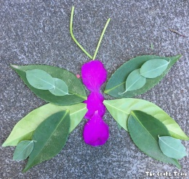
Activity 13 – Nature Masterpiece
Create an artistic masterpiece using items from the outdoors. You can create any art work that you want as long as you use natural materials, such as, leaves, twigs, flowers, pine cones etc. Please remember not to pull items from trees or pick things from other people’s gardens. Use items that you find lying on the ground. There are some ideas below.

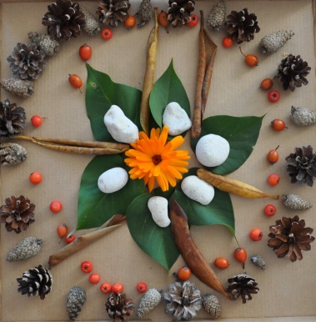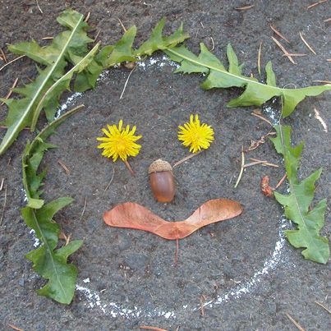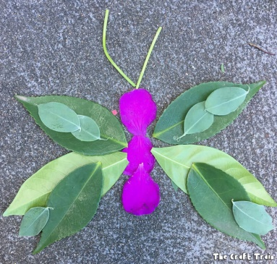

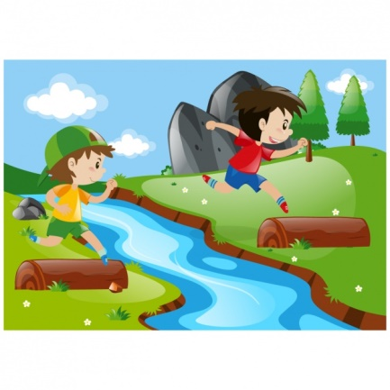
Activity 14 – Jump the River
There is always a river at camp. In your house or garden build your own river that you can jump over. Then see how far you can jump! The world record for a child is 3.47 meters. Can you beat this?

