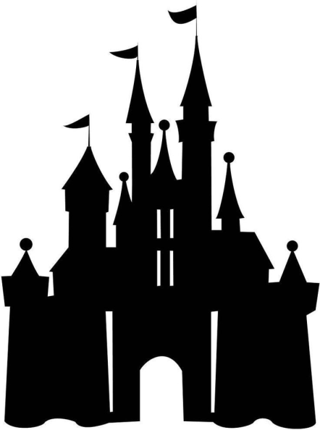
Disney Virtual Trip

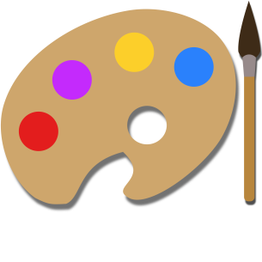
Activity 1 - Art

Create a passport that you can use during your trip! Remember to include a front cover, your name, a picture of yourself and lots of space for characters names! Each time you see a character this week in a ride, video or song, make sure to write their name in your passport! How many characters will you meet by the end of the week?

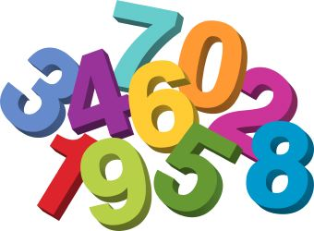
Activity 2 – Numeracy
To go on today’s rides you must be taller than:
- 6 pieces of cutlery
- 6 of your own shoes/socks
- 3 books
- 15 blades of grass
Estimate and then measure whether you are tall enough to ride!
Extension/P2: If you have a measuring tape/ruler, you could measure how tall you are. Can you find 3 things that are taller and 3 things that are shorter than you. Measure the height of each thing.

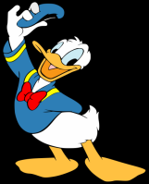
Activity 3 – Writing
Take a tour of Donald Duck’s house boat. What can you see? Draw and label 5 things that you can see inside his house.
Challenge: Can you think of a story using Donald Duck’s house as the setting?
P2: Write about how Donald Duck’s house is different to yours, for example, my windows are not circles and I do not dry my washing on my roof!
https://www.youtube.com/watch?v=XERRGapwSVQ&t=17s
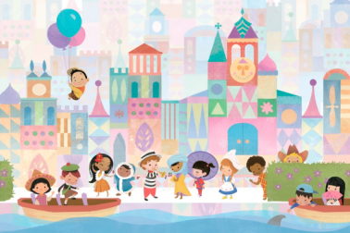
Activity 4 – It’s A Small World
Task: Enjoy the ‘It’s a Small World’ ride. The ride shows many countries and places around the world.
P1: Find out 2 facts about another country You could add photos/drawings/text to the template or record yourself saying what you have found out.
P2: Compare Scotland with another country. You might think about: weather, food, attractions/scenery, events and celebrations, flags or anything else you are interested in. You could present your information in a poster or by speaking
https://www.youtube.com/watch?v=I2Do309e4YU

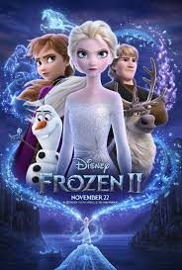
Activity 5 – Reading
Watch the Frozen ride – how many words can you think of that rhyme with snow. Record yourself saying all of the words that you can think of. https://www.youtube.com/watch?v=J8OHP9OriMA&t=33s
Challenge: Make a silly sentence using as many of the words as you can.
P2: Write down your list and create a silly story using lots of rhyming words.

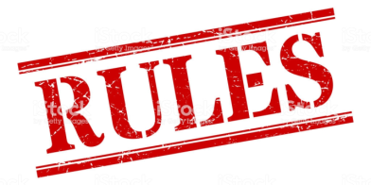
Activity 6 – Health & Wellbeing
Safety Rules
Look at the video of Disney Land. Can you think of any rules or things that you would need to do to keep safe at the park? Think about what you should do on rides, who you would speak to and any extra rules that you can think of.
Extension/P2: Create a safety poster to display the rules.
https://www.youtube.com/watch?v=HyZfIlxwsfI

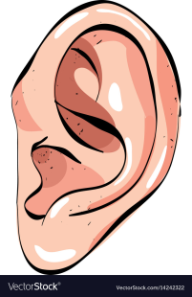
Activity 7 – Talking & Listening
Watch the Monsters Inc ride clip, it is a 360 degree experience so you can drag the screen to see all around you.
Design your own monster and record yourself describing them. Are they kind, scary, fluffy, angry? Can you think of any other ways to describe them?
Challenge/P2 – Create a story where your monster is the main character.
https://www.youtube.com/watch?v=vDNUXa5sIHU

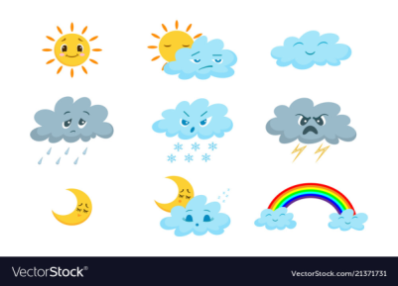
Activity 8 – The Weather
Disney Land is in Orlando in America.
Find out what the weather is like in Orlando today. Is it sunny, cloudy or windy? What is the temperature?
Extension: What is the weather and temperature here? Is it hotter or colder?
P2 Extension: How many degrees hotter/colder is Orlando than Aberdeen today?
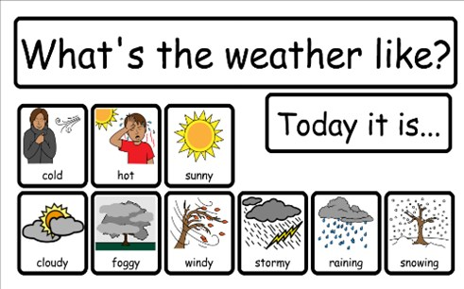

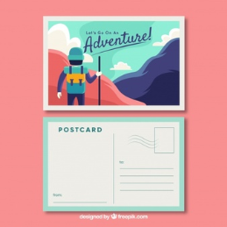
Activity 9 – Postcard
P1: Make a postcard to tell somebody all about your virtual trip to Disney Land! You will need to draw a detailed picture on one side and write your message on the other side. Challenge: Can you write the person’s address?
P2: Write a diary entry about your day at Disney Land, remember to include what you did at various times throughout the day. How descriptive can you be?

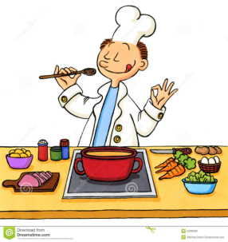
Activity 10 – Cooking
Watch the clip of Ratatouille. Can you help to prepare a meal or snack today? You could look at a recipe with an adult if they are using one.
https://www.youtube.com/watch?v=jwLKPDJqldw
P2 - You could write down the recipe/instructions for somebody to follow.

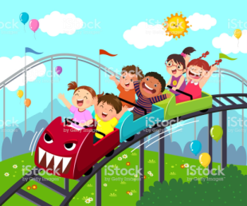
Activity 11 –Technology
- P1: Mickey has asked for your help to design a new ride for Disney Land! You could draw your ride, video yourself describing it, or build it out of blocks, recycling etc.
- P2: As above and then you could make a poster to advertise your ride if you wish – remember to include the price, height limit and any safety rules that you have.

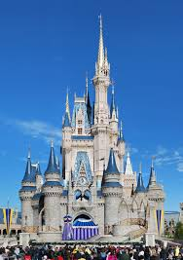
Activity 12 –STEM
Look at the picture of Cinderella’s castle. Can you create your own castle using materials of your choice? You could use sticks, blocks, or anything else that you wish. Be as creative as you can!

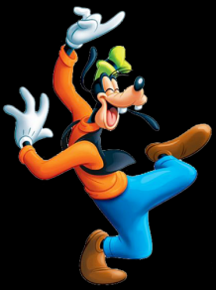
Activity 13 – Dancing
Watch the video of the parade. Can you join in with any of the dancing?
https://www.youtube.com/watch?v=rR-KP8KH1Ng

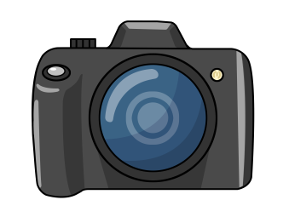
Activity 14 - Memories
Create a souvenir photo! Take a close photo of your face and add it to the template as your souvenir!
