Home Learning – Week Beginning 8th June 2020
Good morning Primary 1/2! I hope you all had a very good and safe weekend. I hope you enjoyed all of the activities that I set for you last week. Here are some more fun tasks for you to try this week. Remember you also have the games and challenges on Education City and Sumdog. You do not have to complete all of these task and there is no particular order that they should be done in. Remember the most important thing is to stay safe and well.

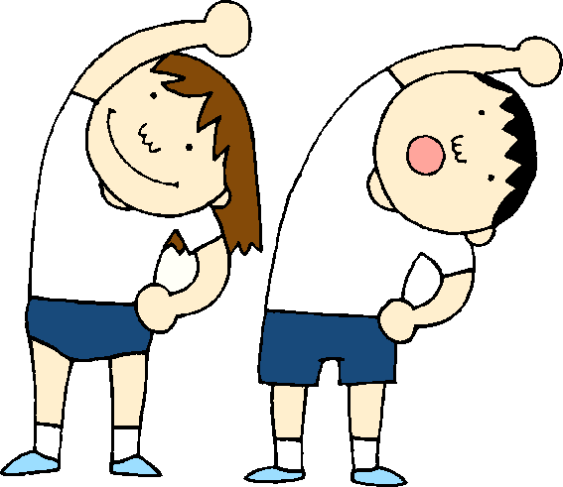

PE
A good way to start your day is with a little exercise. Every morning Joe Wicks will be live streaming a free PE lesson on his YouTube channel at 9am. You can access it through this link:
https://www.youtube.com/user/thebodycoach1

Jump Start Johnny is another good way to start the day.
https://www.youtube.com/channel/UC8PDFwCV0HHcl08-1SzdiBw

Cosmic Kids Yoga is another great way to relax and start the day.
https://www.youtube.com/user/CosmicKidsYoga

=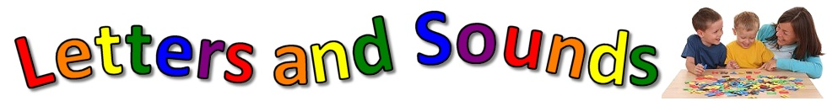
Phonics
This week we will consolidate the sounds
igh oi ou
igh, oi and ou – all live in the lift in the Vowel House.

igh
oi
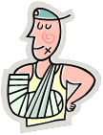 ou

- Practice reading and writing different words that contain each phoneme.
- Use some of the words that you have come up with and write them in a sentence.
- Air Writing – Write your sounds in the air with your finger. Ask someone at home if they know what sound you are writing.
***Challenge – Write some words containing your phoneme in the air and see if someone at home knows what word you have written.
- Use YouTube to watch Geraldine Giraffe. She will be finding objects around her house that start with the sound. Can you do the same?

igh - https://www.youtube.com/watch?v=OYCR2RZ4ZYY
oi - https://www.youtube.com/watch?v=IRTITdRL_cU
ou - https://www.youtube.com/watch?v=-qtCB7CYH3I

Reading
Listen to Jack and the Flumflum Tree being read by Mrs Warner on our school blog.
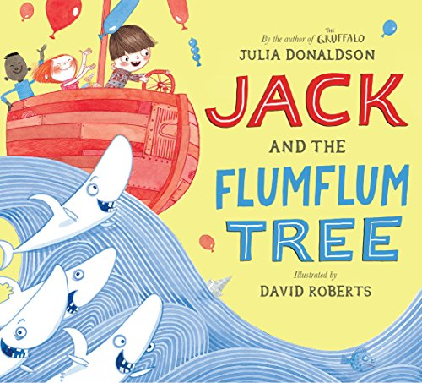
https://blogs.glowscotland.org.uk/wl/StJosephsPS/2020/06/03/session-6-of-storytime/

- After you have listened to the story talk to a parent or someone at home about the story.
- Plan an adventure that you would like to go on like Jack did.
Where would you go?
Why would you go there?
How would you get there?
Who would go with you?
What would you need to take?
- Complete one box from the Reading Activity Grid.
- Read a book or magazine that you have at home with someone in your house.

Beginning. Middle & End  Write a sentence about the Beginning, Middle and End of the story. Then draw a picture for each part.  BME | Character Profile  Choose a character from the story and draw a detailed picture of them. Write a sentence about the character.  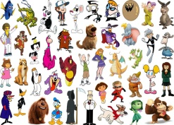 | Alternative Front Cover  Look at the front cover of your book. Now design your own front cover for that same book. Remember to include the title.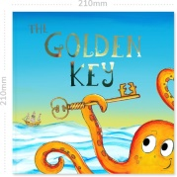
Write a Blurb  The Blurb is the piece of writing on the back cover of the book that tells you a little bit about the story. Write a blurb for your book.  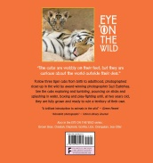 | 2,3,4 & 5 Letter Words  Look through your book and find words with 2 letters, 3 letters, 4 letters and 5 letters.  2,3,4,5 | Question Time  Make up some questions about the story that you could ask someone else at home.
Book Review  Write a review of the book you have read. Inclue things like Title, Author, Favourite part, Characters and if you would recommend it to others or not.  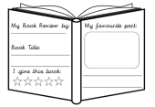 | Comic Strip  Make a comic strip for your book. Draw some pictures and a few short sentences to show what happened in the story.  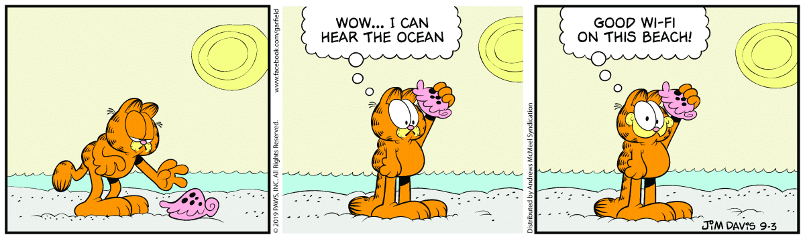 | Favourite part  What was your favourite part of the story? Draw a picture of it and then write a sentence.  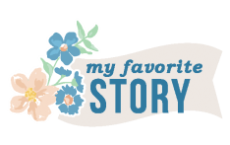
Different Ending  Write a different ending for the book. What would you have changed? | New Character  Make up a new character that could be in this book or story. Draw a picture of them. Then write a sentence about them. | Setting  Where did the story take place? Draw a detailed picture of the setting of the story.

Sight Words
a, the, I, is, he, she, his, as, has, to, do, no, go, me, my, of, off, have, you.
- Practice reading and writing your sight words.
- Find your sight words in a book.
- Write your sight words out twice. First write then in lowercase then write them again in uppercase.
the - THE

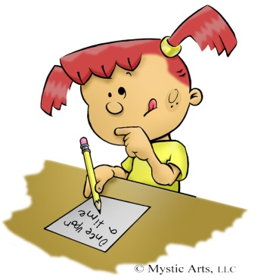
Writing
Listen to Jack and the Flumflum Tree again.
https://blogs.glowscotland.org.uk/wl/StJosephsPS/2020/06/03/session-6-of-storytime/

- Write a sentence to retell the story.
- Draw a picture to show what you have written.
Remember to use a Capital Letter, Finger Spaces and Full Stops.
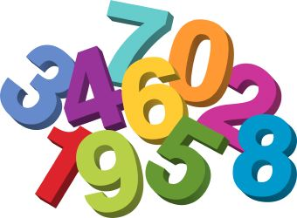
Maths
Money
Sorting Coins
Collect some coins that you have around the house (you may need to ask an adult to borrow some). Sort them into a table o that you have all the coins that are the same together.
1p | 2p | 5p | 10p | 20p
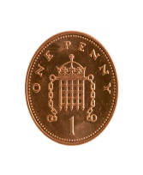

Shops

Use some food packaging from the recycling to make your own shop.
Make some price tags for the items. You could then use the coins that you
have sorted to buy some of the items.

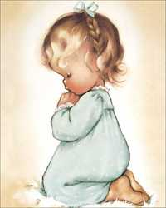

RE
Remember to be saying our morning and evening prayer each day with your family.

For the next few weeks we will look at some Bible stories. This week we will look at The Story Adam and Eve. Listen to the story here.

https://www.youtube.com/watch?v=1Ny3lh5DO8s

After you have listened to the story draw a picture of Adam and Eve.

Science

Go on a Plant and Flower Hunt when you are on your daily walk. Can you spot any of these plants and flowers?

Plants and Flowers Hunt Sheet
Tick the plants and flowers that you have found
Picture | Name of Flower | Tick
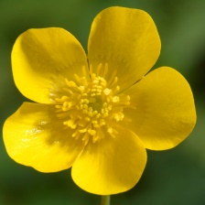 | Buttercup
 | Daisy
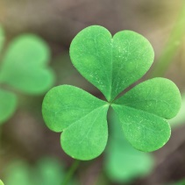 | Clover
 | Tulip
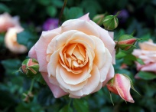 | Rose
 | Dandelion

STEM Challenge
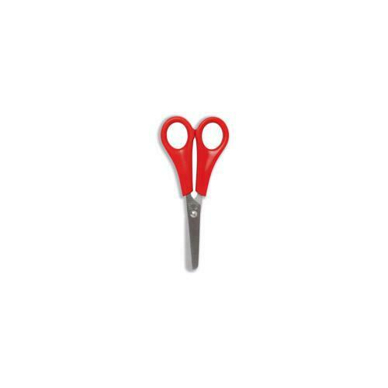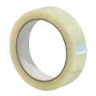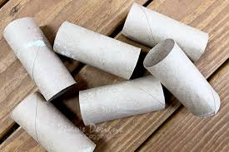
Design and make a bridge that can hold as much weight as possible. Use any items that you have around the house.

Other Ideas
- Ask your friends and family to tell you what their favourite things about summer are. Make a list of the things that they said.
- Offer to help with some chores around the house to help your family out.
- Use Education City and Sumdog to complete the games set.
- Have some time out to relax and spend time with your family.

