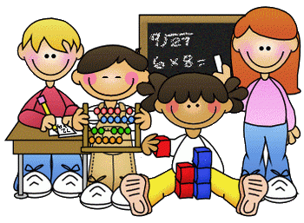

**Home Learning – Week Beginning 1st June 2020**

Good morning Primary 1/2! I hope you all had a very good and safe weekend. I hope you enjoyed all of the activities that I set for you last week. Here are some more fun tasks for you to try this week. Remember you also have the games and challenges on Education City and Sumdog. You do not have to complete all of these task and there is no particular order that they should be done in. Remember the most important thing is to stay safe and well.

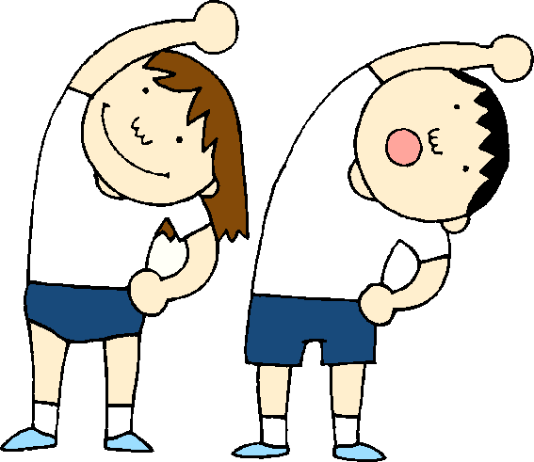

**PE**

A good way to start your day is with a little exercise. Every morning Joe Wicks will be live streaming a free PE lesson on his YouTube channel at 9am. You can access it through this link:

<https://www.youtube.com/user/thebodycoach1>

Jump Start Johnny is another good way to start the day.

<https://www.youtube.com/channel/UC8PDFwCV0HHcl08-1SzdiBw>

Cosmic Kids Yoga is another great way to relax and start the day.

<https://www.youtube.com/user/CosmicKidsYoga>

=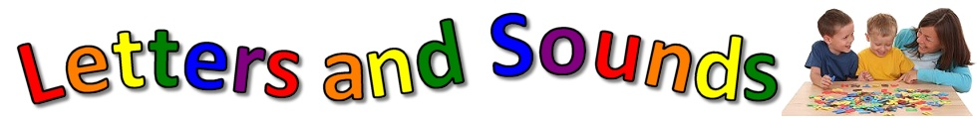

**Phonics**

This week we will consolidate thesounds

y qu ai oa

y – I can use y at the **end** of some ***short*** words.

j0141317qu – qu is a *a back of the throat and a lip sound.*

ai - ai is a sound from the Vowel House.

oa – oa is a sound from the Vowel House.

1. Practice reading and writing different words that contain each phoneme.
2. Use some of the words that you have come up with and write them in a sentence.
3. Fill an empty bottle with some water and ask an adult to make a hole in the lid of the bottle. Now use your bottle to write your sounds outside on the pavement.
4. Use YouTube to watch Geraldine Giraffe. She will be finding objects around her house that start with the sound. Can you do the same?

y - <https://www.youtube.com/watch?v=k8y4VsZIn_Y>

qu - <https://www.youtube.com/watch?v=mYGGk0MH_xQ>

ai - <https://www.youtube.com/watch?v=Fbmpw192MSg&t=3s>

oa - <https://www.youtube.com/watch?v=KCJyHN0IFE8>

**Reading**

Listen to Hare And Tortoise being read by Mr Benyon on our school blog.

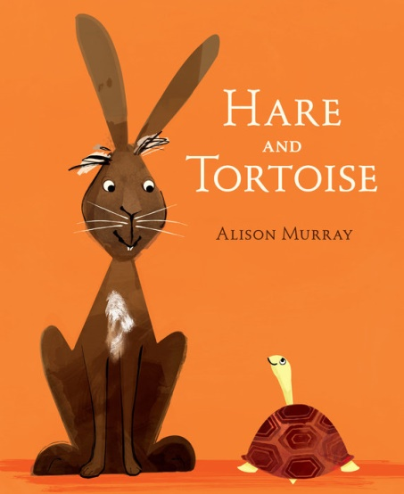

<https://blogs.glowscotland.org.uk/wl/StJosephsPS/2020/05/26/session-5-of-storytime/>

1. After you have listened to the story talk to a parent or someone at home about the story.
2. Have a think about a time that you thought you would win something but you didn’t. How did you feel when you didn’t win. Write about this time.
3. Complete one box from the Reading Activity Grid.
4. Read a book or magazine that you have at home with someone in your house.

|  |  |  |
| --- | --- | --- |
| Beginning. Middle & End  Write a sentence about the Beginning, Middle and End of the story. Then draw a picture for each part.  **BME** | Character Profile  Choose a character from the story and draw a detailed picture of them. Write a sentence about the character.  Click the 'D' Cartoon Characters Quiz - By ddd62291 | Alternative Front Cover  Look at the front cover of your book. Now design your own front cover for that same book. Remember to include the title.The Golden Key, Personalised Pirate Book – Bang On Books |
| Write a Blurb  The Blurb is the piece of writing on the back cover of the book that tells you a little bit about the story. Write a blurb for your book.  Children's Book, "Eye on the Wild" ⎯ Tiger - Baby Animal Prints ... | 2,3,4 & 5 Letter Words  Look through your book and find words with 2 letters, 3 letters, 4 letters and 5 letters.  **2,3,4,5** | Question Time  Make up some questions about the story that you could ask someone else at home.  What is a Question Mark? - Twinkl Teaching Wiki |
| Book Review  Write a review of the book you have read. Inclue things like Title, Author, Favourite part, Characters and if you would recommend it to others or not.  Very Simple Book Review Template | Teaching Resources | Comic Strip  Make a comic strip for your book. Draw some pictures and a few short sentences to show what happened in the story.  Garfield | Daily Comic Strip on September 3rd, 2019 | Favourite part  What was your favourite part of the story? Draw a picture of it and then write a sentence.  Paper Collection Reveal: My Favorite Story + GIVEAWAY – Pinkfresh ... |
| Different Ending  Write a different ending for the book. What would you have changed?  The Art of the Last Line: How to Find Your Story's… | NY Book Editors | New Character  Make up a new character that could be in this book or story. Draw a picture of them. Then write a sentence about them.  Milo Murphy Character Melissa Chase transparent PNG - StickPNG | Setting  Where did the story take place? Draw a detailed picture of the setting of the story.  Set of scenes or background in nature setting | Free Vector |

**Sight Words**

a, the, I, is, he, she, his, as, has, to, do, no, go, me, my, of, off, have, you.

1. Practice reading and writing your sight words.
2. Find your sight words in a book.
3. Pick 3 of your sight words and then write a sentence for each of them.

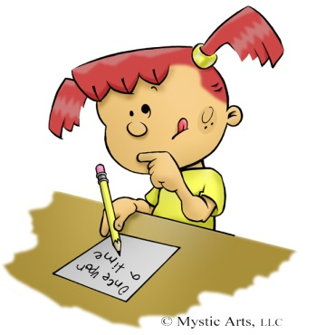

**Writing**

Listen to Hare And Tortoise again.

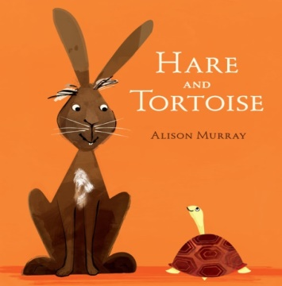

<https://blogs.glowscotland.org.uk/wl/StJosephsPS/2020/05/26/session-5-of-storytime/>

1. Write a sentence to retell the story.
2. Draw a picture to show what you have written.

**Remember to use a Capital Letter, Finger Spaces and Full Stops.**

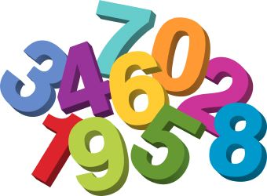

**Maths**

**Time**

**Daily Timetable**

Think about all the things that you do in a day. Draw a picture of something that you do in the morning, something you do in the afternoon and something that you do at night time.

|  |  |
| --- | --- |
| **Morning** |  |
| **Afternoon** |  |
| **Night** |  |

|  |
| --- |
| **Time Objects**    Go around you house and find some objects that tell the time.  For Example – the oven, a watch, the television.  See how many item you can find.  C:\Users\laura.mccullagh1\AppData\Local\Microsoft\Windows\INetCache\IE\8035IPMS\Little-girl-praying[1].jpg |

**RE**

Remember to be saying our morning and evening prayer each day with your family.

For the next few weeks we will look at some Bible stories. This week we will look at The Story of Creation. Listen to the story here.

<https://www.youtube.com/watch?v=teu7BCZTgDs>

After you have listened to the story pick your favourite day and draw a picture of what God created.

**Science**

1. Can you find any butterflies in your garden or when you are out for a walk. What do they look like? What colours are they? What did you notice about their wings?
2. Create a picture of a Butterfly. Can you make sure that the wings are symmetrical?

**STEM Challenge**

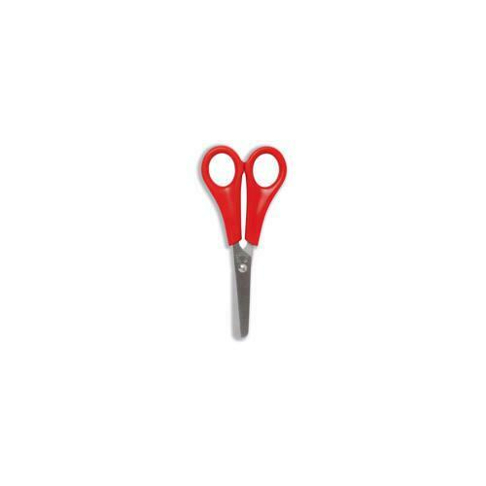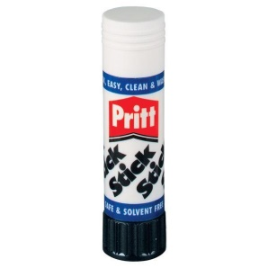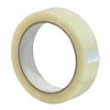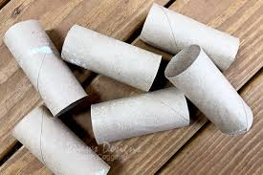

Make a boat that can float in a basin/ bucket of water and can carry a cargo of at least one penny. You can use any materials that you have lying around your house to make your boat.



**Other Ideas**

1. Go on a Sensory Walk with an adult. What can you see, hear and smell on your walk. When you get back home draw a picture of all the things from your walk.
2. Offer to help with some chores around the house to help your family out.
3. Use Education City and Sumdog to complete the games set.
4. Have some time out to relax and spend time with your family.