Ancient Egyptian Gods
- How many gods were there in ancient Egypt?

- What kind of snake sat on Ra’s head?

- Who is Isis?

- What was the name of the first mummy?

- What was special about Amun?

- Who created hieroglyphics?

- Who was married to Thoth?

- Choose one of the gods and explain what you understand about them.

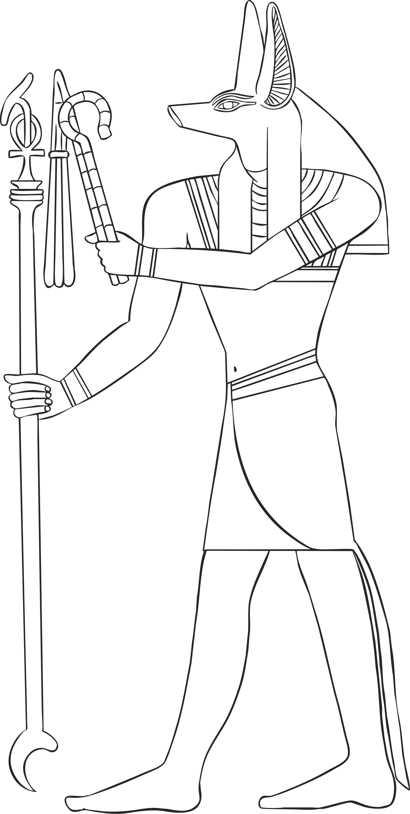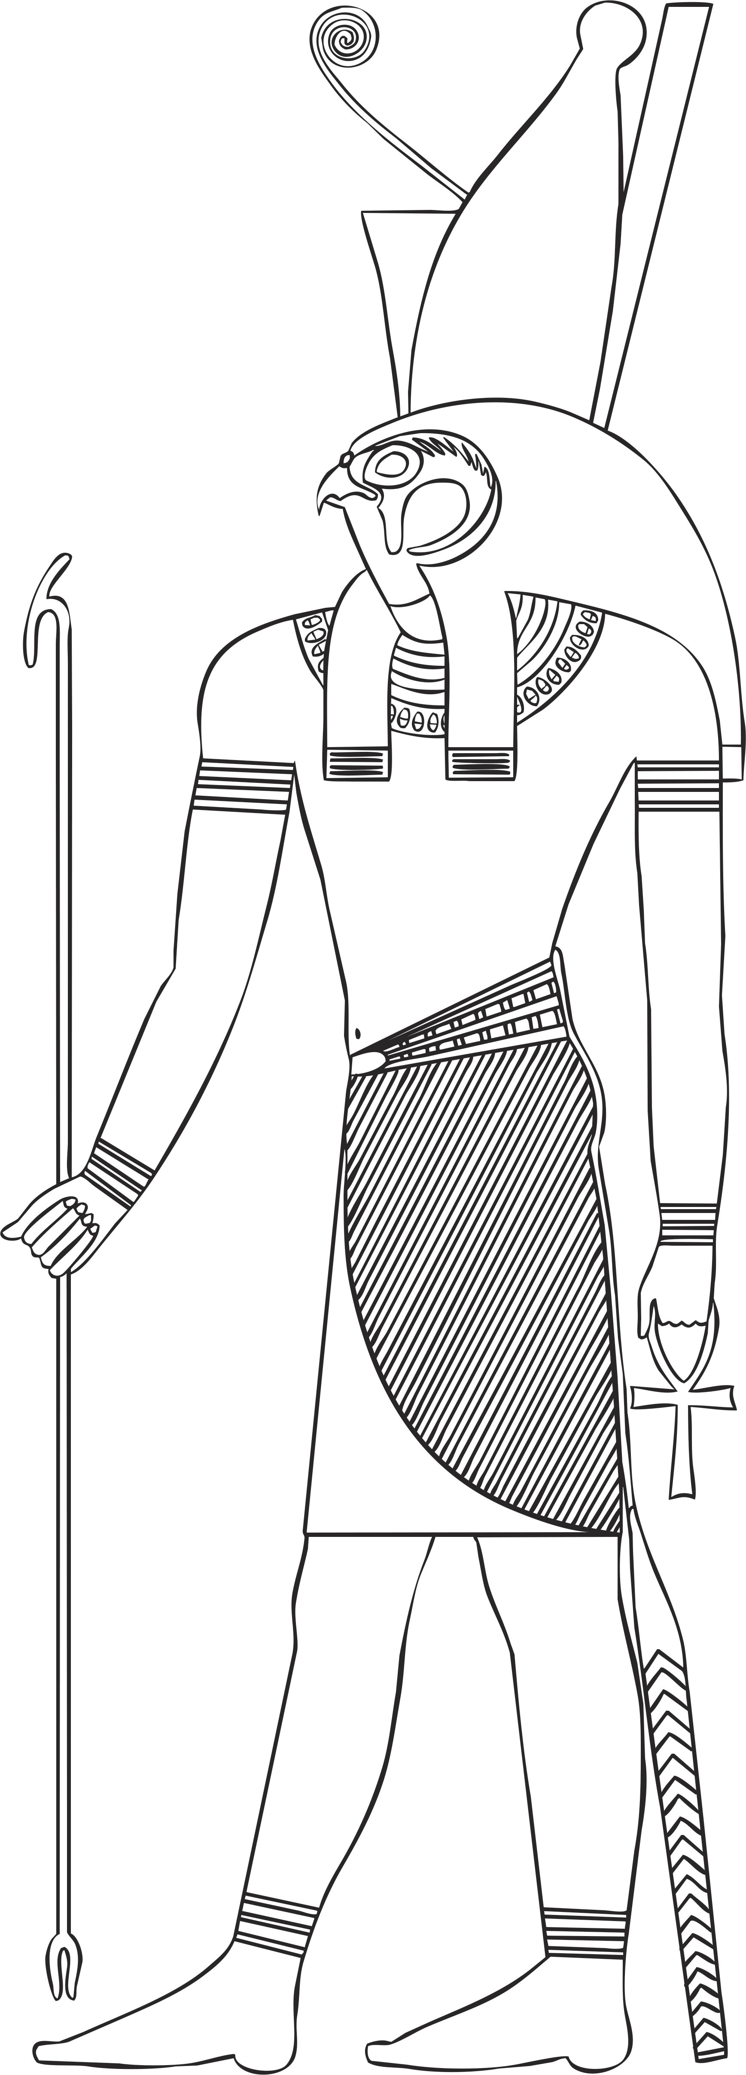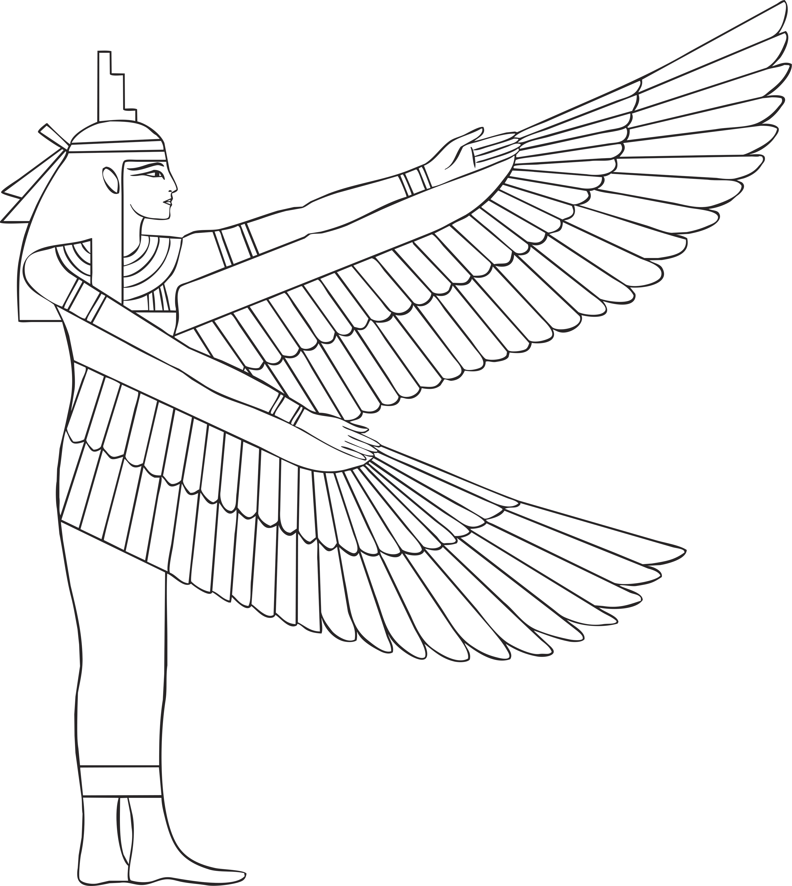

Suggested Answers
- There were more than 2000 gods in ancient Egypt.
- A sacred cobra sat on Ra’s head.
- Isis is the mother of Horus and the queen of the goddesses.
- Anubis is believed to be the first mummy.
- It is said that Amun created all things, so he is special.
- It is believed that Thoth, the god of wisdom, invented hieroglyphics.
- Ma’at was married to Thoth.

