Home Learning – Week Beginning 25th May 2020
Good morning Primary 1/2! I hope you all had a very good and safe weekend. I hope you enjoyed all of the activities that I set for you last week. Here are some more fun tasks for you to try this week. Remember you also have the games and challenges on Education City and Sumdog. You do not have to complete all of these task and there is no particular order that they should be done in. Remember the most important thing is to stay safe and well.

PE
A good way to start your day is with a little exercise. Every morning Joe Wicks will be live streaming a free PE lesson on his YouTube channel at 9am. You can access it through this link:
https://www.youtube.com/user/thebodycoach1

Jump Start Johnny is another good way to start the day.
https://www.youtube.com/channel/UC8PDFwCV0HHcl08-1SzdiBw

Cosmic Kids Yoga is another great way to relax and start the day.
https://www.youtube.com/user/CosmicKidsYoga

=
Phonics
This week we will consolidate the sounds
sh ch th j
sh – sh is a tongue sound, it uses the flat centre of the tongue.
ch – ch is a tongue sound, it uses the flat centre of the tongue.
th - th is a quiet tongue tip sound.
j – j is a tongue sound, it uses the flat centre of the tongue.

- Practice reading and writing different words that contain each phoneme.
- Draw a detailed picture. Write your phonemes in the picture then colour it in. Ask someone in your house to try to find the phonemes in your picture.
- Use YouTube to watch Geraldine Giraffe. She will be finding objects around her house that start with the sound. Can you do the same?
sh - https://www.youtube.com/watch?v=nx2Tf9TE1bc
ch - https://www.youtube.com/watch?v=OyrYDitif1o&t=2s
th - https://www.youtube.com/watch?v=6U354eD-hgQ
j - https://www.youtube.com/watch?v=oHe1GoxTyEI

Reading
Listen to Freddie and the Fairy being read by Mrs Warner on our school blog.
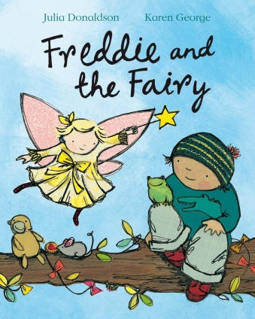
https://blogs.glowscotland.org.uk/wl/StJosephsPS/2020/05/19/session-4-of-storytime-freddy-and-the-fairy/

- After you have listened to the story talk to a parent or someone at home about the story.
- Have a think about something that you would wish for if you met a fairy. What would it be? Draw a picture of what it is and then write a sentence about why that would be your wish.
- Complete one box from the Reading Activity Grid.
- Read a book or magazine that you have at home with someone in your house.

Beginning. Middle & End  Write a sentence about the Beginning, Middle and End of the story. Then draw a picture for each part.  BME | Character Profile  Choose a character from the story and draw a detailed picture of them. Write a sentence about the character. | Alternative Front Cover  Look at the front cover of your book. Now design your own front cover for that same book. Remember to include the title.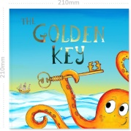
Write a Blurb  The Blurb is the piece of writing on the back cover of the book that tells you a little bit about the story. Write a blurb for your book. | 2,3,4 & 5 Letter Words  Look through your book and find words with 2 letters, 3 letters, 4 letters and 5 letters.  2,3,4,5 | Question Time  Make up some questions about the story that you could ask someone else at home.
Book Review  Write a review of the book you have read. Inclue things like Title, Author, Favourite part, Characters and if you would recommend it to others or not.  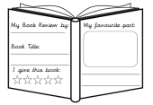 | Comic Strip  Make a comic strip for your book. Draw some pictures and a few short sentences to show what happened in the story. | Favourite part  What was your favourite part of the story? Draw a picture of it and then write a sentence.
Different Ending  Write a different ending for the book. What would you have changed? | New Character  Make up a new character that could be in this book or story. Draw a picture of them. Then write a sentence about them. | Setting  Where did the story take place? Draw a detailed picture of the setting of the story.

Sight Words
a, the, I, is, he, she, his, as, has, to, do, no, go, me, my, of, off, have, you.
- Practice reading and writing your sight words.
- Find your sight words in a book.
- Pyramid Writing – Write your words normally to begin with then write your words in a pyramid shape.
she – s
sh
she

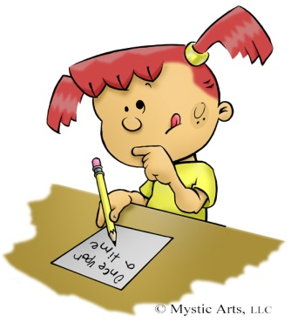
Writing
Listen to Freddie and the Fairy again.
https://blogs.glowscotland.org.uk/wl/StJosephsPS/2020/05/19/session-4-of-storytime-freddy-and-the-fairy/

- Write a sentence to retell the story.
- Draw a picture to show what you have written.
Remember to use a Capital Letter, Finger Spaces and Full Stops.

Maths
Addition to 10
Snap
Make some addition to 10 Snap cards. Write out some addition sums on one set of cards and then on the other set write the answers. Play a game of Snap with someone else in your house.
Rules
- Shuffle all the cards together.
- Give each player the same number of cards. Don’t show the other player your cards or look at them yourself.
- Take turns to put a card down. If you match a sum and an answer you win the pile of cards.

Object Addition

Use some objects from around your house or garden to make some addition to 10 sums.
You could use soft toys, cutlery, Lego, sticks, leaves.
+=

RE
Remember to be saying our morning and evening prayer each day with your family.
Learn the Our Father.

Science

- Create a Minibeast hotel. Use an old box or jar that you have lying around your house. Fill it with things that bugs love, like leaves, twigs, grass and stones. You can decorate your box or jar in any way that you want. Leave your hotel outside overnight and see if you have any visitors in the morning.

STEM Challenge
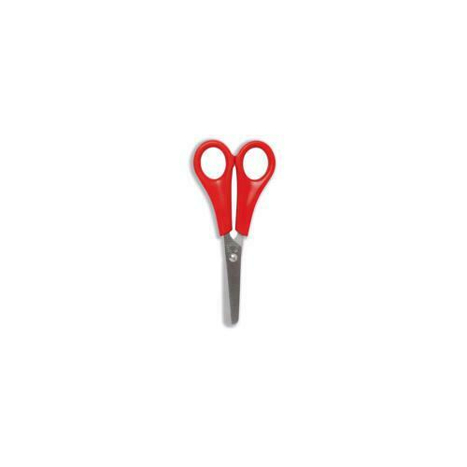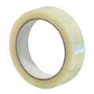
Make the tallest tower you can which is capable of standing freely and not attached to anything. You can use anything that you have in your house to make your tower.

Other Ideas
- If you go on a walk with your family can find any of these items?
4 twigs/sticks, some grass, a flower, some stones, some leaves. When you get home can you use the items to make a nature photo frame. Use the twigs as the frame and put the other items inside to make a nature picture.

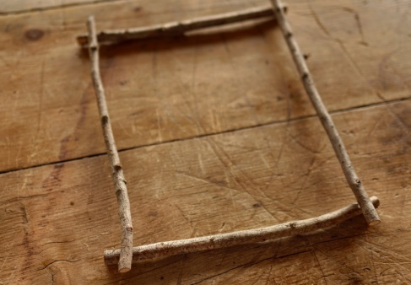
- Offer to help with some chores around the house to help your family out.
- Use Education City and Sumdog to complete the games set.
- Have some time out to relax and spend time with your family.

