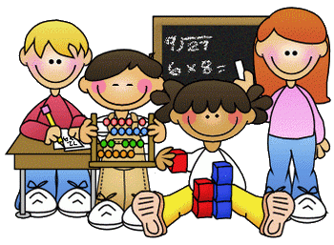

**Home Learning – Week Beginning 19th May 2020**

Good morning Primary 1/2! I hope you all had a very good and safe weekend. I hope you enjoyed all of the activities that I set for you last week. Here are some more fun tasks for you to try this week. Remember you also have the games and challenges on Education City and Sumdog. You do not have to complete all of these task and there is no particular order that they should be done in. Remember the most important thing is to stay safe and well.

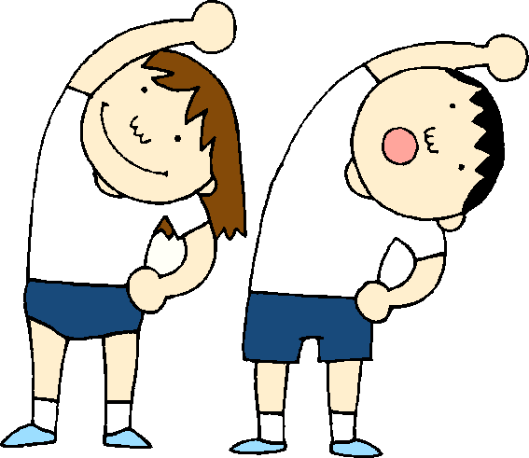

**PE**

A good way to start your day is with a little exercise. Every morning Joe Wicks will be live streaming a free PE lesson on his YouTube channel at 9am. You can access it through this link:

<https://www.youtube.com/user/thebodycoach1>

Jump Start Johnny is another good way to start the day.

<https://www.youtube.com/channel/UC8PDFwCV0HHcl08-1SzdiBw>

Cosmic Kids Yoga is another great way to relax and start the day.

<https://www.youtube.com/user/CosmicKidsYoga>

=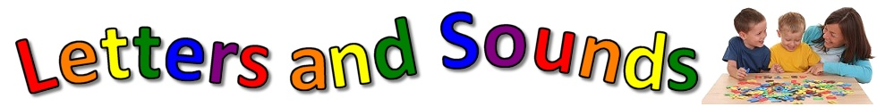

**Phonics**

This week we will consolidate thesounds

ck ee oo ng

ck – ck is a *short*, *quiet,* ***back of the throat*** sound.



ee – ee lives in the vowel house.

oo - oo is a sound from the Vowel House. MCj03799870000[1]

ng – when n and g are together the make one ***back of the throat*** sound.

1. Practice reading and writing different words that contain each phoneme.
2. Make a phonics Snap/Pairs game. Write your sounds out twice and then cut them up into squares. Use them to play Snap or Pairs with someone else at home. Challenge – make some more cards with the Capital letters of your sounds and if you could add them into your game.

|  |  |  |  |
| --- | --- | --- | --- |
| ck | ck | ee | ee |
| oo | ng | ng | CK |
| CK | EE | EE | OO |
| OO | NG | NG |  |

1. Use YouTube to watch Geraldine Giraffe. She will be finding objects around her house that start with the sound. Can you do the same?

ck - <https://www.youtube.com/watch?v=EU1MPzpuvvo>

ee - <https://www.youtube.com/watch?v=qfM7Hz7US0U>

oo - <https://www.youtube.com/watch?v=-3UUnmNk1UM>

ng - <https://www.youtube.com/watch?v=vQshNmncnBs>

**Reading**

Listen to The Cook and the King being read by Mrs Mooney on our school blog.

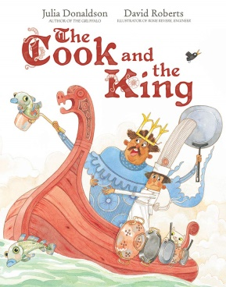

<https://blogs.glowscotland.org.uk/wl/StJosephsPS/2020/05/12/storytime-3/>

1. After you have listened to the story talk to a parent or someone at home about the story.
2. Pick a character from the story and draw a picture of them, then write a sentence about the character.
3. Complete one box from the Reading Activity Grid.
4. Read a book or magazine that you have at home with someone in your house.

|  |  |  |
| --- | --- | --- |
| Beginning. Middle & End  Write a sentence about the Beginning, Middle and End of the story. Then draw a picture for each part.  **BME** | Character Profile  Choose a character from the story and draw a detailed picture of them. Write a sentence about the character.  Click the 'D' Cartoon Characters Quiz - By ddd62291 | Alternative Front Cover  Look at the front cover of your book. Now design your own front cover for that same book. Remember to include the title.The Golden Key, Personalised Pirate Book – Bang On Books |
| Write a Blurb  The Blurb is the piece of writing on the back cover of the book that tells you a little bit about the story. Write a blurb for your book.  Children's Book, "Eye on the Wild" ⎯ Tiger - Baby Animal Prints ... | 2,3,4 & 5 Letter Words  Look through your book and find words with 2 letters, 3 letters, 4 letters and 5 letters.  **2,3,4,5** | Question Time  Make up some questions about the story that you could ask someone else at home.  What is a Question Mark? - Twinkl Teaching Wiki |
| Book Review  Write a review of the book you have read. Inclue things like Title, Author, Favourite part, Characters and if you would recommend it to others or not.  Very Simple Book Review Template | Teaching Resources | Comic Strip  Make a comic strip for your book. Draw some pictures and a few short sentences to show what happened in the story.  Garfield | Daily Comic Strip on September 3rd, 2019 | Favourite part  What was your favourite part of the story? Draw a picture of it and then write a sentence.  Paper Collection Reveal: My Favorite Story + GIVEAWAY – Pinkfresh ... |
| Different Ending  Write a different ending for the book. What would you have changed?  The Art of the Last Line: How to Find Your Story's… | NY Book Editors | New Character  Make up a new character that could be in this book or story. Draw a picture of them. Then write a sentence about them.  Milo Murphy Character Melissa Chase transparent PNG - StickPNG | Setting  Where did the story take place? Draw a detailed picture of the setting of the story.  Set of scenes or background in nature setting | Free Vector |

**Sight Words**

a, the, I, is, he, she, his, as, has, to, do, no, go, me, my, of, off, have, you.

1. Practice reading and writing your sight words.
2. Find your sight words in a book.
3. Backwards words – Write your words then write them again but this time backwards.

she - ehs

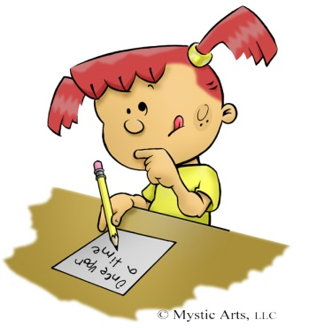

**Writing**

Listen to The Cook and the King again.



<https://blogs.glowscotland.org.uk/wl/StJosephsPS/2020/05/12/storytime-3/>

1. Write a sentence to retell the story.
2. Draw a picture to show what you have written.

**Remember to use a Capital Letter, Finger Spaces and Full Stops.**

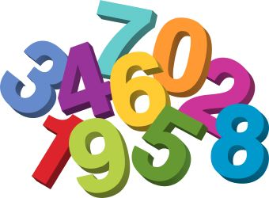

**Maths**

**Shape Hunt**

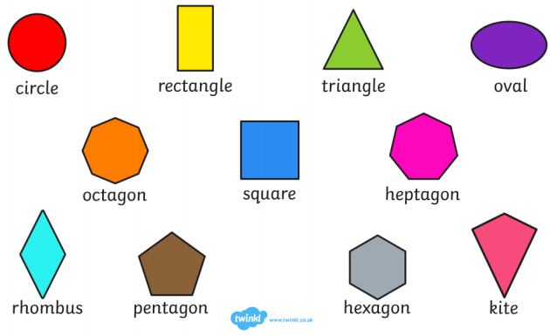

|  |  |  |
| --- | --- | --- |
| |  | | --- | | Find four different 2D shapes in your house.  Tell an adult about each one using its name, how many sides it has and how many  corners it has. |   **2D Shape Patterns**  A set of 30 2D shape repeating pattern cards – a great resource ...   |  | | --- | | Pick 3 of the shapes from the above picture and use them to create a repeating pattern.  Colour your pattern in. | |

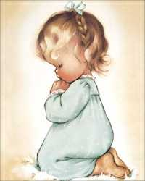

**RE**

Remember to be saying our morning and evening prayer each day with your family.

Learn the Our Father.

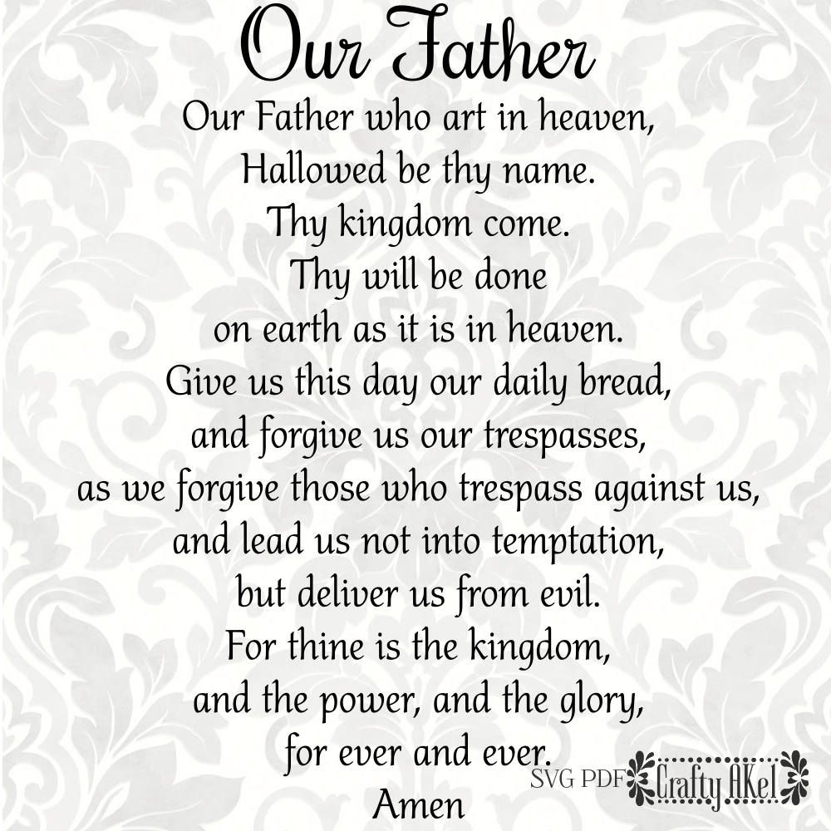

**Health and Wellbeing**

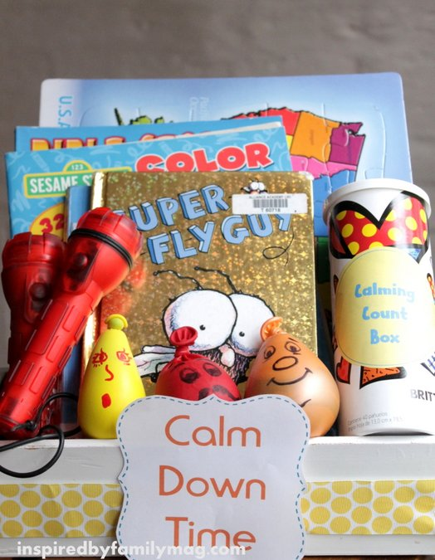

Create a Calm Box for you and your family. If you or anyone in your house are feeling sad or upset you could use something from the box to cheer you up. You could use an old shoe box or a box from a delivery. Inside you could put things that make you feel happy and safe; a teddy, a photograph, a blanket, a book that you love to read, a favourite toy, some colouring materials. You could also decorate the box.

**STEM Challenge**

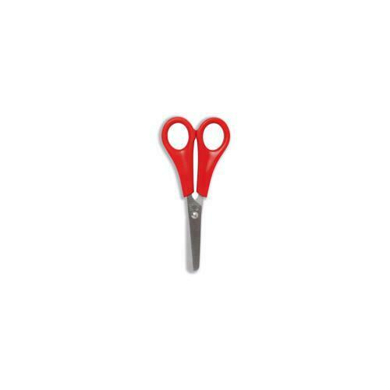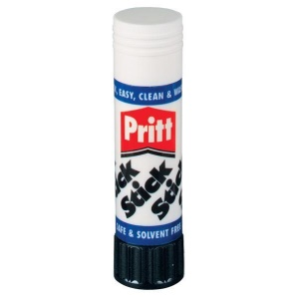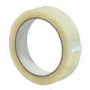

Use some junk and recycling materials that you have lying around at home to create a model. You can make a model of anything that you like.



**Other Ideas**

1. If you go on a walk with you family try this

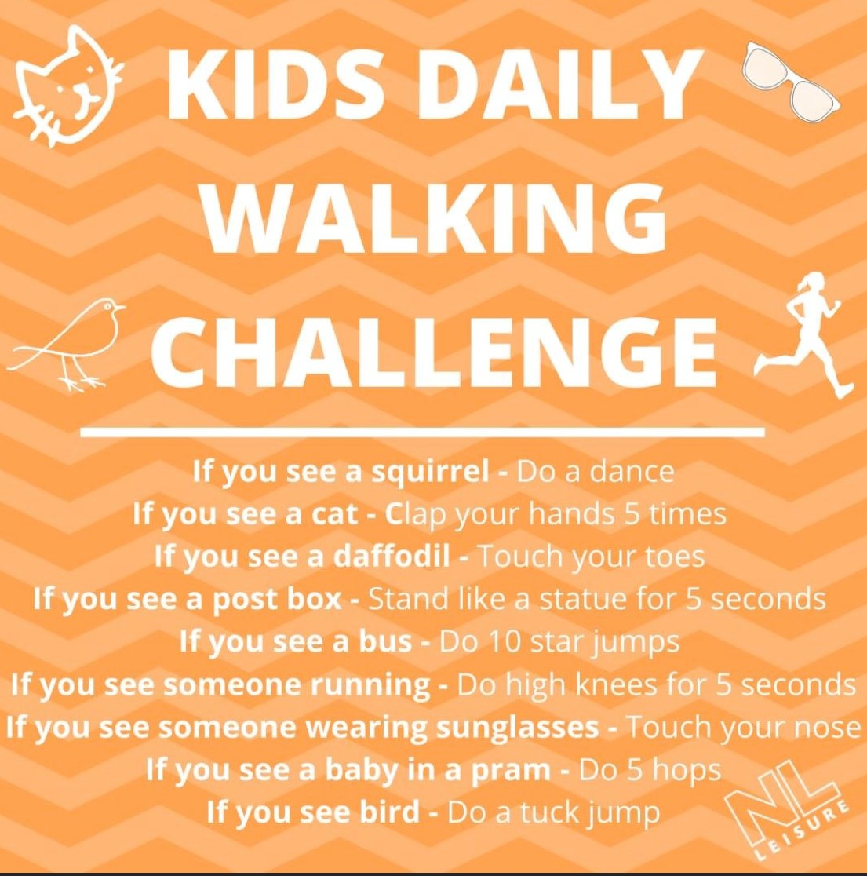

1. Offer to help with some chores around the house to help your family out.
2. Use Education City and Sumdog to complete the games set.
3. Have some time out to relax and spend time with your family.