Home Learning – Week Beginning 11th May 2020
Good morning Primary 1/2! I hope you all had a very good and safe weekend. I hope you enjoyed all of the activities that I set for you last week. Here are some more fun tasks for you to try this week. Remember you also have the games and challenges on Education City and Sumdog. You do not have to complete all of these task and there is no particular order that they should be done in. Remember the most important thing is to stay safe and well.

PE
A good way to start your day is with a little exercise. Every morning Joe Wicks will be live streaming a free PE lesson on his YouTube channel at 9am. You can access it through this link:
https://www.youtube.com/user/thebodycoach1

Cosmic Kids Yoga is another great way to relax and start the day.
https://www.youtube.com/user/CosmicKidsYoga

Phonics
This week we will consolidate the sounds
v z l r
- Practice reading and writing different words that contain each phoneme.
- Use some objects that you have around the house to make your sounds eg, Lego, bottle tops, soft toys.
- Use YouTube to watch Geraldine Giraffe. She will be finding objects around her house that start with the sound. Can you do the same?
v - https://www.youtube.com/watch?v=Q8qklEXh7Dc
z - https://www.youtube.com/watch?v=O6jgGvZ-3zQ
l - https://www.youtube.com/watch?v=sq-q2jzM78c
r - https://www.youtube.com/watch?v=R_NgOtt0Htw

Reading
Listen to Room on the Broom being read by Mrs Thomson on our school blog.
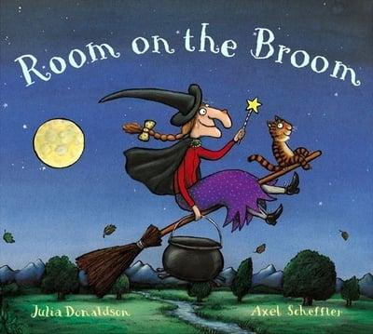
https://blogs.glowscotland.org.uk/wl/StJosephsPS/2020/05/05/storytime-2/

- After you have listened to the story talk to a parent or someone at home about the story.
- Write a sentence and draw a picture of your favourite part of the story.
- Complete one box from the Reading Activity Grid.

Reading Activity Grid
Beginning. Middle & End  Write a sentence about the Beginning, Middle and End of the story. Then draw a picture for each part.  BME | Character Profile  Choose a character from the story and draw a detailed picture of them. Write a sentence about the character. | Alternative Front Cover  Look at the front cover of your book. Now design your own front cover for that same book. Remember to include the title.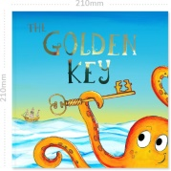
Write a Blurb  The Blurb is the piece of writing on the back cover of the book that tells you a little bit about the story. Write a blurb for your book. | 2,3,4 & 5 Letter Words  Look through your book and find words with 2 letters, 3 letters, 4 letters and 5 letters.  2,3,4,5 | Question Time  Make up some questions about the story that you could ask someone else at home.
Book Review  Write a review of the book you have read. Inclue things like Title, Author, Favourite part, Characters and if you would recommend it to others or not. | Comic Strip  Make a comic strip for your book. Draw some pictures and a few short sentences to show what happened in the story.  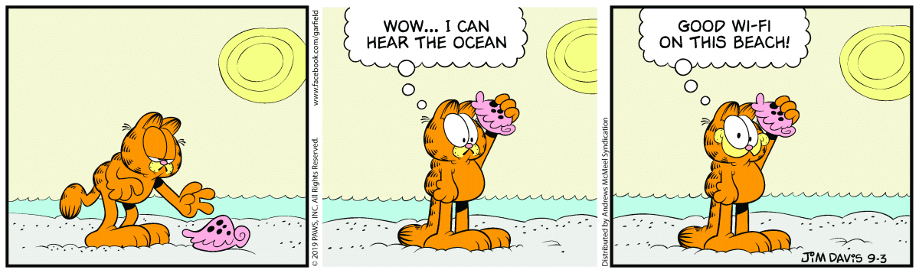 | Favourite part  What was your favourite part of the story? Draw a picture of it and then write a sentence.
Different Ending  Write a different ending for the book. What would you have changed? | New Character  Make up a new character that could be in this book or story. Draw a picture of them. Then write a sentence about them. | Setting  Where did the story take place? Draw a detailed picture of the setting of the story.

Sight Words
a, the, I, is, he, she, his, as, has, to, do, no, go, me, my, of, off, have, you.
- Practice reading and writing your sight words.
- Find your sight words in your book.
- Pick 5 of your words and write a silly sentence with them in it.

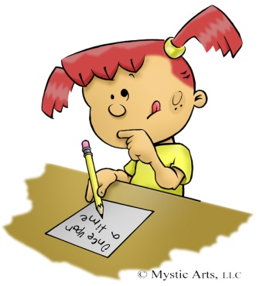
Writing
Listen to Room on the Broom again.
https://www.youtube.com/watch?v=XRany_OScms
- Write a sentence to retell the story.
- Draw a picture to show what you have written.

Maths
Size Ordering

Ask an adult for three items and put them in order from the smallest to largest.
Then, ask for a different three items to put into order.
For an extra challenge, try to order five items

Outdoor Patterns

Using items that you can find outside, create a pattern.
Try leaf, stone, leaf, stone, etc. or stick, stone, grass, stick, stone, grass.

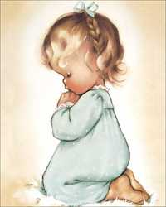

RE
Remember to be saying our morning and evening prayer each day with your family. May is the Month of Mary. You can say a Hail Mary daily for your own intentions.

Hail Mary
Hail Mary full of Grace, the Lord is with thee.
Blessed art thou amongst women and blessed is the fruit of thy womb Jesus.
Holy Mary Mother of God,
pray for us sinners now and at the hour of our death.
Amen.

Here is a link to a PowerPoint for you to look at about Remembering Mary during the month of May.
https://www.twinkl.co.uk/resource/roi-re-3-may-is-the-month-of-mary

Expressive Arts
Make a Stained Glass Window for the Month of May. There is a template below to use.

Science/Outdoor Learning
Go on a Nature Walk Scavenger Hunt. There is a Check Sheet below to use.

Other Ideas
- Draw a picture or write a note to put in your window to show the people that go passed that you are there for them and to cheer everyone up.
- Offer to help with some chores around the house to help your family out.
- Use Education City and Sumdog to complete the games set.
- Have some time out to relax and spend time with your family.

