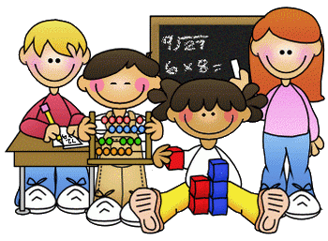
Home Learning – Week Beginning 4th May 2020
Good morning Primary 1/2! I hope you all had a fun and safe long weekend. Here are some more fun tasks for you to try this week. I hope you all enjoyed the tasks set last week. Remember you also have the games and challenges on Education City and SUMDOG. You do not have to complete all tasks and there is no particular order that they should be done in. Remember the most important thing is to stay safe and well.

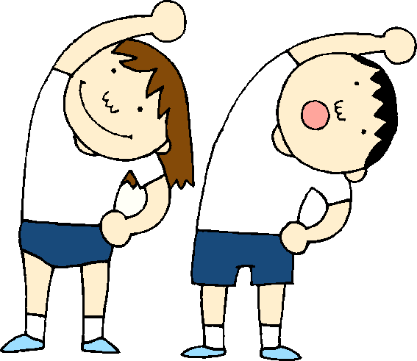
PE- Keep Moving!
A good way to start your day is with a little exercise. Every morning Joe Wicks will be live streaming a free PE lesson on his YouTube channel at 9am. You can access it through this link:
https://www.youtube.com/user/thebodycoach1

Jump Start Jonny Dance and Workouts- each morning at 9am.
https://www.youtube.com/channel/UC8PDFwCV0HHcl08-1SzdiBw

The Wake Up Dance- we all know this one well and I am missing dancing to this every morning with you all
https://www.youtube.com/watch?list=RD7zySLpeEUcM&v=1gUbdNbu6ak
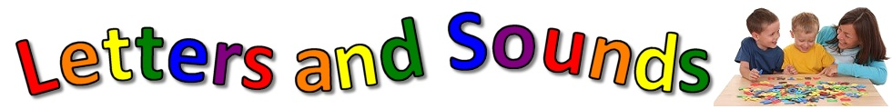

Phonics
This week we will consolidate the sounds
o t w
o –is a short vowel sound which lives in the vowel house, put the light on
t- you feel ‘t’ at the tip of your tongue, it is a tongue tip sound
w- is a stretchy lip sound

Phonics Songs
Click on the links below for some songs for this week’s sounds
o- https://www.youtube.com/watch?v=a5npjY6shlI
t- https://www.youtube.com/watch?v=7r2pT-8cOA0
w- https://www.youtube.com/watch?v=PlDPegyV6XI

Phonics Tasks
- Practice reading and writing different words that contain each phoneme.
- Make letters from playdough or trace fingers in playdough to write the letter and practise saying the sound.
- Play Phonics BINGO- make BINGO cards with this week’s sounds!
Reading

https://www.youtube.com/watch?v=BzZuS3ze-Ho
- Listen to The Rainbow Fish (click link above) and discuss the story with someone at home- talk about your favourite part. What happened at the beginning, the middle and the end
- Questions to ask while listening to the story-
- How does the Rainbow Fish feel about his beautiful scales?
- Why do you think the little blue fish wants one of Rainbow Fish’s special scales?
- How do you think the other fish felt when Rainbow Fish wouldn’t play with them?
- How did the other fish feel when Rainbow Fish shared his with them?
- How can you share with your friends?
- The Rainbow Fish's scales 'shimmer'. Can you find other words that could be used to describe the scales?
- Read a book each day with someone at home and discuss the story
Sight Words
they, are, is, the, as, was, we, he, she, his, has.
- Practice reading and writing your sight words.
- Pour sugar, salt or shaving cream on a tray and write the words in that
- Partner Spell - take turns adding a letter to spell each word. For example, for the word FUN - child starts by saying the letter F, parents adds letter U and child then completes word by adding the letter N
- Play ‘Spelling noughts and crosses’ – draw a noughts and crosses board and choose a word each to write, who will get three in a row first?
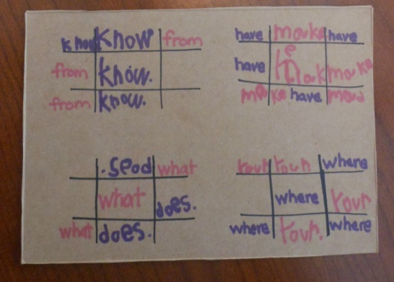
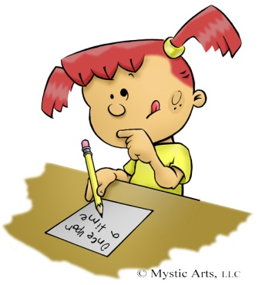
Writing
Please listen to the story ‘The Rainbow Fish’ under the reading section before writing activities
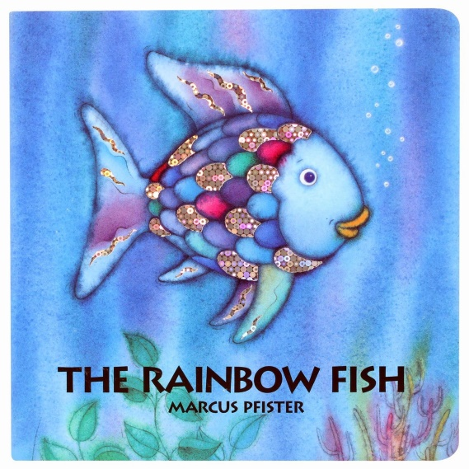
- The Rainbow Fish learned how to make his friends feel special. Write a sentence about how you make your friends feel special.
I make my friends feel special when I …
- Create your own fish, complete the sentences below and draw a picture
- My fish is…
- It can…
- My fish likes to…
- It is…
- My fish can…

Remember to use a capital letter at the beginning, finger spaces in between your words and a full stop at the end.
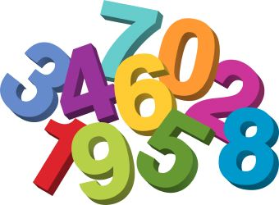
Maths
Addition using a Number Line
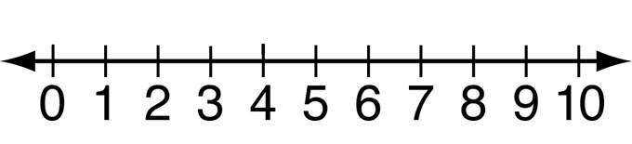
Write your own number line to help with addition. Put a counter on a number then role a dice. Count on in ones to see where you end up.
Counting forwards and backwards!
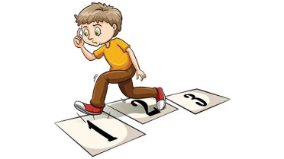
How many steps does it take you to go somewhere in your house? Count how many steps from your bedroom to the kitchen or from the sofa to the door. Can you then reverse the journey by counting backwards?
Counting to 100
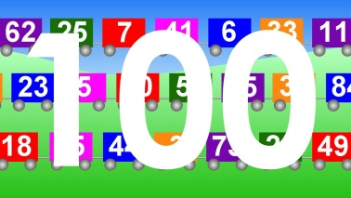
Last week we were counting to 100 on Education City! Keep working on this skill by using the count to 100 song and get yourself moving- we love this one in class!
https://www.youtube.com/watch?v=0TgLtF3PMOc

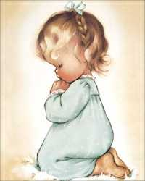
RE
Remember to be saying our morning and evening prayer each day with your family. As May is the month of Our Lady, Please continue to pray a Hail Mary daily.
Hail Mary
Hail Mary full of Grace, the Lord is with thee.
Blessed art thou amongst women and blessed is the fruit of thy womb Jesus.
Holy Mary Mother of God,
pray for us sinners now and at the hour of our death.
Amen.
The Month of May
This week we will learn a hymn honouring Mary as Gods Mother and Mother of us all.
It is called ‘Hail Mary

https://www.youtube.com/watch?v=7OxeUAtiuHk
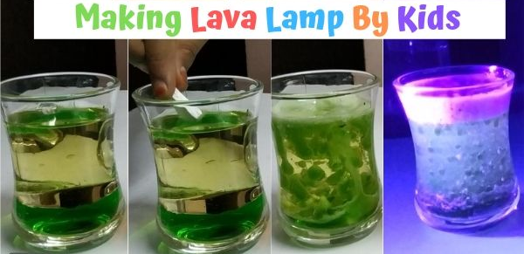
Science- Make your own Lava Lamp (Adult Assistance Required)
You will need:
- Vegetable Oil
- Food colour of your choice (red one looks better)
- Fizzy Tablets / Effervescent tablets
- Water
- Glass container
- Black light (optional – for extra visual effect)
Method:
Pour water in your glass container. Fill just 1/4th of your container. You can choose the size of the container based on your preference. Longer the height of the container, better the effect.
Add food colours to the water that you already added. You can choose your own colour.
Just to be sure, we stirred the food colour & water mixture a bit with a fork. Normally, the food colours get dissolved in water instantly.
Fill up the 3/4 of the container with oil. This is where all the action is going to happen, so it is important to have enough oil to show the blobs clearly. Also be gentle with pouring oil. Let is sit for a few minutes so that all the bubbles would settle down
Add fizzy tablet into the glass
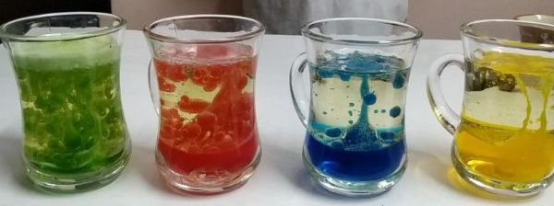

Expressive Arts
Music
Try some of these songs which link to ‘The Rainbow Fish’. Can you create a dance to match the songs?
Fish are Swimming (Tune: Frere Jacques)
Fish are swimming, fish are swimming,
In the sea, in the sea,
A-splishing and a-splashing,
A-splishing and a-splashing,
Look and see, look and see.
5 Little Fishes
5 little fishes swimming near the shore
1 took a dive and then there was 4
4 little fishes were swimming out to sea
One went for food and then there was 3
3 little fishes said now what should we do?
One swam away and then there were 2
2 little fishes we are having great fun
One went home and then there was 1
1 little fish said I like the warm sun
Off she went and then there were none!
Art and Design

Rainbow Fish Craft Supplies:
- paper plate
- Paper
- glitter glue
- sequins
- tissue paper
- clear contact paper
- aluminium foil
- scissors
- googly eye
- tape
- glue stick

Step 1 - Prep the rainbow fish craft by cutting a circle from the middle of the paper plate.
Cut a circular piece of clear contact paper a little bit bigger than the hole in the paper plate. Fix it to the underside of the plate- sticky side up.

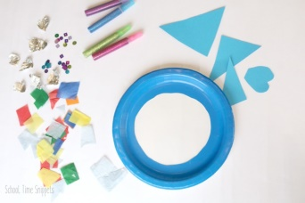
Step 2- Have your child fill the middle of the paper plate with tissue paper, sequins, and ripped up foil pieces. No glue necessary! Just arrange the colourful paper on the contact paper and it'll stick right to it.

Once the inside of the rainbow fish has been filled up, next it's time to add the fins. Cut three triangular pieces out: one for the tail and two for fins on the top and bottom of the fish, along with a heart shaped piece for the rainbow fish's lips
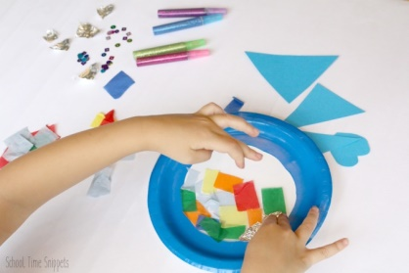
Step 3- Decorate the fins with glitter glue.
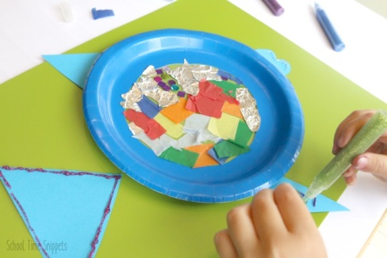
Step 4- Allow the glue to dry and then glue the pieces to the back of the paper plate. Glue on a googly eye.
Add some tape and hang on the window! Enjoy your own personal rainbow fish!
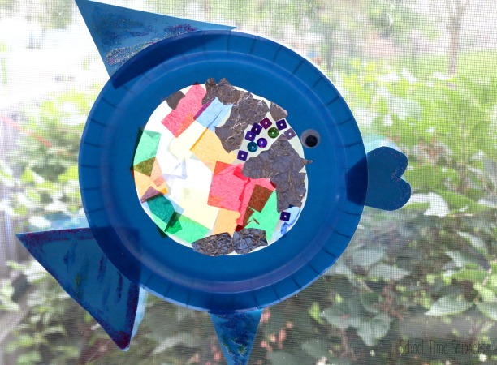

Help at Home (Always check with an adult first)

- Pick up and tidy up your toys 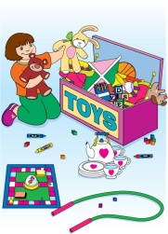

- Put your clothes into the washing basket 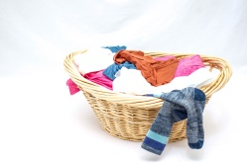

- Help sweep or clean up any spills 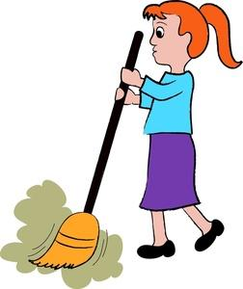

- Make your bed every morning 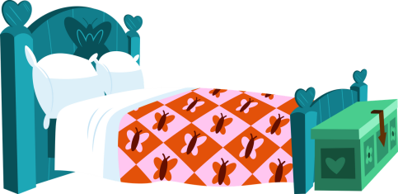
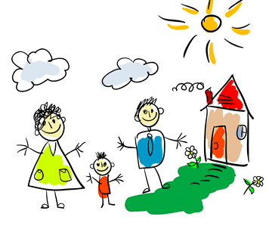
Take Time Out
Remember to take some time out to relax and spend with your loved ones.

- Have a drive in movie day- Make a box car or use the washing basket for an indoor drive-in film
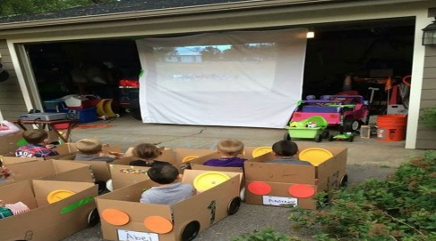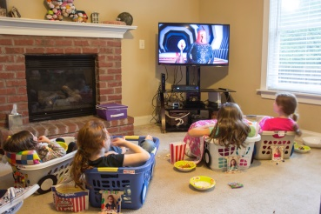

- Play card games! 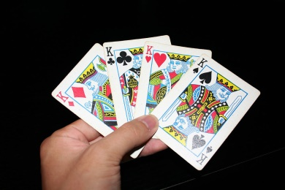

Play freeze dance - Choose some of your kids’ favourite tunes and ask them to dance until the music stops. When it does, they have to freeze in whatever position they find themselves in – even if they have one leg up. To make the game more challenging, ask the kids to freeze in specific poses: animals, shapes, letter

