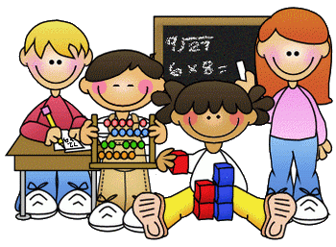
Home Learning Week 2 – Week beginning 30/03/2020
Good Morning Primary 2/1 and welcome to your 2nd week of home learning. I hope you all enjoyed your activities last week and I have more fun challenges for you all this week!
Parents/ carers these activities are for the whole week, they can be completed in any order and not every single activity has to be completed. The children also have their home learning pack to work through, daily reading BINGO, Digital Learning challenges, Education City tasks and SUMDOG. It is up to you how many and which activities your child completes. Please also remember the importance of play whilst completing daily activities.
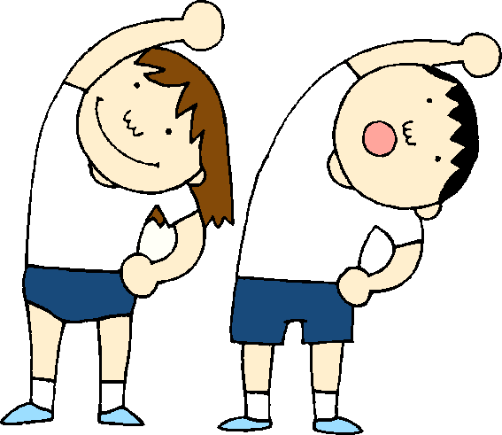
PE – Keep Moving!
A good way to start your day is with a little exercise. Every morning Joe Wicks will be live streaming a free PE lesson on his YouTube channel at 9am. You can access it through this link:
https://www.youtube.com/user/thebodycoach1

Go Noodle has a range of fun workout videos, games and calming exercises
https://www.gonoodle.com/good-energy-at-home-kids-games-and-videos/

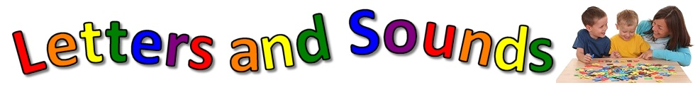

Literacy- Phonics
This week we will consolidate the sounds
a s m c
- Practice reading and writing different words that contain each phoneme.
- Find and cut out the letters from a newspaper or magazine.

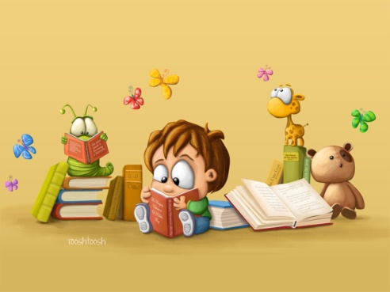

Reading
- Read a book that you have at home with an adult. Draw a picture of your favourite character in the story.
- Complete 1 box on the reading challenge each day
- Re-tell the story to someone in your family
- How many characters are in the story? Count them!

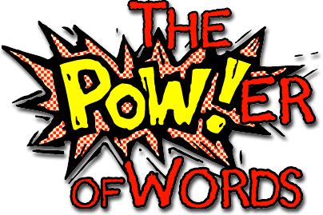

Sight Words
they, are, was, we, he, she, is, his, has, as
- Practice reading and writing your sight words.
- Draw a flower and in each petal write one of your words
- Rainbow words- spell your sight words using different colours for each letter
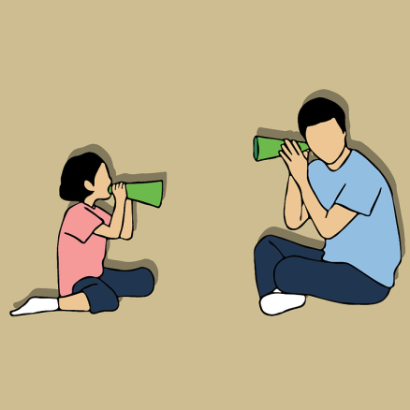
Listening and Talking
- Category game- In 1 minute, name as many… animals, fruit, colours… as you can think of
- Rhyming Words- Think of as many words as you can which rhyme with: Cat, Key, Ball… This means they sound the same at the end e.g. cat… bat

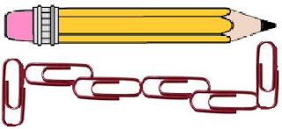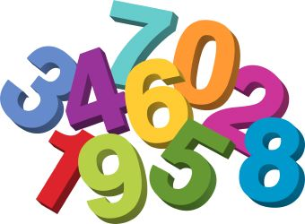

Maths- Measuring!

Measure the length of 5 or more items.
Use paper clips, coins, pens or something similar to measure the items.
Line up the paper clips along the length of the item.
Then count the number of paper clips to see how long it is.
Tell an adult what the longest item was and the shortest item was.

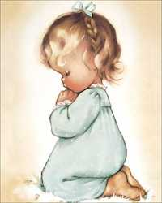

RE
Remember to be saying our morning and evening prayer each day with your family. You can also say an Our Father daily for your own intentions.
Our Father
Our Father, Who art in Heaven, hallowed be Thy name: Thy Kingdom come, Thy will be done on earth as it is in Heaven. Give us this day our daily bread and forgive us our trespasses, As we forgive those who trespass against us: and lead us not into temptation, but deliver us from evil. Amen.
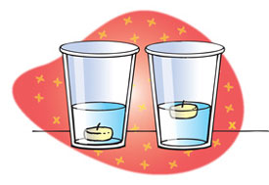

Science- Floating or Sinking!
Float or sink experiment! Using fruits and vegetables you have at home, predict which ones you think will float/ sink- giving reasons why.
What will happen if you half it or take off the skin? Do you notice anything about the items that float/ sink?

Helping at Home (always check with an adult first)
Make your bed 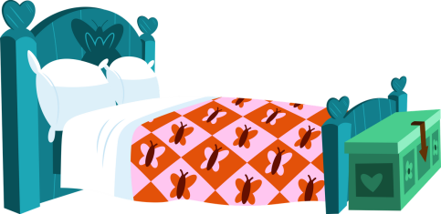

Help to make breakfast/ lunch/ dinner
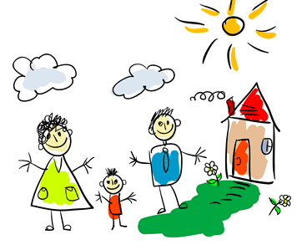
Take Time Out
Remember to take some time out to relax and spend with your loved ones.
- Build a Den 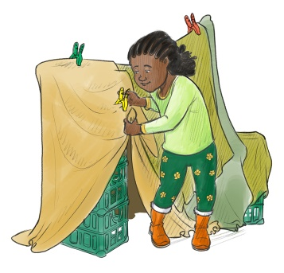

- Watch a film together

- Play a game together 