

Sacrament of

Reconciliation

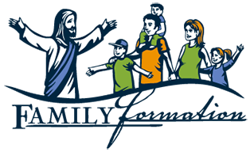

**Preparation - Family Activities**

Parents and pupils are invited to a presentation and workshop of the Family activites:

on Friday 7th February 2020 at 9.00am

in St Joseph’s Primary School.

