Please Wear Christmas Jumpers
Charity
Nursery Christmas Nativity Concert
Supporting Christmas Jumper Day

In aid of Save the Children

Thursday 13th December 2018
10.15am till 11.00am
2.15pm till 3.oopm
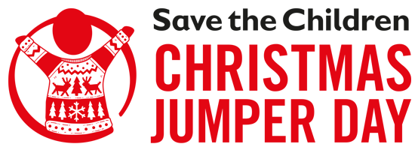

Programme Suggested Donation £1.00

