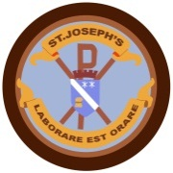

**October - December 2016**

The school will close at lunchtime on Friday 14th October for the October break. Staff in-service training will be on Monday the 24th and pupils will resume on Tuesday the 25th October. We hope the beautiful weather we have had recently, extends for the holiday week and pupils can enjoy time outdoors with friends and family.

*Playground Safety*

Thank you for your co-operation in keeping our playground clear of adults in the morning, making it easier to see the pupils. We now have an additional member of staff to assist in the supervision of the infant playground. When the whistle is blown for the pupils to line up, the gate will be closed. This will allow staff to supervise the pupils in their lines. The gate will be opened by staff for any late comers.

**Hallowe’en Parties**

The school Hallowe’en parties will be held on Thursday the 27thOctober. P1-3 will be in the afternoon and P4-7 will be from 6.30 – 800 pm. As it will be dark when the party ends, pupils must be collected. Please come to the main entrance to collect pupils.

Sacramental Preparation Meetings 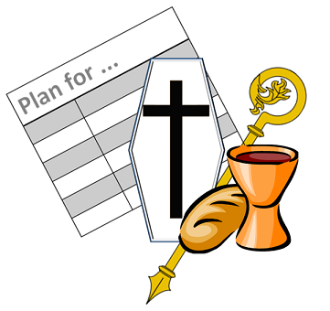

Father Sebastian and Deacon Ronnie have arranged meetings to prepare pupils to receive the sacrament of Reconciliation in P3 and Confirmation and Eucharist in P4. The dates below will be put on to a parish calendar and given to parents.

P3 Reconciliation

7 Nov 7pm Parents’ meeting St Anthony’s Church

5 Feb 10am Rite of Illumination St Joseph’s Church

2 Mar 7pm Parents’ meeting St Joseph’s Church

30 Mar 7pm First Reconciliation St Anthony’s Church

P4 Confirmation and Eucharist

30 Oct 10am Enrolement Service St Joseph’s Church

13 Nov 10 am Presentation of the Gospels St Joseph’s

Church

8 Jan 10 am Presentation of the Creed St Joseph’s

Church

25 Jan 7pm Parents’ meeting St Joseph’s Church

26 Feb 10am Presentation of the Our Father St

Joseph’s Church

12 May 7pm Confirmation St Joseph’s Church

3 June 10 am First Communion St Joseph’s Church



Mrs McDonnell has left to begin her maternity leave we wish her well and look forward to hearing some exciting news soon. Mrs Gardner is covering P6 until the new teacher arrives.

Miss Wood is leaving to become a foster carer. We wish her well in her new role.

Miss Emsworth has a new position as class teacher in Winchburgh Primary. We wish her every success in her new school.

Three new teachers have been recruited and will join the staff once Church approval has been received and they have completed their period of notice. During the transition period current staff will cover classes and parents will be kept informed of any changes.

**Christmas Events **

Please see below a list of planned Christmas events. More details to follow after October break

3 Dec School Christmas Fayre in the hall 10am -12 Noon

7 Dec Christmas Lunch for pupils

9 Dec Christmas Jumper Day. Wear a Christmas jumper and pay £1 to Charity

12 Dec P1-3 Panto Red Riding Hood Howden Park Centre

13 Dec Dress Rehearsal

14 Dec Evening Show

15 Dec Morning Show

16 Dec PM P4-7 Panto Mac Robert Centre Stirling

19 Dec 10am Mass with Carols in St Joseph’s Church AM then PM nursery parties

20 Dec AM P1,1/2& 2 Party PM P3 & 4 Party 6.30pm – 8.00 pm P5,6 & 7 Party

21 Dec 3.05 pm end of term

 then PM Nursery Parties

20 Dec AM P1, P1/2 and P2 Party PM P3 and 4 Party 6.30pm -8pm P5,6,7 Party

*Once a week, take a peek! *

*Please check your child’s hair regularly. Treatment can be prescribed by your doctor or purchased at the pharmacy.*

**Dates for your Diary**

14 October am Good to Be Green PJ party and DVD

27 Oct Hallowe’en parties

1 Nov 10 am Mass for All Saints in Church

17 Nov Dental inspection for P1 & P7

**The School Office**

To tackle the increased amount of administration, the office will remain closed on a Wednesday afternoon. If your enquiry can be dealt with another time this would be appreciated. Thank you.



House System

Having trialled a House Point System last session, we have adapted the system in response to comments from staff and pupils. We will now have six houses in place of four to facilitate greater discussion and opportunities to carry out tasks. The houses are in keeping with the space craft theme. Each house will have responsibility for developing an aspect of school life and building partnerships with agencies out with the school. Points will be awarded to pupils for demonstrating the skills discussed at assembly e.g. respect. The Houses are:-

Voyager, Discovery, Endeavour, Enterprise, Apollo and Pioneer. The Houses held their first meeting this week to elect House Captains. Next, they will hold a competition to design their shield. The designs will be made into a jigsaw with the winning house receiving a piece each time they have the highest score. The House with the most pieces will win the prize for the term.



Ho

***Rosary***

Thank you to the members of the parish who have given their time to lead the pupils in saying the Rosary during the month of October***.***

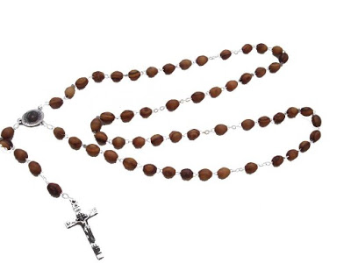

.

C:\Users\Frances.burns2\AppData\Local\Microsoft\Windows\Temporary Internet Files\Content.IE5\0ODSXSZI\132156608[1].jpg