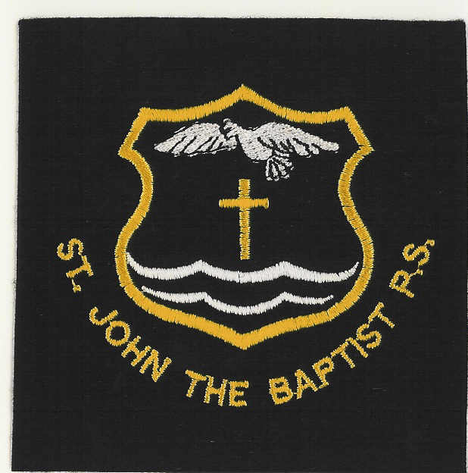

18 June 2013

SCHOOL MILK
Dear Parent

If you wish your child to have milk at mid morning break, please complete the attached slip and return it to school along with payment. This milk period runs from:

Tuesday 19 August 2013 – Friday 18 October 2013 at a cost of £7.56

You have the opportunity of paying milk until Easter 2014 break. The cost for this would be £25.92

(milk in school is sold at a reduced price - 18p per 200ml tetrapack - as a result of the EC School Milk Subsidy Scheme).

To ensure your child receives milk, I would be grateful if you would return the attached form and the full amount by Wednesday 26 June 2013.

Thank you for your co-operation.

Children whose parents are in receipt of income support are eligible for free milk provided they have completed the free meals form (available from the school office) and had this form approved by West Lothian Council.

Please note that no receipts can be given and no refunds can be paid other than in exceptional circumstances.

Yours sincerely

A PURDIE
HEAD TEACHER
................................................................................................................................................

ST JOHN THE BAPTIST PRIMARY SCHOOL

MILK :

Period 20 August – 18 October 2013 or August 2013 to Easter 2014

I wish my child ………………………………….. Class ………. to

take school milk, and enclose £7.56 or £25.92 in payment. (circle which option of payment you are making)

