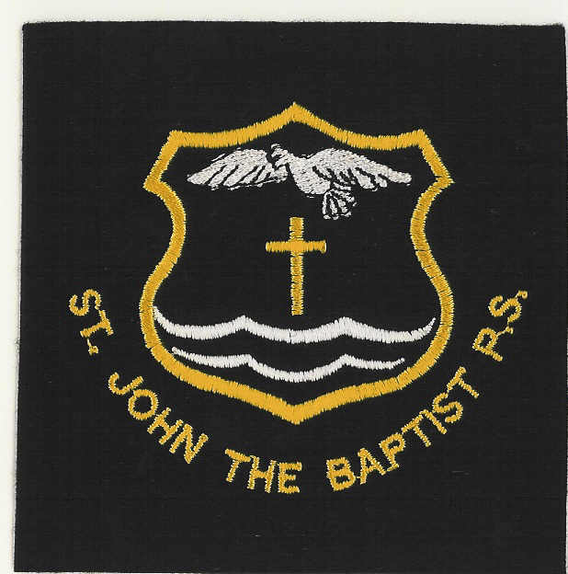

**St John the Baptist PS Blog**

Our school Blog is regularly updated. You will find loads of helpful information about the school on it. Please check it out on <https://blogs.glowscotland.org.uk/wl/StJohnsBlog/> or use an internet search engine for: St John the Baptist Primary School Fauldhouse Blog. Various school forms are on the Blog – Uniform, medical form, etc. which can be printed out at home and sent in to school.

***Reminders***: **Latecoming** – please ensure your child arrives at school in time.This avoids disruption to the class.

**Indoor Shoes** – please ensure your child has suitable indoor shoes to change into when in school.

**Eco Group -** New pupil members have been selected and alongside members of staff they will work continue working on Eco issues in the hope of gaining our third Eco Flag.

**Forest School -** P6 will begin Forest School on Monday 9 September and thereafter every second Monday.

**After School Clubs -** Gymnastics has already started on a Thursday. Art Club will start after the September break for P7.

**Rights Respecting School** - Members have been chosen and an after school club have been will start on 10 September. We are working towards Stage 2 of Rights Respecting School.

**Important Dates (see overleaf for Session Dates)**

**09 September – P1 photographed by WL Courier**

**09 September** – 6.30 pm – P1 Parents’ Information Evening

**16 & 17 September** – Autumn Holiday/In-Service

**20 September – Jeans for Genes Day**

**24 September** – P7 to St Kentigern’s (Modern Languages Day)

**24 September** – 6.30 pm Parent Council – New members very welcome

**ClubGolf**

A group of P6 pupils enjoyed their day at the Johnnie Walker Championship at Gleneagles on 22 August. They had participated in the after school Clubgolf club earlier in the year.

**Jeans for Genes Day**

This will take place on Friday 20 September. All children are invited to wear ‘denim’ for a donation of £1.

**Reponsible Citizens**

The P5 and P6 classes took part in a ‘Wild Flower’ planting in the local community to further enhance our Eco work. In spite of rainy weather they thoroughly enjoyed the experience.

**Welcome Back Mass**

It was a pleasure to welcome Father Paul Lee (an ex-pupil) to celebrate Mass with us. We wish him well in his new parish.

**School Priorities for 2013 – 14**

**Priority 1** – To raise attainment in Literacy

**Priority 2** – To raise attainment in Numeracy

**School Lunches/Milk**

***A*** reminder that the cost of a school lunch is £1.80 per day. It would be extremely helpful if full payment for the week is made each Monday. This helps ease disruption to learning and teaching.

***S***chool Milk for the forthcoming session will be £7.56.

***T***he children are also encouraged to bring a small bottle of water to school.

**Free Breakfast Provision - P1-P7**

This service is up and running and is proving popular with the pupils who attend. If you wish to enquire about this please contact the school office.

**Head Boy/Head Girl**

I am looking forward to working with Callum Goldie and Dani Love in their roles of Head Boy/Girl respectively and know they will represent the school well in their role. They were elected by their P7 class members.

**Dear Parent/Carer**

**After a lovely summer break all pupils have settled well into the new school session, especially the P1 pupils. The P7 buddies have taken on their roles exceptionally well and are a credit to the school. We welcome Miss Timmins to our school community and wish her a successful year in P1. Now the P1 children are in for the full day and, if having a packed lunch, it would be helpful to have their names on their boxes. A huge thank you to parents/carers for their continued support in ensuring school uniform is worn by all the pupils. All the children looked so well turned out on their first day – a credit to you! Now we are looking forward to a challenging, productive year.**

**A Purdie, Headteacher**