STANDARDS & QUALITY
REPORT
St John the Baptist Primary School
Fauldhouse Nursery Class

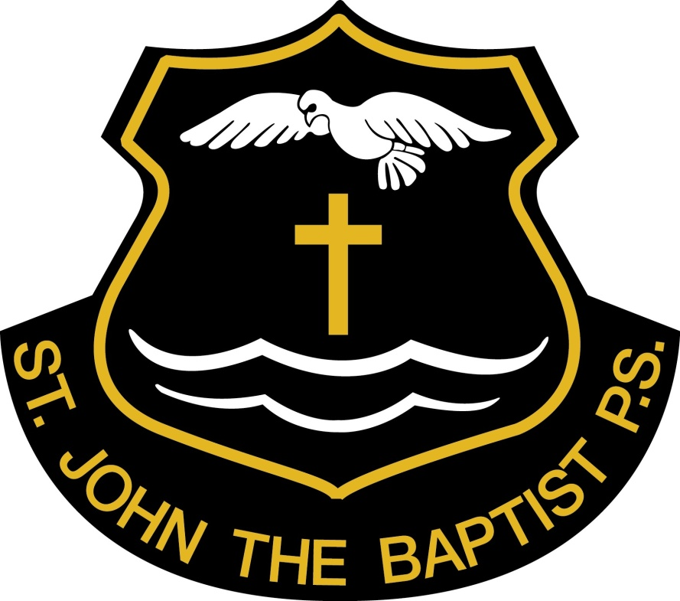

2010-2011

OUR VISION AND VALUES
As a Roman Catholic school promoting Christian values, we aim, in partnership with parents and carers, to develop:

- an ethos where children’s self-esteem can be developed through the acknowledgement of achievements in all areas of their life and where they can be proud of their own work and that of others.

- our young people’s capacity to become, confident individuals, successful learners, responsible citizens and effective contributors.

- Active participation by all concerned, encouraging the children to practise and develop their faith through a commitment to the building of a Christian community that shows by example, faith, love and justice inclusively.

- A concern for others through strong partnership with all members of the school, as well as the wider community.

- A supportive environment where children feel happy, secure and willing to learn through mutual trust and understanding.

- The provision of equality of opportunity which enables every child to achieve his or her potential and know they are always valued.

BACKGROUND INFORMATION

St John the Baptist Primary School is a denominational school which serves the communities of Fauldhouse and Longridge.
The school opened in 1968 and accommodates a nursery class and 8 primary classes. For session 2010-2011 the school roll was 175, with 30 nursery places in the morning and 30 in the afternoon sessions.
For session 2010-2011, the staffing allocation was 8 full time members of staff including the Head teacher and Principal teacher. There were four part time members in a job share role. In addition to the core allocation, a teacher to support pupils with additional learning needs is part of the staff team. A probationer teacher also joined the staff for the session. The school has four pupil support staff members, two of whom supervise the dinner hall and playground. The school has a full time administrative assistant and a full time facilities manager. There are also visiting specialists of music, PE, brass and strings.
St John the Baptist Primary School is a member of the St Kentigern’s Academy Cluster Group.
The school works closely with both the Parent Council and local parish to establish wider links with the local community.
This report evaluates progress made and is set within the context of The Journey to Excellence (JTE) and the National Priorities in Education. It is measured against self-evaluation quality indicators within the HMIe publication “How Good is our School?” (JTE part 3) and “Child at the Centre” (CAC).

Evaluation of priorities in School Action Plan (SIP) 2010-2011

NOTE: The following code was applied to indicate the level of future action:
- Priority for Improvement – will feature as a main priority in SIP.
- Continued Development – will feature in additional tasks/outcomes.
- Maintenance of current practice – not featured in SIP, but indicates that progress will be sustained by becoming the normal work of the school.

Priority 1: To review and develop assessment procedures in line with Building the Curriculum 5-A Framework for assessment. Code-2

Staff members are able to identify the way forward in developing an assessment framework which meets the needs of all learners.
A framework for assessment which ensures children make progress in learning is developed.
Teaching staff further develop knowledge of assessment techniques/strategies which further engage children in learning and in identifying next steps in learning.
Teaching staff are using innovative and creative ways of assessing children’s development which ensures children make progress in learning.
Children have greater involvement in their own learning.
Parents/Carers are aware of school developments in assessing children’s learning within Curriculum for Excellence.

- All staff members have been involved in professional reading of Building the Curriculum 5 – A Framework for Assessment. From professional reading dialogue next steps for our school have been identified.
- School Improvement Groups have developed a forward plan for taking forward the assessment framework. This plan clearly shows how we are going to develop a progressive skills and knowledge framework.
- Staff members have worked at cluster level to develop their knowledge of The Assessment Framework.
- Staff members have used CPD personal time to develop knowledge and understanding of creative and innovative ways of using assessment is for learning to assess children’s learning. Professional development will be shared at CPD/In-service sessions and staff meetings.
- At planning meetings staff members discuss with HT how they are using the NAR and assessment is for learning strategies to ensure progress in children’s learning.
- Learning intentions and success criteria are shared with children and they can identify next steps in their learning and record achievements.
- HT/PT monitor use of reflection and assessment is for learning strategies as part of quality assurance procedures.
- Pupils are making progress through the outcomes at appropriate level and all staff are using assessment is for learning strategies to ensure all children meet their full potential.

.

Overall good progress has been made in this area. All staff members are able to identify the way forward in developing an assessment framework which meets the needs of all learners. They have further developed knowledge of assessment techniques and strategies to further engage children in their learning and in identifying next steps. Through this all children in the nursery and primary classes have greater involvement in their own learning. Parents and carers are now more aware of school developments in assessing their children’s learning following a Parent Information evening. Teaching staff are using creative and innovative methods of assessing children’s development to ensure progress at all stages. All pupils in the nursery and primary classes have folders of evidence in place which enable teaching staff to track and monitor progress. The transition from the nursery class to P1 has been enhanced by discussion of baseline assessment results between staff at the early level. Through rigorous tracking and monitoring as well as analysis of GL test results in English and Mathematics, we were able to identify individual/group needs and provide enhanced support for learning.

Next steps:
- To continue to implement rigorous and thorough assessment strategies for all pupils from nursery to P7. Code-2
- To allow pupils more personalisation and choice in their own learning and through assessment activities, recognise their next steps in learning - Code-2
- To further develop use of assessment materials for recording and reporting purposes - Code -2
- To further develop the method of reporting - Code 2
- To develop a coherent approach to planning the curriculum, Learning and teaching and assessment through clearer understanding of standards, opportunities for moderation and the Quality Assurance of assessment.

Priority 2: To review current programmes of Health and Wellbeing in line with CfE outcomes and experiences.
Overall good progress has been made in this area.

- All staff are confident in planning and delivering well planned Health and Wellbeing Experiences and Outcomes
- A progressive Health and Wellbeing Programme in place
- Pupils engaged in learning and aware of all areas of health
- Parents aware of themes covered in school and become fully aware of and active in their role in health and wellbeing
- Our children will respect the rights and responsibilities they have been given as children in 21st Century Scotland.
- Staff will have developed their knowledge of restorative practices and how they might use these when working with children.
- Our children will accept responsibility for their own actions and develop a sense of how their actions have an impact on others.

New Health and Wellbeing resources have been put in place and have been effectively used by all classes to ensure continuity and progression. A breakfast club was established for P1-3 pupils as well as tooth-brushing in the nursery and P1 classes. The school health co-ordinator organised a very full and engaging Health week drawing on expertise from other sources. All classes are now addressing the two hours of quality physical education and pupils are also being given many opportunities for outdoor learning.

Next steps;

- To gain Stage 2 Accreditation of Rights Respecting Schools – Code 2
- To further develop the Health and Wellbeing programme of work across the stages -Code 2
- To work with parents and outside agencies on a programme of activities to further promote a healthy lifestyle through the Healthy Families, Healthy Children – Code 1
- Emotional wellbeing-Peer Mediation training for pupils by designated staff member - Code 2
- Global Citizenship link developed - Code 1

.
4. PROGRESS WITH KEY AREAS OF THE WORK OF THE SCHOOL

Learning and Teaching - How well do children learn and achieve?

Overall very good progress has been made in this area.
Our children enjoy coming to school and are stimulated by the learning opportunities we provide.
The School Improvement Plan has focused on a small number of priorities, directly relating to improving children’s learning experiences and improved achievement and attainment.

Good progress has been made by staff using assessment data to carefully analyse NFER standardised test results in maths and English, which are used as diagnostic information. This analysis helps inform teachers’ planning and setting targets and has had a positive impact on children’s learning. Analysis was also used to inform whole school developments such as writing and active maths, to improve children’s learning opportunities. Class teachers provide weekly self-evaluations for monitoring by the management team and discuss any issues in relation to the progress of individuals and groups of children and use these to inform next steps in learning. Pupils use learning intentions and success criteria to determine their next steps in learning.
Teachers are now using Curriculum for Excellence principles, experiences and outcomes to plan children’s learning. As a result planned learning activities are more challenging and relevant.
Children’s progress in the nursery continues to be monitored and recorded in the Learner’s Journey. This is used to plan next steps in learning.
There is high quality interaction between staff and pupils. Pupils are becoming increasingly involved in assessing their own progress and that of their peers through use of formative assessment strategies. There is opportunity for children to reflect on their own learning and progress through use of learning logs or “Big Books” in the nursery/early years.

In meeting learning needs of all children, we have clear procedures for referral, assessment and support. At target setting meetings, individual needs are identified and a plan of action put in place, including plans to support the most and least able. Resources are targeted to meet needs of all pupils. Our individual reading programme is monitored by the support for learning teacher and we now support individual readers, for a variety of purposes, at all stages and all abilities.
The school also piloted a new electronic reporting system and this new format was shared with parents and carers.

Next Steps
- To further develop use of GLOW in order to share best practice and pupil achievements
- To develop use of learning logs to include targets for Literacy, Numeracy and Health and Wellbeing
- To continue to develop inter-disciplinary learning through topic work across the stages. To agree excellence in Learning and teaching and to revisit the Learning and Teaching policy.

Partnership - How well do staff work with others to support children’s learning?

Very good progress has been made in engaging and motivating children this session through effective partnership working. Individual and Group Educational Programmes are in place where appropriate and parents and children are involved through review meetings and setting targets for individual plans. Members of staff work well with a range of other agencies including Speech and Language Therapy, School Health and English as an Additional Language Service.

We have involved our school nurse in developing planning for health across the school and she is able to support learning at agreed stages and has provided important links to other health professionals. In addition the Health Visitor plays a significant role supporting nursery children and families.

Almost all parents became actively involved in their children’s learning this year through a new approach to home learning. This has been very well received and helped parents gain a working knowledge of Curriculum for Excellence experiences and outcomes.
Our curricular night for parents focused on children presenting their learning to raise awareness of the wide range of learning and teaching strategies used within our school. Most families reported that they found this experience very valuable in supporting their children’s learning.
In the nursery class parents were given the opportunity to experience the activities on offer to their children, which they have repeated at home.

All teachers focus on strategies to ensure appropriate pace and challenge for all learners. This work is supported by our educational psychologist and through continued professional discussion.

Next Steps
- To actively engage parents in their child’s learning.
- Through engagement with external agencies, establish a Parenting course.
- Establish a nursery forum.

People - How well are staff and children actively involved in improving the school?

Overall progress is very good. Improving the process of self-evaluation is ongoing. Throughout the year we consult and gather evidence to support evaluation and help identify next steps. We form improvement teams to create action plans, undertake tasks, implement change and regularly share and evaluate progress.
We are now more comfortable in the role of self-evaluation with a clearer ethos of distributive leadership emerging at all levels.
All members of staff have contributed to the Standards & Quality Report and School Improvement Plan and are increasingly confident in putting forward their views and suggesting next steps. This session all members of staff have enjoyed the opportunity to develop and share their individual skills both in school and some at authority level. A range of approaches is used to ensure continuous whole school improvement, inform the Standards & Quality Report and build on the evidence from individuals and teams. The views of children and parents are actively sought at key times throughout the session and they comment on how well we are doing and what they would like to see improved. The pupil council has been more involved in talking about learning and influencing improvement in the school. A survey was conducted for children about what makes an effective lesson and this will be used to influence the revised learning and teaching policy in school.

Next Steps

- To ensure improvement teams work together in a more structured and consistent way in order to meet necessary deadlines. Code 2
- To develop increased clarity and shared understanding as to what constitutes excellent practice through review of the school Learning and teaching policy. Code 2
- To gain clearer understanding of Learning Rounds. RACI to ensure improvements impact on pupils’ learning. Code 1
- Staff involved in identifying CPD Code 2
- Staff remits under review – PT involved in cluster development in planning and assessment.

Culture and Ethos - Does the school have high expectations of all children?

The steering and focus group for the Rights Respecting School initiative, impacted positively on development in this area. The articles of the United Nations Convention on the rights of the child were used as a basis for our new positive behaviour policy. All stakeholders contributed fully – parents, children, community education, school chaplain, support and teaching staff – to ensure the success of this initiative.

Attainment and achievement across all areas of school life are celebrated. Examples this session have included
- Eco –school work to maintain Green Flag status.
- Participation in the Levenseat Trust project.
- Participation in the Regional heat First Lego League 2010 Body Forward Challenge at the University of Edinburgh. They won the Judges Award for most promising new team.
- Fundraising for various charities.
- P5-7 group winning through to the national Rotary Club Quiz final.
- West Lothian ‘Young Writer’ winner

These opportunities have provided a rich context within which to develop our learners and we have seen individuals flourish as they begin to develop new skills and grow in confidence. Health and wellbeing for all is placed firmly at the centre of what we do and our children are safe, happy, healthy and achieving. Health and Wellbeing activities will also be sourced and developed for all staff.

We have increasingly involved children in sharing learning at assemblies and raising awareness at whole school level. These opportunities allow children to demonstrate the impact of enterprise, creativity and transferable skills.

Next Steps

- To gain stage 2 of Rights Respecting School Award – Code-2
- To further develop Eco work –Code 2
- To further develop the ‘house system’ programme to encourage children to work towards goals and targets-Code 2

Vision and Leadership - Does the school have a clear sense of direction?

The school has a clear focus and leadership at all levels is very good. This session we have worked with staff, parents, children and partners to develop and shape a common vision for our school and community. We have done this in consultation with our Parent Council and our Pupil Council and this has been a focus at our in-school Continuing Professional Development sessions. All teachers have taken on areas of responsibility thus contributing to the sharing practice which has led to whole-school improvement. As a result children have experienced an enriched curriculum.
At the start of the new session staff review the school vision and endeavour to embrace new initiatives by forming improvement groups or working parties to take these forward.

Next Steps
- To enhance the self-evaluation process in order to ensure effective teaching and learning across the stages. Code 2
- Parents to be more actively involved in revising the vision and values of the school. Code 2
- To review the school Learning and Teaching policy.

WHAT IS OUR CAPACITY FOR IMPROVEMENT?

Overall our progress in all areas is good especially in literacy across the stages. Staff are now more confident in their self-evaluation practice and this has helped inform next steps in learning. The further embedding of CfE will be enhanced by closer collegiate working and will hopefully impact on the quality of pupils’ learning experiences.

IMPROVEMENT PRIORITIES (2011-2012)

The following priorities for improvement have been identified within this standards and quality report.

Priority 1:

Continue to develop assessment procedures in line with Building the Curriculum 5 –A Framework for Assessment. To ensure a clear approach to assessment with further development of tracking and monitoring pupil progress.

Priority 2:
To further develop and establish a Health and Wellbeing project alongside multi agencies.

Priority 3:
To develop a RERC programme of work relevant to the needs of young people today

Additional improvements to be action planned

Work towards Level 1 in the Rights Respecting School award
To fully implement ‘This is our Faith’ document into the RERC programme of work
To develop work on Learning Rounds in order to enhance the self-evaluation process
To re-establish Peer Mediation in the school
To engage more fully in Outdoor Learning in line with CfE

