St John Ogilvie RC Primary School

Woodlands Nursery

Harburn Avenue, Deans

Livingston EH54 8NQ

Tel: 01506 412560

Headteacher: Margaret Johns, MA(Hons), PGCE(P), PGCEL

Monday 6th March 2017

Dear pupils, parents and carers,

Lenten Appeal,

Our Mini Vinnie group in school would like to support further a group of St Margaret’s Academy pupils who are travelling to Malawi to build new classrooms in a school. We have already donated £1200 from our Advent fundraising to help fund the buildings. A big thank you to everyone who contributed. We would like pupils to donate the following items so that they can be distributed to pupils within the school in Malawi.

The items include: soap, erasers, sharpeners, colouring pencils, biro pens, pencils, toothpaste, toothbrush and a ball. A small packet of sweets would also be fantastic but please do not send chocolate.

Pupils can bring complete packs or donate individual items as we will make them up into the packs below.

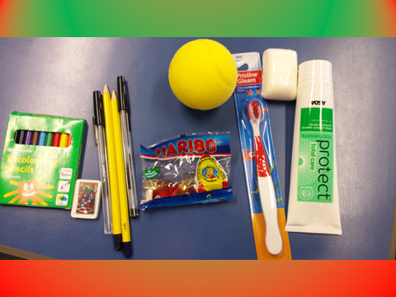

Many thanks in advance for your support,

Mrs Smith and Mini Vinnies Group

