

**Maths Daily Tasks**

* Count forwards and

backwards.

* Sumdog challenge

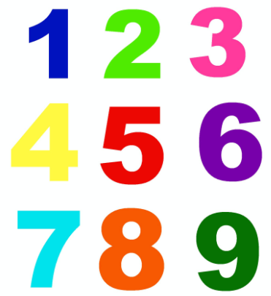



**Home Learning**

Primary 1

Week beginning 1st June



**Literacy Daily Tasks**

* Practise your word walls.
* Read some books and complete activities on Oxford e-owl.

*Literacy – try and complete as many tasks as you can.*

* *Practise your tricky words, how many can you say in 1 minute?*
* *Can you find words with your sound of the week? Use a paintbrush and water to write your words outside. How many can you write before they disappear?*
* *On the blog you will find your writing task on Wednesday, which will link to our fairyland topic. You will need to remember to use capital letters, full stops and finger spacing. Add lots of detail to your picture too.*
* *Practise your handwriting – can you form all the letters the correct way round and sitting on the line.*
* *Practise writing your first name and your last name.*

**Maths/Numeracy** - try and complete as many tasks as you can!

* *Subtraction – as someone at home to give you a subtraction question. You could use items in the house to help you practise e.g. 7-3. Get 7 pieces of pasta and take 3 pieces away how many do you have left?*
* *Position and movement – ask an adult at home to give you an instruction e.g. place the teddy on, under, beside, in or between. Can you make it a little bit trickier – place the teddy on the table at the left side?*
* *Can you make a symmetrical picture using Lego, check out the blog for some ideas you can try.*
* When your outside why not pick up 12 stones and 2 sticks. Once your home can you write the numbers 1-12 on the stones and make a clock face. The sticks can be used as the hands. Can someone at home give you a time and can you make it on the clock.

**Topic**

* *Check the blog for our fairyland topic! You will find the way with lots of ideas for you to choose from.*
* **Fine motor skills**
* *Can you improve your fine motor skills by practising your cutting. Check the blog for ideas to try.*

**Health and Wellbeing**

* *Can you make a poster to keep safe in the sun.*
* *Remember to drink lots of water to keep you hydrated – keep note of how many glasses you drink each day.*
* *Can you go outside each day and exercise?*