**Maths – Length**

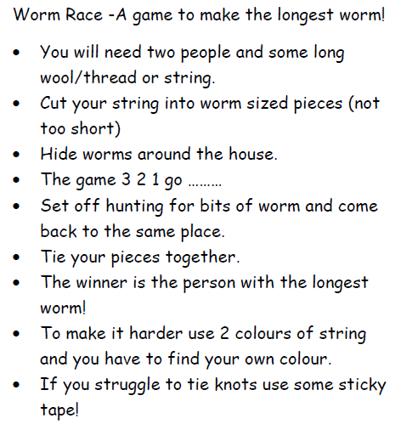

**If you have a measuring tape, measure the strings to the nearest meter or nearest half meter.**

If you have a ruler or measuring tape, measure the string to the nearest meter or half meters.

**fff**