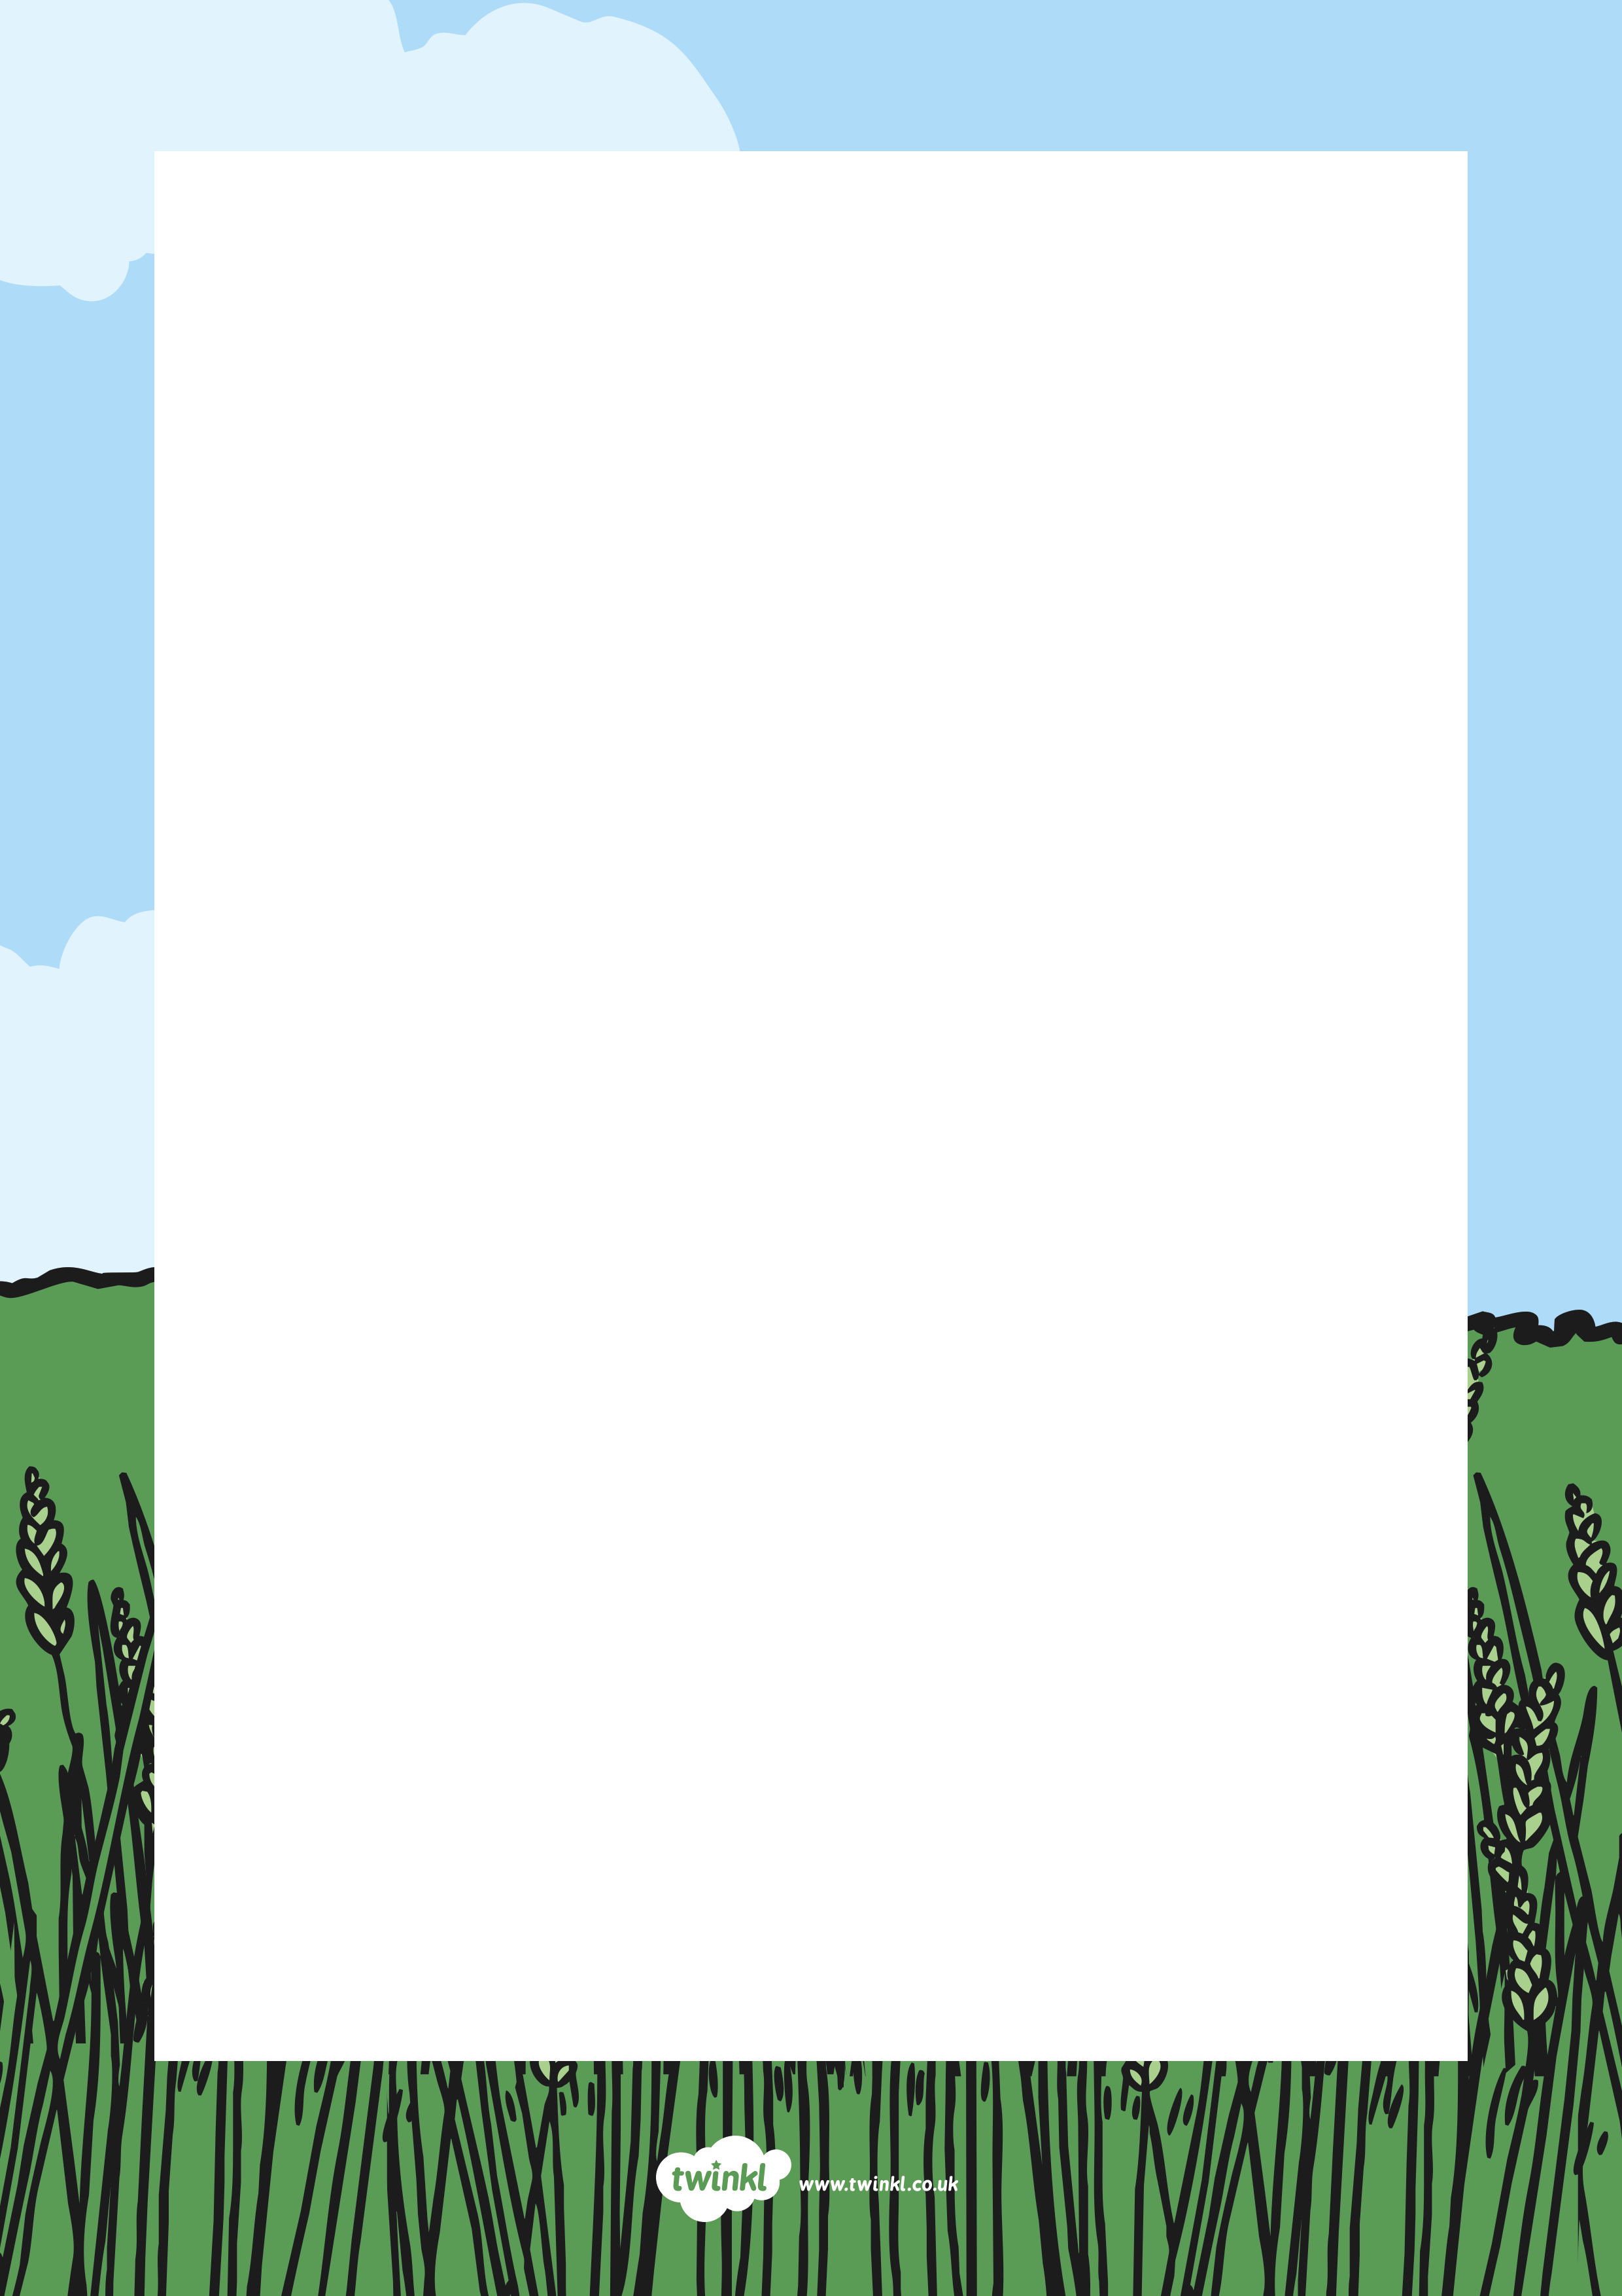

Hello children,
My name is Russell and I am a scarecrow. I live in a big field on a farm. All around me, lots of vegetable plants are growing and it is my job to look after them. However, I have a bit of a problem and I have heard that you are all very are kind and helpful, so I hope you can help me.
I am supposed to scare away the hungry birds that want to eat the seeds and vegetable plants as they are growing but I’m not doing a very good job and now there aren’t many vegetables left!
Please could you help me? Maybe you could make something to scare the birds away. Perhaps you could make something to feed the birds. What do you think?
Thank you for your help.

From
Russell

