
-

Polbeth Nursery

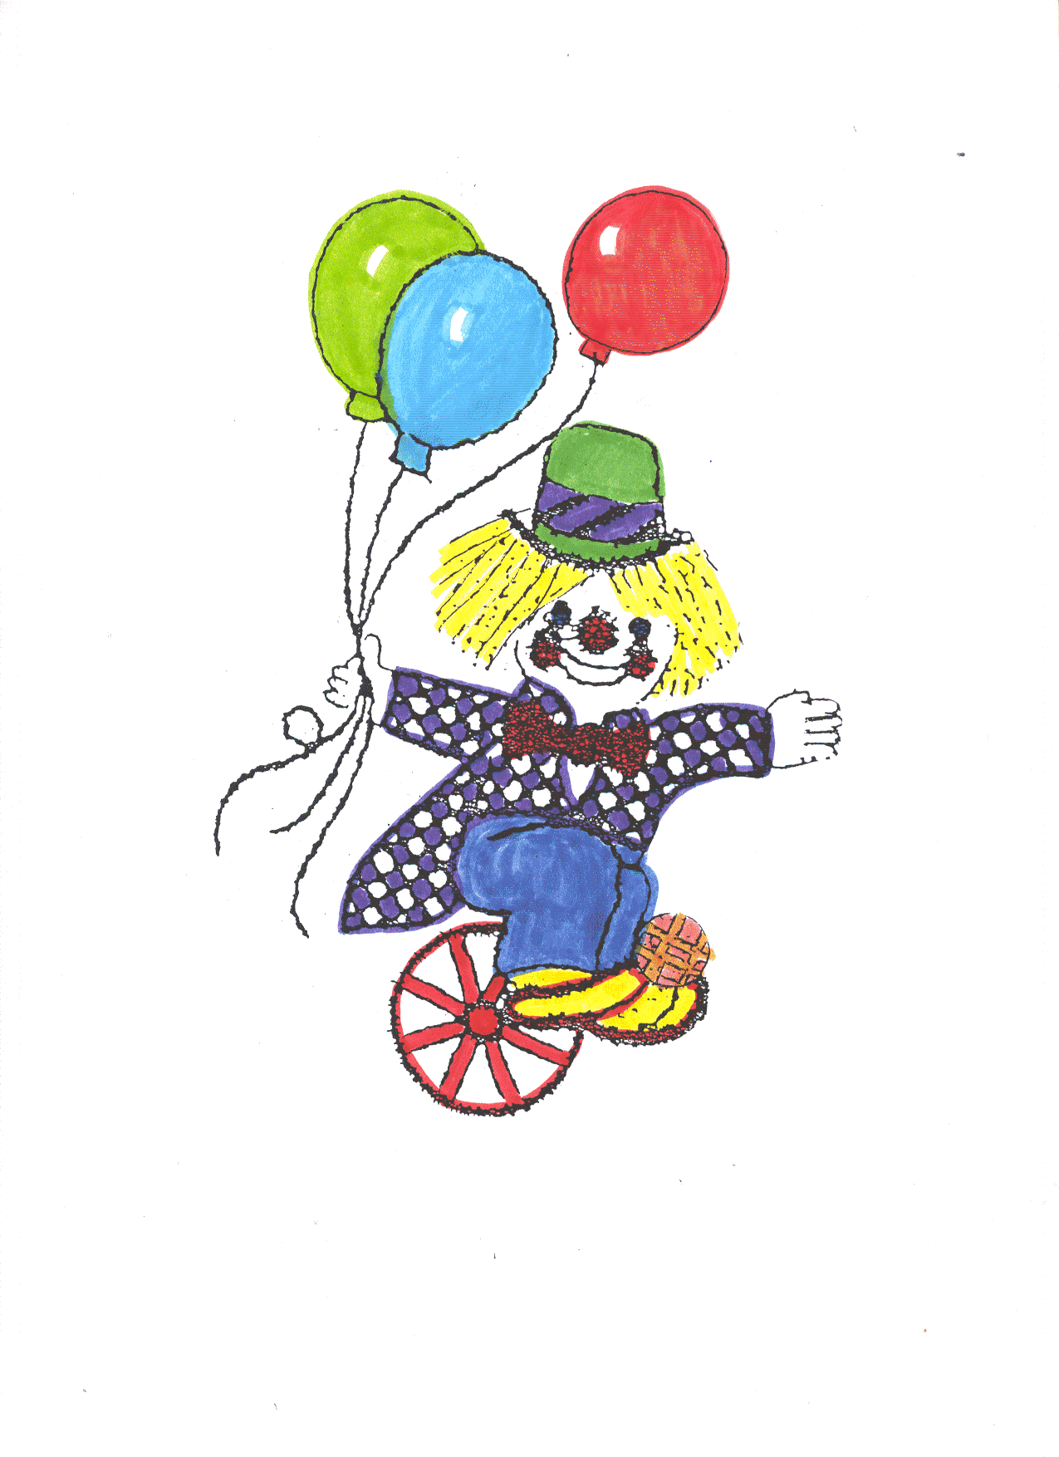
Telephone: 01506 872511
e-mail : wlpolbeth.ns@westlothian.org.uk
Address : Polbeth Road, Polbeth, West Lothian, EH55 8SR
Blog : https://blogs.glowscotland.org.uk/wl/PolbethNurserySchoolBlog/
Facebook: Find us on facebook! Search “Polbeth Nursery”


CONTENTS

Page No.

- The Staff and Nursery hours. 3
- Welcome to Polbeth Nursery School. 4
- The Nursery Curriculum. 5
- Early Intervention. 6
- Dress. 7
- Outdoor play 7
- Nursery Fund. 8
- Attendance. 9
- Polbeth Nursery Values. 10
- Photography Policy 11-12
- General Information. 13
- Additional Support Needs 14
- Child Protection 15
- Complaints Procedures 15

THE STAFF

Head Teacher Miss H. Pritchard
Acting Deputy Head Mairi Morton
ELCASM Tayloranne Kelly
Early Years Officer Miss N. Trench

Early Years Graduate Miss E. Robertson
Miss T. Livingstone

EYP Ms. L. Taylor
EYP Mrs L. Prentice
EYP Mrs S. Gray
EYP Miss J. Kellagher
EYP Miss J. O’Hara
EYP Morag Lind
Pupil Support Worker Mrs A. Leonard
Pupil Support Worker Ms R King
Caretaker/Cleaner Mr D. Armit and Mrs A. Greame

As members of West Lothian’s Education Department, staff are constantly updating their skills and knowledge of the curriculum. Parents are invited to discuss any of our policies, or any other matter, at any time.

Other adults working in the nursery school may be, support staff, students, auxiliaries, supply staff or other professionals who may see your child during nursery school time.

Check our blog regularly for info and learning posts: https://blogs.glowscotland.org.uk/wl/PolbethNurserySchoolBlog/


Morning Session: Monday – Thursday
Session Time: 7.50 am – 12.30
Afternoon session: 12.30 – 6.14pm
2 All Day Sessions: 8am - 6pm
Friday Morning: 7.50am – 11.47
Parents have the option for their child to attend 2 full day sessions Mon-Thurs 8.00am-6.00pm. This can be applied for through pupil placement.
Extra hours are allocated either in the afternoon or Friday morning.
Pupil placement allocate these hours

WELCOME TO POLBETH NURSERY

By now your child should have enrolled and you will know how important it is that all information on the enrolment form is as full as possible. Do please tell us if there are changes in information. Your child’s safety is so important that we would ask you to remember that:

- Only those named on the enrolment form may take your child from nursery. (Name anyone who may collect)

- The person collecting the child must be 16 years or over.

- The adult must bring the child right into the nursery making sure that a qualified member of staff has welcomed him/her.

- If an emergency arises concerning your child and you or a nominated person cannot be contacted, the Head Teacher will take such decisions as are necessary in the circumstances.

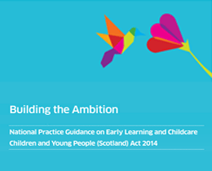

THE NURSERY CURRICULUM

To help us achieve our aims for learning we use Curriculum for Excellence, GIRFEC, the Scottish Government ‘Building the Ambition’ document and their self-evaluation guide “How Good is our Early Learning and Childcare” and Pre birth - 3 for our two year olds.
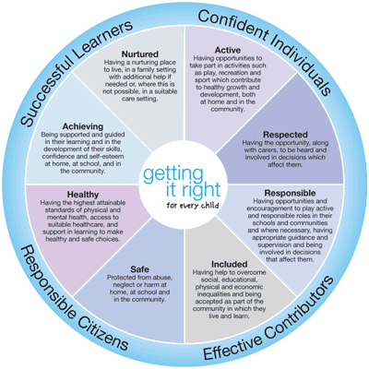
We aim to ensure that every child should experience a broad education which develops skills for learning, for life and work, with a real focus on literacy and numeracy and promotes an active and healthy lifestyle. Briefly, there are eight main areas of learning:-

- Expressive Arts
- Literacy and English
- Technologies
- Religious and Moral Education
- Social Studies
- Health & Well Being
- Science
- Numeracy and Mathematics

The staff observe the children and interact with them in a way that supports and extends their learning. Each child is treated as an individual and our curriculum is child centred.

You are invited to ask staff about this at any time, and there are regular opportunities, daily to speak to staff and parents’ evenings to find out more.

Children learn through play. They listen, observe, talk, explore, investigate and experiment in order to learn about the world. Our secure, stimulating environment means that this happens – and it’s FUN!

EARLY INTERVENTION

Some of the recommendations for early intervention which we follow are :-

- The children have a story time every day.
- We use lots of rhymes and songs.
- We provide books throughout the nursery, and use words and signs where appropriate, we regularly update familiar stories in our tuft trays.
- We encourage early writing skills, by providing pens, pencils, paper, paint, chalk etc.,
- Our well stocked software means that your child will enjoy many early intervention learning opportunities on the computer and Ipad.
- Numeracy plays a big part in your child’s learning and this information will be shared with you. You are our partners and your child’s first and continuing educators.

Health Visitor

We have close relationships with health visitors and speak to them informally on a regular basis about the children to ensure the needs of every child are being met.

Outdoor Play

Outdoor play and going for walks is an important part of the nursery day, we go outside everyday in all weathers. In order that your child may enjoy this he/she should come to nursery with warm outdoor clothing in the winter and have sun cream applied in the summer. Please encourage your child to put on his/her own coat and shoes.

Our mud kitchen and digging areas are very popular and there are so many learning opportunities in our garden. Please send your child to nursery in clothes that are ok to get a bit wet / muddy. Mud washes off! ☺

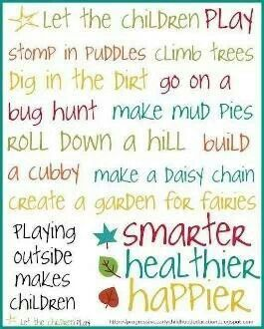

DRESS

You can help your child to be independent by giving him/her named, elasticated front or velcro fastening, gym shoes, and NEVER having him/her wear jeans or tight trousers with buttons. Jogging suits are ideal – trousers can be easily (and quickly) pulled down, and sweatshirt cuffs don’t have buttons. Please don’t have your child wearing good clothes for nursery and do encourage him/her to dress himself/herself and put on shoes.
We are part of West Lothian’s Education provision and this is one of the many ways in which we attempt to better prepare your child for primary school. Please put your child’s name on all clothing or footwear which may be removed during the school day. Please also note that football strips are not to be worn in nursery.

Your child will have a healthy snack with us when he/she is here. Breakfast and afternoon snack is also provided alongside the main snack. The children are involved in choosing snack and this is changed weekly. You can see our weekly snack menu displayed at the main entrance. Please speak to a member of staff if your child has any food allergies or intolerances.

All day children bring packed lunch from home

ATTENDANCE

Please don’t send an ill child to nursery (even if the child says he/she wants to go). We do not want illness does not spread to the other children and staff. It is vital that we have up to date contact and emergency contact telephone numbers in case your child becomes ill whilst at nursery.

If your child is absent from nursery, you must inform us prior or during your child’s nursery session, and we must be kept informed each day of your child’s absence. A staff member will phone you if we are not informed of any absence.
If your child has been sick or had diarrhoea please ensure your child stays off nursery for at least 48 hours from the last time sickness or diarrhoea occurred.



(Updated January 2019)
Children, parents and staff worked together to establish our nursery values.

Our Vision Statement:

At Polbeth Nursery we aim to provide a nurturing and inclusive learning community for all our families. We are committed to delivering a welcoming, caring, secure and stimulating environment for all. Children experience and enjoy the essential and special nature of being indoors and outdoors by engaging their curiosity and imagination through creative play.

#Buildingforsuccess
Our Aims:
Culture and Ethos
* To promote a safe and nurturing environment where children are encouraged to manage their own risk.
Partnerships
* To provide an inclusive community where children are respected and motivated to take responsibility for their own learning.
Vision and Leadership
* To promote healthy and active choices through play-based learning, developing essential life skills.
Learning and Teaching
* To offer an environment where children are challenged and supported to achieve their full potential.

PHOTOGRAPHY POLICY

West Lothian schools have a photography policy which is in accordance with data protection and human rights legislation.

Photographs taken for curricular, assessment, security, registration, training and development will not be used for any other purpose.

Publicity Photography is helpful in publicising the success of the school and promoting educational initiatives. From time to time members of the press and media are invited into schools to cover events celebrating success. However, the views of parents who, for any reason, do not wish their children to appear in such photographs will be respected at all times.

School Trips Photography by staff on school trips and visits may be used in the curriculum and displayed within the school, on the blog or at parents’ evenings to illustrate the work of the school.

Events Parents and guests should check with the Head Teacher to ensure that permission has been given for photographs to be taken.

School Photographer Class and individual or group photographs are regular school events. Parents are asked in advance whether or not they wish their children to be included in these events. Reputable commercial photographers are involved and the law allows them to retain the copyright in the photographs.

Blog and social Media Our learning is shared daily with parents and the community via our Glow blog. Updates are provided via our facebook. Photographs of the children will be used for educational purposes to share learning. If you do not wish for your child to be included in our learning posts your wishes will be respected.

Online Learner Journals Your child’s photographs will be added to their private learning journal which only you will have access to. Group photos may be included so your child’s photo may appear in other’s journals. If you do not wish for your child to appear in others children’s learners journals photos please speak to a member of staff.

Phone Cameras The use of mobile phone cameras is prohibited in schools in view of the risks inherent in such use, possibly but not necessarily covert, which include the existence and/or
distribution of photographs contrary to the wishes, welfare and privacy of pupils, young people and staff.





GENERAL INFORMATION

We have excellent liaison with all the primary schools to which we send children.

At the enrolment, you give us permission to take your child for walks within nursery time. Other outings e.g. trips by public transport, we will ask you to sign a permission slip.

If your child wets or soils themselves whilst at nursery, he/she will be changed by a member of staff and the wet/soiled clothes will be sealed in a bag and hung on your child’s coat peg. All members of staff are fully trained and aware of the council policy on personal care.

Please try to bring one box of tissues when your child starts
with us, as we encourage children to wipe their noses!

You are our partners and it is important that we work together for the benefit of your child. You can speak with staff at any
time and we also have 2 parents’ evenings each year and regular stay and play sessions.

Throughout the year a record of your child’s development and learning is being taken. This is your child’s Learner Journey. You can look through your child’s Learners Journey online at any time. We really value your input into the Learner Journey. Please add in information, comments, photographs etc… of your child’s learning and experiences. There are sections for parental comments on the site.

Check our blog regularly for info and learning posts: https://blogs.glowscotland.org.uk/wl/PolbethNurserySchoolBlog/

ADDITIONAL SUPPORT NEEDS (ASN)

Additional Support is extra provision (educational or otherwise) given to some children.

If you would like further information regarding ASN, please speak to a member of staff.

There is also a West Lothian blog for parents of children with Additional Support Needs which can be found at:-

http://blogs.wled.org.uk/aslparentbulletin/

The nursery also works closely with our Speech and Language Therapist and Educational Psychologist. Please speak to a member of staff if you have any concerns regarding your child’s speech, language and communication or behavioural needs.

BREASTFEEDING FRIENDLY NURSERY

It is known that breastfeeding can have enormous benefit to the health of both the mother and the child. However, as well as “knowing the benefits”, supportive environments are needed to enable and support breastfeeding.
At Polbeth Nursery we:
- Use positive and culturally appropriate images of breastfeeding
- Avoid materials which promote artificial feeding.
- Provide appropriate education and training for staff to enable them to promote, protect and support breastfeeding.
- Increase awareness of sources of support and information for breastfeeding families.
- To provide a welcoming atmosphere for breastfeeding families and to encourage breastfeeding in the public areas of the establishment.
- To support informed choice in relation to infant feeding.

CHILD PROTECTION/SAFETY

Nursery staff have all been trained in Child Protection procedures.
The Edinburgh and Lothians Inter-Agency Policy on Child Protection is
implemented in all Nurseries. A copy can be found at
www.westlothian.gov.uk/content/education/ed_policylist/childprotectionguide

COMPLAINTS PROCEDURE

If you have any concerns please let us know.
There are three ways to do this:-

- Speak to a member of staff.

- If you are still unhappy after discussing the matter with the staff and/or Head Teacher, you can contact :-

Care Inspectorate
www.scswis.com
Or
Telephone: 0845 600 9527
Fax: 01382 207 289
Web: Online complaints form
Email: enquiries@careinspectorate.com

- You may also contact Customer Service Centre,
West Lothian Council
West Lothian Civic Centre
Howden South Road
Livingston
EH54 6FF
Tel.no. 01506 280000
customer.service@westlothian.gov.uk

