

#### **Polbeth Nursery School**

#### **Newsletter**

December 2020

**We would like to thank all our parents and carers for their patience during this difficult time as we have had to embrace new challenges and changes within the nursery! The children have taken it in their stride!**

**Christmas concert**

Due to the current climate this year we are unfortunately unable to hold our Christmas concert. The children will however continue to have access to Christmas songs and music in the run up to Christmas.

**Christmas Celebration days**

To celebrate Christmas the nursery will be having festive Christmas themed celebratory days! We will be playing Christmas games and making lots of lovely Christmas crafts to bring home! The children are more than welcome to come dressed in a Christmas jumper or Christmas outfit on their selected celebration day.

To accommodate and ensure all our full day children have the opportunity to participate, two celebratory days will be held. If your child(ren) attends both days, your child(ren)/2 year old bubble can choose to dress up for one or both days.

**Bubble groups**

The children have adapted well to the introduction of bubble groups. The children have taken ownership of their new nursery areas and helped adapt their areas with resources they would like to use daily. As a team we have decided for each bubble to remain in their current areas until Christmas as we feel children have just settled into their new areas and to swap areas now may become unsettling for some of our children.

Bubble 1: Full day and 2 year old children  
Bubble 2: Am Children/Pm Children

**Diary Dates:**

**Christmas Celebration Days:**Full day children: Tue 15th and Thur 17th Dec  
Am Children: Tue 15th Dec Pm Children: Thur 17th Dec

**Last day of term:**

Thursday 17th Dec

**Speech and Language Therapist**

We work closely with speech and language. Please speak to a member of staff or give us a call if you have concerns about your child’s speech and language.

**A warm welcome…**

To our new pupil support workers Miss King and Mrs Rennie. Miss King will be working with bubble 1 and Mrs Rennie will be rotating round each of the bubble groups and be with us until the end of term.

**A temporary goodbye…**

To Miss Robertson who will be leaving the nursery to go on maternity leave before the end of term. We wish you all the best for when your Christmas baby arrives!

**Important Reminders**

***Please remember to pack:***

* Warm jackets
* Waterproof clothing
* Wellies
* Change of clothes

**We like to go out in all weathers and love to get muddy! Please try and ensure your child’s clothes/shoes are labelled.**

**Curriculum Corner**

The children will continue to explore emotions and developing friendships as they adapt to the new nursery bubble groups and areas.   
We have been talking a lot about our feelings and emotions, discussing what we feel and how we can express this. The children have enjoyed exploring the mood monsters at nursery which they have been doing through nursery sign in and games.

The children will be learning about Christmas through stories and role play. We will be learning about the importance of both giving and receiving gifts. The children will be using lots of creative skills as we engage in Christmas crafts this month.

We will continue to promote child led learning and encourage all of our children to engage in their own ideas. We also encourage lots of risky play and creative play, which helps to develop children’s curiosity and inquiry. Please keep an eye on your child(ren)’s learners journey and the nursery blog for updates on what they are learning in nursery.

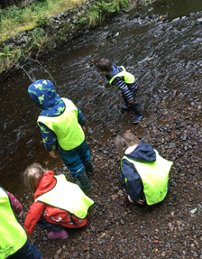

**Outdoor Learning**

We promote a variety of outdoor learning opportunities at Polbeth nursery. Children have daily access to our nursery garden whatever the weather! Children are encouraged to manage their own risks and loose parts play.

**We will be out in all weathers so please ensure your child always has a coat, waterproofs and wellies at nursery.**



**Car Park**

Please use the village hall when dropping off and collecting your child(ren) at nursery. The nursery car park is strictly for staff use only. The disabled parking space must not be used for drop offs / collections.

In line with West Lothian Council policy, there is no smoking and no dogs permitted in the nursery and/or school grounds. This will ensure all our children are safe.

Many thanks for your cooperation with these matters.

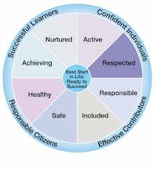

**Staggered Times**

It is advised we stagger our start times and pick up times to avoid congestion and allow for physical distancing.

**Please adhere strictly to your drop off and pick up times. If at any point you require your slot to be changed. Please speak to a member of staff.**

**Lost property**

**Due to the current climate we have been unable to have our normal lost property box. We will display a picture of lost property at the front entrance. If it has not been claimed after one month we will re-home the property and take the picture down. Please check this regularly to ensure your child(ren)’s property makes it home.**

**Learning Journals**

Learning journals are used to document your child’s learning journey throughout their time at nursery. Parents are encouraged to post their child’s learning at home also.

All new children have now been added to the learning journals, parents should have received an email to access their child’s learning journal. There is also an app available (Learning Journals parents).

**Please let a member of staff know or call the nursery if you cannot access this.**



**Snack / Healthy Eating**

Snack time in the nursery is regarded as one of the most important times of the day. Children develop valuable life and communication skills in a social setting. The nursery promotes healthy eating and children are involved in the snack ordering process.

Healthy snack will be provided during each session:

* Breakfast (8am-9.30am)
* AM Snack
* PM Snack
* End of the day snack (4.15pm-4.30pm)

Full day children must provide a healthy packed lunch from home. Please ensure a drink and cutlery is provided.

A menu will be available on your child’s learning journal weekly.

**Parents are reminded nuts and products containing nuts are not permitted in nursery**.

**Nursery updates**

Due to the current circumstances we can no longer use the outside foyer/shutter area to display our monthly learning focuses and weekly activity updates.

**For now we have added a board which will be just outside the nursery shutter to keep you informed with what we are doing weekly.**

The children take pride in completing our daily floor books to display what they have been learning and what they would like to learn about next. We will be taking photographs of each bubble groups floor book and sharing these with you weekly via your child(ren)’s learning journal.



**Illness**

Please ensure that if your child will not be attending nursery due to illness or any other reason to notify staff of their absence. If your child is ill, please do not allow them to come to nursery until they are fully recovered.

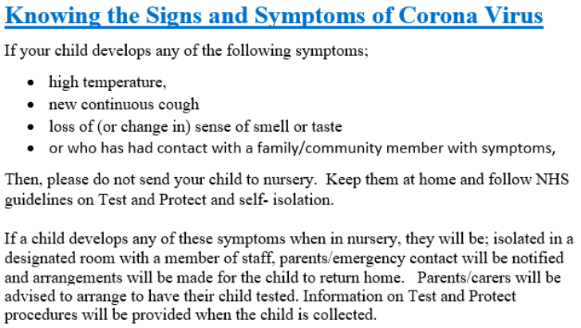



**Drop off/Pick up**

**Please do not enter/stand under the shutter area including the indoor foyer. The buzzer system is currently not in use if you arrive early/late or a member of staff is not present please call the nursery on 01506 872511.**

* One parent per child at drop off/pick up.
* Clear markers are in place to indicate a safe 2m distance. Parents are asked to remain on the yellow marker when their child is called to enter the nursery.
* If your child is not carrying their own bag into nursery – Please leave it on the blue table and a staff member will collect it.

**A staff member form your child(ren)’s allocated bubble will come out at your allocated drop off/pick up time to collect your child. A staff member will then bring your child(ren) in/out. Please remain on a yellow marker during these times.**

Remember to find us on facebook and check our blog for nursery updates:

**Our learning blog: Like us on facebook:**

** **

If you have any questions, staff are always happy to help. Thank you for all your support

The Nursery Team

