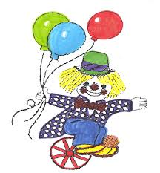
Polbeth Nursery School
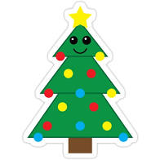
12 Days of ChriSTEMas
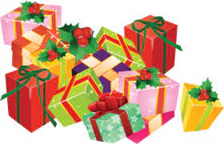

Science Technology Engineering Maths
What is STEM?
"Children think like scientists. They are naturally curious because everything is new to them"
STEM stands for Science, Technology, Engineering and Mathematics. The world depends on these areas of learning; the economy, our general well-being are all linked to developments in science, technology, engineering, and maths.
Children need to develop natural curiosity and engagement with the world around them. They need sufficient space, time and choice with a range of activities and experiences to play with and explore, some of which have been planned and prepared by the practitioners like STEM activities on the basis of their observations of individual children’s current interests, talents, learning styles and stages of development.
At Polbeth Nursery, we have implemented STEM throughout all the areas of the nursery, both indoors and outdoors. The children are giving a variety of opportunities to participate in STEM activities on a daily basis through regular observations, building blocks, the numeracy area and using natural resources as well as planned science experiments.
We hope you can carry out as many of the different activities at home during the Christmas break and would love to hear or see any photographs of the activities carried out. Please don’t worry if you don’t have the ingredients. You can use different household materials, especially recyclable ones.
If you find any other STEM activities of your own please send photos and share these with us
Merry ChriSTEMas Everyone!

Activities
Day 1- Dissolving candy canes
Day 2-Help the Grinch
Day 3-The tallest, jolliest snowman
Day 4-Blubber Polar bear experiement
Day 5-Make your own snow
Day 6-Make your own playdough Christmas Tree
Day 7-Build a gingerbread house with clay
Day 8-Make Christmas gluck
Day 9-Explore mixing colours onto cotton wool snow
Day 10-Make a Christmas Tree with plastic cups
Day 11-Arctic Engineering (Make an igloo)
Day 12- Make your own snowman sesnsory bottle

Day 1 - Dissolving candy canes
Materials:
Water
Oil
Vinegar
Candy Canes
- Fill 4 cups up with the same amount of liquid in each glass.
- Label the jars and fill them according to their labels with warm water, cold water, vinegar, and oil
- Make predictions about what will happen to the candy canes when they are put in the liquid in the jars
- Put the candy canes in the jars and observe
- You will need:• four jars• labels• hot water• cold water• vinegar• oil• candy canes• lab observation sheet
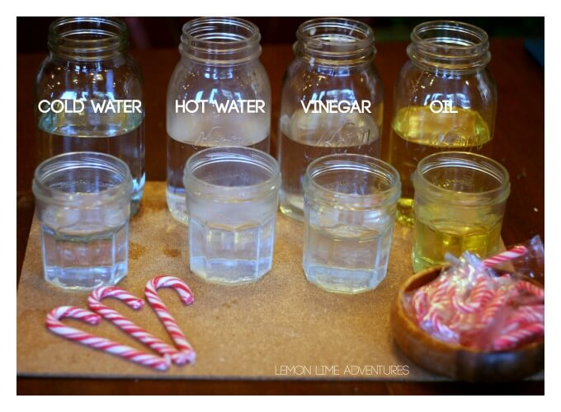

Day 2 – Help the Grinch
Oh no! The Grinch’s heart is too small. Can you help him grow it by creating a chemical reaction?
Materials:
1 Balloon
Funnel
Pen
1 Plastic bottle
Baking soda
Vinegar

- Draw a heart on your balloon

- Attach the balloon to the bottom of the funnel and pour 2-3 spoonful’s of baking soda into the balloon

- Add some vinegar into the empty water bottle

- Very carefully, as not to tip the baking powder in, attach the balloon to the open part of the water bottle

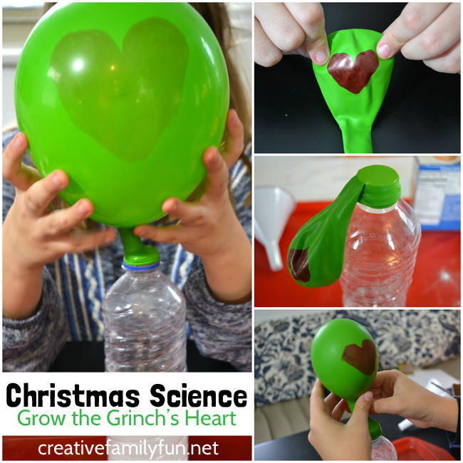
- When you’re ready lift the balloon so the baking powder falls in and watch his heart grow!

Day 3 - The Tallest, Jolliest Snowman

Materials
Marshmallows (different sizes)
Cocktail sticks

- Can you build the tallest, jolliest, free-standing snowman using marshmallows and cocktail sticks?

- Plan out how you will build him first.

- Think carefully about how you can build him in a way which will stop him from falling over.

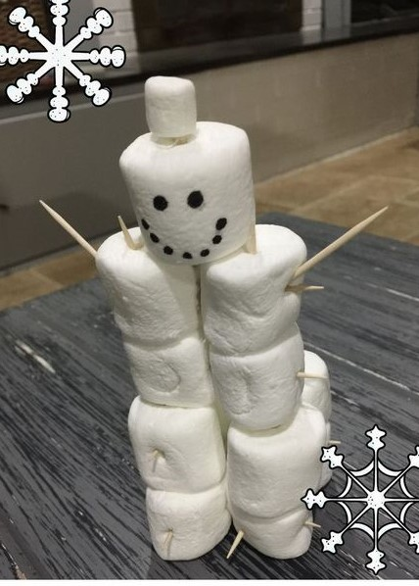

Day 4 – Blubber Polar Bear Experiement

How do polar bears stay warm with those freezing temperatures, icy water, and relentless wind in the Arctic? What keeps a polar bear warm? This super simple polar bear blubber experiment will help kids feel and see what keeps them warm!
Materials
Large bowl
Ice cubes
2 plastic food bags
Lard (fat)
- Fill the large bowl with cold water and ice cubes.

- Put your hand in and see how cold it is.

- Fill one of the food bags two thirds full with lard fat.

- Put one of your hands in the other food bag

- then push it into the lard fat filled-bag

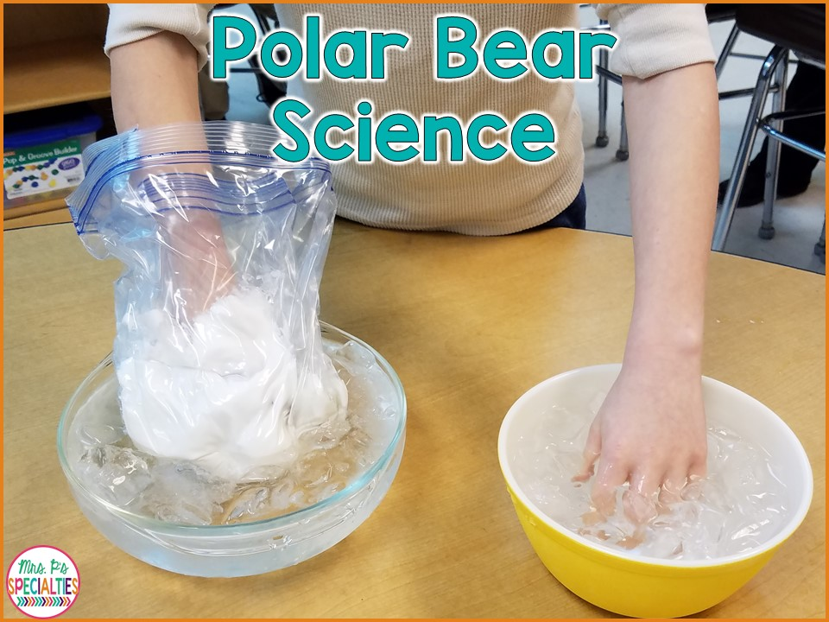
- Put your blubber glove in your freezing cold water and compare what was colder.

Day 5 – Make your own snow

Materials
Tray or bowl
Cornflour
Bicarbonate of soda
Water

- In a bowl, mix together equal quantities of cornflour and bicarbonate of soda. With this simple 1:1 ratio 250g cornflour and 250g bicarbonate of soda.

- Once combined, gradually introduce a very small amount of water into the bowl and mix together with your hands. Add a little more water – just a few drops at a time – until you reach a good consistency.

- Stop adding water when the mixture starts to hold its own shape, but crumbles when pressed (like snow). 1½ tbsp water in total for the amounts above.

- Now you’re ready to play! Try squidging together the snow to make a snowman, use biscuit cutters to push the snow into shapes and use the snow to create a wintery landscape.

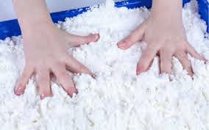

Day 6 – Make your own playdough Christmas Tree

Materials
2 cups of plain flour

½ cup salt

2 tablespoons of Cream of Tartar

1½ cups of water

2 tablespoons of vegetable oil

Green Food Colouring (optional)

Decorative objects for tree Sequence, Tinsel, Stars

- Add your flour, salt and Cream of Tartar to a bowl

- Add your oil, food colouring (optional) and water into your dry ingredients

- Mix all the ingredients together using your hands to combine them.

- Once your playdough is made, you can get to work to create your own Christmas Tree

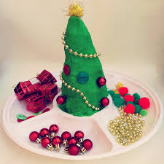

Day 7 – Build a gingerbread house with clay

If you don’t have any clay you can always make your own gingerbread house with playdough. Follow the instructions on how to make playdough on (day 6)
Problem solve how you are going to make your gingerbread house. You could draw it on a piece of paper what it will look like.
Materials
Clay/ playdough
Recyclable materials to add props
Scissors to cut out door
Rolling pin (to roll out clay/playdough)

- What do you need to make the windows or doors.

- How will it stay up and what size will it be.

- Manipulate the clay to make it soft.

- Use objects you might have around the house including lollipop sticks or cardboard cut outs.

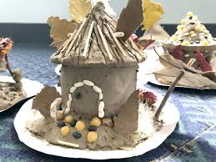

Day 8 – Make Christmas Gluck

Materials
Bowl or tray
2 cups of Cornflour
1 cup of Water
Food colouring
Christmas props

- Mix the water and food colouring together

- Add the coloured water to the cornflour and see what happens to the consistency

- Add the props and explore, mixing and digging the props out of the gluck

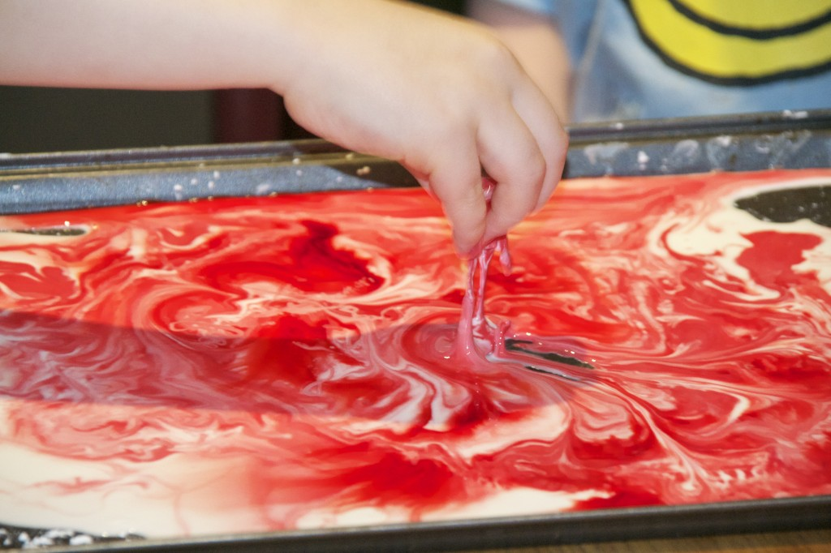

Day 9 – Explore mixing colours onto cotton wool snow

Materials
Cotton wool
Pippets
Food colouring
Water
Beakers or jars

- Add the food colouring to the jar of water.

- Use a variety of different colours.

- Use the pippets to pick up the coloured water and drop it onto the cotton wool snow.

- Watch what happens when you mix the colours together. What colours do they make?

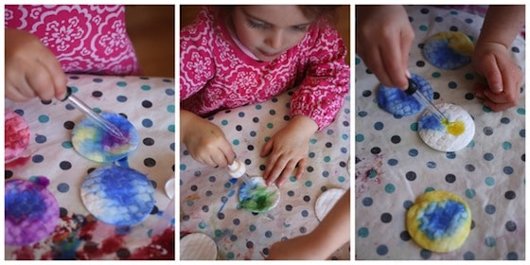

Day 10 – Make a Christmas Tree with plastic cups

Materials

Plastic cups

- Build a Christmas tree using plastic cups

- How tall can you build the tree?

- How many cups did you use?

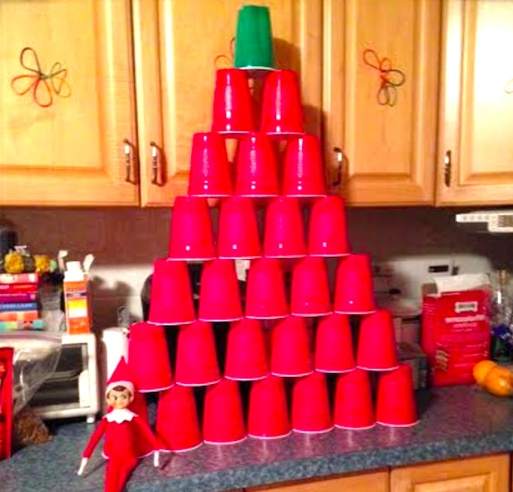
- Which base made for the most stable tree?

Day 11 – Arctic Engineering (Make an igloo)

Materials

Marshmallows

Cocktail sticks

Paper bowl (optional)

- Start with the bottom of the igloo. Use the cocktail sticks and marshmallows to create the bottom of it leaving an opening for the door.

- Using the cocktail sticks and marshmalls, start to make the walls of the igloo building up the way.

- You can use a paper bowl to get the base of the igloo sticking the cocktail sticks into the bowl.

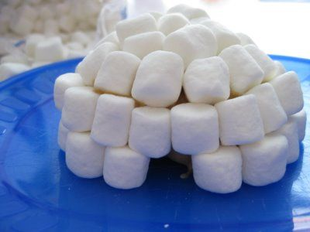

Day 12 – Make your own snowman sesnsory bottle

Materials

Water bottle
Glue
Water
Glitter
Snowflake confetti and sequins
Buttons and beads for eyes and decoration
Orange foam or paper for noses
Pipe cleaners or fabric scraps for scarves
Sharpies for drawing on the bottles

- Add glue into the water bottle. The glue helps slow the settling of the glitter and sequins. The more you use the slower the glitter settles, so how much is up to you.
- Fill up the rest of the bottle with water.
- Add glitter and other decorations
- Seal lid (you can use sellotape to make sure it doesn’t open up)
- Draw on your bottle. Give your snowman sensory bottle a face and buttons.
- Add a scarf and glue on a nose from foam paper or construction paper. You could also use an orange Sharpie to draw one on too.
- To make a scarf, cut a long strip of fabric and simply tie in a knot.
