

#### **Polbeth Nursery School**

#### **Newsletter**

October/Nov 2020

**It has been wonderful to meet so many new children and families, also to welcome back our returning children.**

**Parent Consultation**

**Thursday 5th November: 6pm – 7.20pm**

**Friday 6th November 9.30am – 11am**

As we are unable to have face to face parent consultations we have made the following alternative arrangements:

* 10 minute phone call with your child’s Keyworker.
* You will book a slot using the online parent consultation booking system (You will receive this through group-call nearer the time)

We would request that you stick to your 10 minutes so that staff don’t run over. The call may be from a withheld number so please look out for that.

The phone call will be an opportunity for your child’s keyworker to discuss with you how your child has settled into nursery and to ask any questions.

**Thank you as always for your support during these challenging time.**

**Diary Dates**

**October Holidays**

All break: Friday 9th October

All Resume: Wednesday 14th October

**Just a reminder schools will be closed but nursery will be open as usual.**

**Halloween Week – 26-10-20**

* Tuesday 27th Oct & Thursday 29th Oct – Dress up for Halloween days.

**Parent Consultations**

* **Thursday 5th November: 6pm – 7.20pm**
* **Friday 6th November 9.30am – 11am**

**Big bedtime read, peep groups and stay and play are currently on hold due the current circumstances.**



**Important Reminders**

***Please remember to pack:***

* Warm jackets
* Waterproof clothing
* Wellies
* Change of clothes

**We like to go out in all weathers and love to get muddy! Please try and ensure your child’s clothes/shoes are labelled.**

**Speech and Language Therapist**

We work closely with speech and language. Please speak to a member of staff or give us a call if you have concerns about your child’s speech and language.

**Parent Council**

There is a Parent council meeting held once a month in St.Mary’s Primary School. Please speak to a member of staff or call the nursery if you would like to join.

**Outdoor Learning**

We are continuing to introduce further outdoor learning opportunities for the children this term. We have begun taking groups of children out into the community to explore the local woods, rivers and parks. This will occur on a fortnightly basis and will be alternating with the use of the fire pit. This will offer opportunities for the children to learn about fire safety and carry out a variety of cooking activities.

**We will be out in all weathers so please ensure your child always has a coat, waterproofs and wellies at nursery.**

**Curriculum Corner**

The children have continued to explore emotions and developing friendships as they adapt to the nursery rules and routines. We have been talking a lot about our feelings and emotions, discussing what we feel and how we can express this. The children have enjoyed exploring the mood monsters at nursery which they have been doing through nursery sign in and games.

We have started our outdoor learning walks, going into the community and exploring the local woods, rivers and parks. We will be discussing and exploring the upcoming seasonal changes discussing the weather changes and the new colours and patterns that will be beginning to emerge. The children have begun harvesting the fruit from the outdoor learning area and will be discussing/exploring where some foods come from and what we can do with these foods.

We will continue to promote child led learning and encourage all of our children to engage in their own ideas. We also encourage lots of risky play and creative play, which helps to develop children’s curiosity and inquiry.

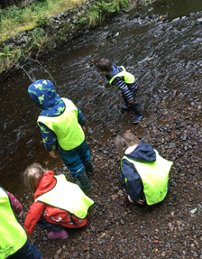



**Car Park**

Please use the village hall when dropping off and collecting your child(ren) at nursery. The nursery car park is strictly for staff use only. The disabled parking space must not be used for drop offs / collections.

In line with West Lothian Council policy, there is no smoking and no dogs permitted in the nursery and/or school grounds, gentle reminder that we discourage the use of unsuitable language in front of the nursery children. Please be mindful when dropping off and picking up. This will ensure all our children are safe.

Many thanks for your cooperation with these matters.

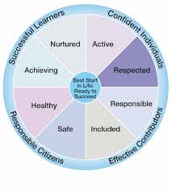



**Lost property**

**Due to the current climate we have been unable to have our normal lost property box. We will now be using a sway which we will regularly update with pictures of all the lost belongings in our nursery. We will upload each picture with a date and after one month we will re-home the property and take the picture down. Please regularly check this sway for lost property.**

The link for this sway will be added to your child’s learning journal when up and running.

**Staggered Times**

It is advised we stagger our start times and pick up times to avoid congestion and allow for physical distancing.

**Please adhere strictly to your drop off and pick up times. If at any point you require your slot to be changed. Please speak to a member of staff.**



**Learning Journals**

Learning journals are used to document your child’s learning journey throughout their time at nursery. Parents are encouraged to post their child’s learning at home also.

All new children have now been added to the learning journals, parents should have received an email to access their child’s learning journal. There is also an app available (Learning Journals parents).

**Please let a member of staff know or call the nursery if you cannot access your child’s learning journal.**

**Snack / Healthy Eating**

Snack time in the nursery is regarded as one of the most important times of the day. Children develop valuable life and communication skills in a social setting. The nursery promotes healthy eating and children are involved in the snack ordering process.

Healthy snack will be provided during each session:

* Breakfast (8am-9.30am)
* AM Snack
* PM Snack
* End of the day snack (4.15pm-4.30pm)

Full day children must provide a healthy packed lunch from home. Please ensure a drink and cutlery is provided.

A menu will be available on your child’s learning journal weekly.

**Parents are reminded nuts and products containing nuts are not permitted in nursery**.



**Nursery updates**

Due to the current circumstances we can no longer use the outside foyer/shutter area to display our monthly learning focuses, weekly activity updates and snack menu.

**For now we have added a board which will be just outside the nursery shutter to keep you informed with what we are doing weekly.**

**Illness**

Please ensure that if your child will not be attending nursery due to illness or any other reason to notify staff of their absence. If your child is ill, please do not allow them to come to nursery until they are fully recovered

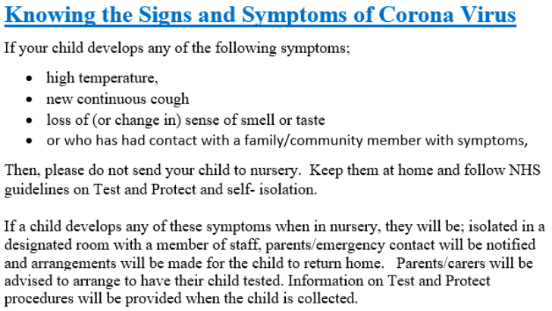



**Drop off/Pick up**

**Please do not enter/stand under the shutter area including the indoor foyer. The buzzer system is currently not in use if you arrive early/late or a member of staff is not present please call the nursery on 01506 872511.**

* One parent per child at drop off/pick up.
* Clear markers are in place to indicate a safe 2m distance. Parents are asked to remain on the yellow marker when their child is called to enter the nursery.
* If your child is not carrying their own bag into nursery – Please leave it on the blue table and a staff member will collect it.

**A staff member will come out at your child’s allocated drop off time to collect your child. A staff member will then bring your child out at their allocated pick up time please remain on a yellow marker during these times.**

**Remember to find us on facebook and check our blog for nursery updates:**

**Our learning blog: Like us on facebook:**

** **

If you have any questions, staff are always happy to help. Thank you for all your support

The Nursery Team

