

#### **Polbeth Nursery School**

#### **Newsletter**

August 2020

**Welcome back!**

**We are delighted to welcome back our returning children and our new children.**

We have lots of new and exciting learning opportunities in store for this term! Currently we are focusing on talking about our feelings and emotions and how we express them. As summer comes to an end, we will be looking forward to welcoming in the Autumn season.

**Diary Dates**

* September weekend: Monday 21st & Tuesday 22nd
* October Holidays: Monday 12th – Thursday 15th

**Just a reminder schools will be closed but nursery will be open as usual.**

**Big bedtime read, peep groups and stay and play are currently on hold due the current circumstances.**

**Important Reminders**

Please remember to pack:

* Sun cream (Labelled with your child’s name)
* Waterproof clothing
* Wellies
* Change of clothes

**We like to go out in all weathers and love to get muddy! Please try and ensure your child’s clothes/shoes are labelled.**



**Welcome from Head Teacher**

*Welcome back to all our families and a big hello to all our new children! I am looking forward to meeting you over the course of the year. We will be shortly sending out information to parents of the pupils applying to St Mary’s next year –applications for next session will be with you before you know it! I know the Nursery Team have wonderful experiences planned for your children in the coming term – keep up to date with all what is going on via Twitter, Blog and Facebook*

*Mrs Kellock*

**Speech and Language Therapist**

We work closely with speech and language. Please speak to a member of staff or give us a call if you have concerns about your child’s speech and language.

**Parent Council**

There is a Parent council meeting held once a month in St.Mary’s Primary School. Please speak to a member of staff or call the nursery if you would like to join.

**Curriculum Corner**

We begin the term looking at emotions and developing friendships as the children learn the new rules and routines of nursery life and make new friends. We will be talking a lot about our feelings and emotions, discussing what we feel and why and how we can express this. The children will develop their understandings of the importance of being kind and caring towards other and why it is important to share and be respectful.

We will be learning all about upcoming seasonal changes and harvesting. We are excited to get the children outdoors to experience nature hands on, to talk about the weather changes and the new colours and patterns that will be beginning to emerge.

The children will be involved in autumn walks to explore seasonal changes and will be helping to harvest the fruit and vegetables from the garden.

This offers a great opportunity to develop literacy and numeracy skills as the children work together to count, measure, weigh, discuss and learn through their experiences.

**Outdoor Learning**

We are introducing further outdoor learning opportunities for the children this term. We will be taking groups of children out into the community to explore the local woods, rivers and parks. This will occur on a fortnightly basis and will be alternating with the use of the fire pit. This will offer opportunities for the children to learn about fire safety and carry out a variety of cooking activities.

We will be out in all weathers so please ensure your child always has a coat and wellies at nursery.

**Staggered Times**

It is advised we stagger our start times and pick up times to avoid congestion and allow for physical distancing.

**Please adhere strictly to your drop off and pick up times. If at any point you require your slot to be changed. Please speak to a member of staff.**

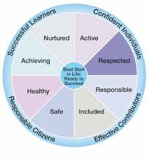

**Drop off/Pick up**

**Please do not enter/stand under the shutter area including the indoor foyer. The buzzer system is currently not in use if you arrive early/late or a member of staff is not present please call the nursery on 01506 872511.**

* One parent per child at drop off/pick up.
* Clear markers are in place to indicate a safe 2m distance. Parents are asked to remain on the yellow marker when their child is called to enter the nursery.
* If your child is not carrying their own bag into nursery – Please leave it on the blue table and a staff member will collect it.

**A staff member will come out at your child’s allocated drop off time to collect your child. A staff member will then bring your child out at their allocated pick up time please remain on a yellow marker during these times.**



**Car Park**

Please use the village hall when dropping off and collecting your child(ren) at nursery. The nursery car park is strictly for staff use only. The disabled parking space must not be used for drop offs / collections.

In line with West Lothian Council policy, there is no smoking and no dogs permitted in the nursery and/or school grounds. This will ensure all our children are safe.

Many thanks for your cooperation with these matters.



**Learning Journals**

Learning journals are used to document your child’s learning journey throughout their time at nursery. Parents are encouraged to post their child’s learning at home also.

All new children have now been added to the learning journals, parents should have received an email to access their child’s learning journal. There is also an app available (Learning Journals parents).

**Please let a member of staff know or call the nursery if you cannot access your child’s learning journal.**

**Snack / Healthy Eating**

Snack time in the nursery is regarded as one of the most important times of the day. Children develop valuable life and communication skills in a social setting. The nursery promotes healthy eating and children are involved in the snack ordering process.

Healthy snack will be provided during each session:

* Breakfast (8am-9.30am)
* AM Snack
* PM Snack
* End of the day snack (4.15pm-4.30pm)

Full day children must provide a healthy packed lunch from home. Please ensure a drink and cutlery is provided.

A menu will be available on your child’s learning journal weekly.

**Parents are reminded nuts and products containing nuts are not permitted in nursery**.



**Nursery updates**

Due to the current circumstances we can no longer use the outside foyer/shutter area to display our monthly learning focuses, weekly activity updates and snack menu.

**For now we will be uploading this information to children’s learning journals.**

**Illness**

Please ensure that if your child will not be attending nursery due to illness or any other reason to notify staff of their absence. If your child is ill, please do not allow them to come to nursery until they are fully recovered

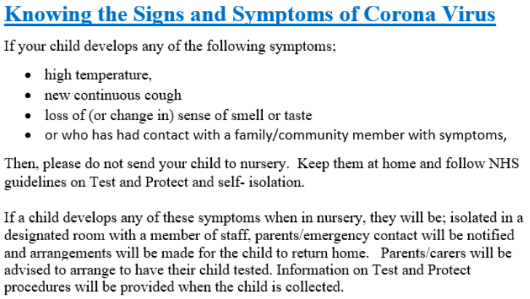



**Remember to find us on facebook and check our blog for nursery updates:**

**Our learning blog: Like us on facebook:**

** **



If you have any questions, staff are always happy to help. Thank you for all your support

The Nursery Team

