Our class rules
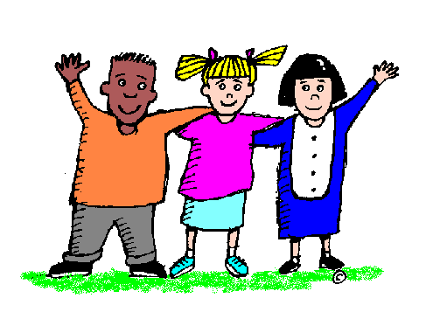 • Be kind and helpful

•Keep hands and feet to yourself -Don’t hurt anyone

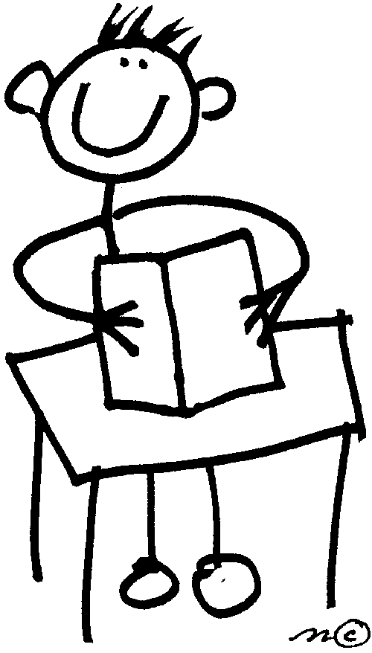
•Work quietly - Don’t disturb anyone
• Put your hand up – don’t shout out
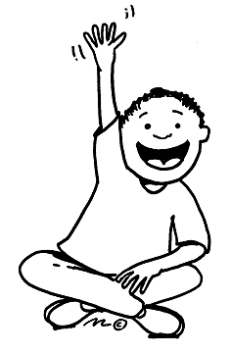

Our hands show we all agree with this Full Value Contract

