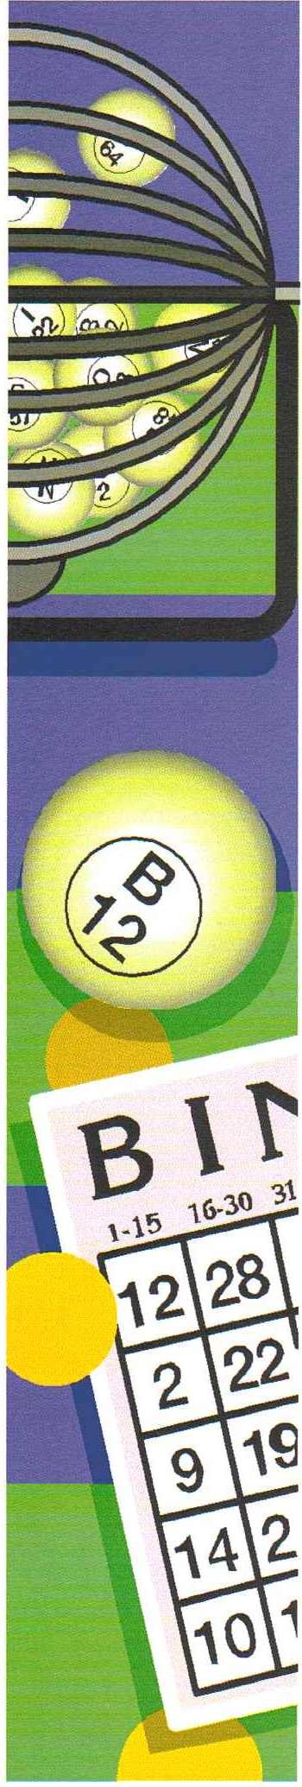
Pies, Peas & Bingo Night
British Legion, Bathgate
Bathgate West Nursery School is holding a Bingo Evening
On

Thursday the 28th of March 2019
Doors open: 6:30pm Eyes down: 7:30pm
Tickets are on sale in the
Nursery
£2.50 each
(This includes a pie at the break)

