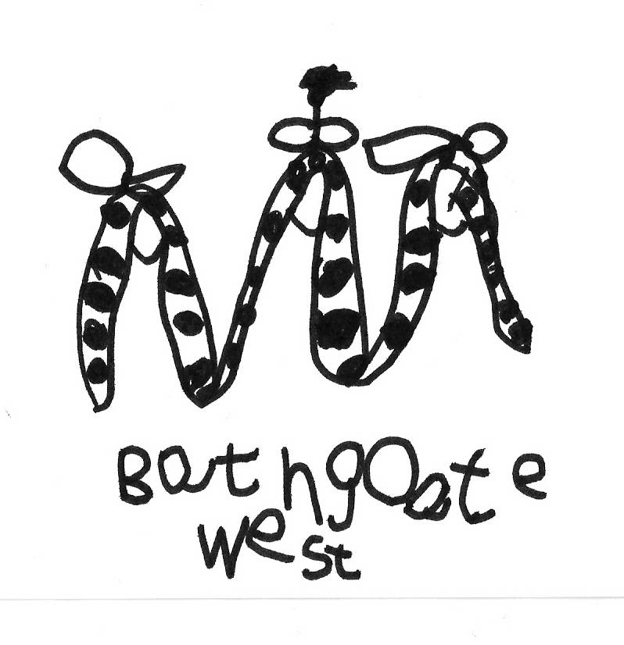
Bathgate West Nursery School,
63 Millburn Road
Bathgate EH48 2AF
Telephone & Fax - 01506 652004
e-mail – bathgatewest.ns@westlothian.org.uk
Head Teacher: Mrs Margaret Johns

Dear Parents and Carers

Happy New Year
We hope you have had a lovely festive break and enjoyed the time spent with family. This year we have a lot to look forward to including revamping our Vision, Values and Aims and finishing our outdoor developments

Staffing changes
Mrs Young has accepted another post as an Early Years Officer; we wish her all the best in her new venture. However, we will be welcoming back Mrs Hendry who will be working between Bathgate West in the mornings and Bathgate Early Years in the afternoons. She will be taking over the green group morning children and is looking forward to her return to Bathgate West.

Outdoor Play
We would like to remind you that although the weather is very cold and sometimes wet, we still aim to take the children outdoor. With this in mind, can we ask that children are appropriately dressed for outdoor play (wellies, gloves, hats, etc). Thank you!

What are we learning about next month?

We are planning on learning some Scottish songs and rhymes, in preparation
for Burns Day, and we aim to celebrate this on Thursday 24th January.
Children are invited to wear something tartan/Scottish on this day.

Winter “Bugs”
Once again we would like to remind you that it is very important that all parents/ carers adhere strictly to the WLC policy and guidelines on sickness. If any child has vomiting/diarrhoea they should not return to nursery until 48 hours after the symptoms have ceased. This helps to prevent infection spreading among the other children at the nursery.

Thorough hand-washing and personal hygiene should be followed by all parents/carers and children at all times. If everyone works together in this way, we will help to keep our children, parents/carers and staff healthy and sickness free. If your child is going to be absent from nursery please remember to contact the nursery informing us of the reason for his/her absence. If we do not hear from you by 9.30am/12.50pm, a member of staff will try to contact you. It is, however, preferable if you make contact with us.

Snack Fund Money
As per WL Council guidelines, we would like to encourage parents to pay their snack money online through IpayImpact, which helps to count down on the amount of cash handling in the nursery. You can pay as little or as much as you like in this way. If you would like further details regarding this please speak to Miss Robertson/Miss Reid.
If you wish to pay snack money on a termly basis, the amounts involved would be:
January to Easter: £19.50 and April to June £15.00.
If you are handing money into nursery please can it be in a sealed envelope with the child’s name and amount written on. Please also remember we are unable to give change.


Food Allergies and Intolerances
As always please keep staff up to date with all allergies or intolerances that your child may have so we can continue to provide a healthy, nutritional snack for all.

We would like to take this opportunity to thank you all for your continued support and we hope you all had the very best Christmas and New Year!

The Nursery Team

Dates for the Diary
Date | Time | Event
24th January 2018 | am and pm | Burns Supper

