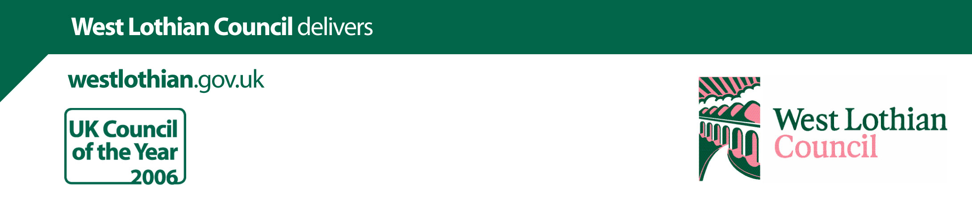

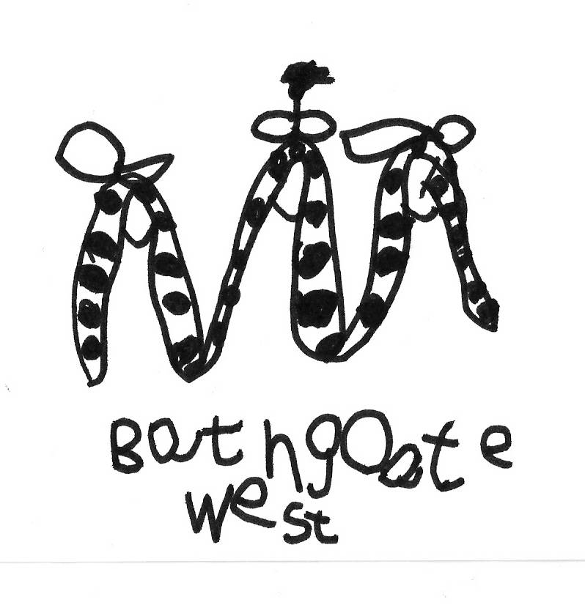
BATHGATE WEST NURSERY SCHOOL
63 MILLBURN ROAD
BATHGATE
West Lothian
EH48 2AF
Tel: 01506 652004

e-mail: wlbathgatewest.ns@westlothian.org.uk
Head Teacher (acting): Mrs Lesley Coutts Miglis
Dear Parents/Carers,

Learning at Bathgate West
Our current learning context is ‘A Castle Adventure’. The children are already being very creative and have been making models and writing stories. As their learning develops we will share their learning story via a sway so please look out for the QR code being displayed at nursery to gain direct access to this using your mobile phones. As always you can keep up to date with what is happening in nursery at our blog; https://blogs.glowscotland.org.uk/wl/NurseryNatter. We also love to hear your feedback so please do comment on the posts and share your thoughts.

Parental Consultations

Our parent consultations for pre-school children will take place 6pm to 8pm, 20th March 2018. Appointments are scheduled in 8 minute blocks and are for children that will be attending school in August only. Appointment schedules will
be placed in the entrance area, and you should select your chosen time. If you do not drop your child off on a
regular basis (e.g. grandparent/childminder does this), you can contact the nursery for your name to be added
to the appointment schedule. Orange AM children will be scheduled separately, please speak to
Mrs Drummond for a time.

Fundraising

This month we are holding our annual Pie, Peas and Bingo Evening at the British Legion on Thursday, 15th of March. A big thank you to everyone who has re-donated raffle prizes after we lost so many when we had the leak. We are still looking for donations for the raffle, if you have anything please hand them in to the nursery as soon as possible, this is a brilliant fundraiser for the nursery. We have been lucky to get some good prizes from local businesses too. We are looking forward to seeing you there!

Outdoor Play

A reminder that we go outside to play in all weathers at nursery and much of our outdoor area is grassy and muddy. Therefore please ensure that your child comes to nursery dressed appropriately for outdoor play and even a spare set of clothes on wet and rainy days would be helpful, in case a change of clothes is required. As we always try to encourage independence from all of the children at nursery, please also send your child into nursery wearing shoes that they are able to change into by themselves, this makes a huge difference to them developing their own personal independence.

WLC Absence Management Policy
Like all schools/nurseries in West Lothian, we follow the WLC Pupil Absence Management Policy. If your child is going to be absent from nursery please contact the nursery informing us of the reason for his/her absence. If we do not hear from you by 9.30am/12.50pm, a member of staff will try to contact you. It is, however, preferable if you make contact with us. If no-one is at home when we call, and in line with WLC Policy, we may contact our Health Visitor who in turn may try to contact you or in some instances pay a visit to the home.

Food Allergies and Intolerances

In the interest of the health and safety, please keep Nursery informed and up to date of any food allergies and intolerances that your child may have.

Bathgate Procession 2018

Following on from our consultation with the children, Bathgate West Nursery’s theme for this year will be ‘Under The Sea’. Please let your child’s keyworker know ASAP if you are going to walk with the nursery on the day of the Procession
and if so, how many children and adults there will be, so that we can begin the long process of making the costumes
with our Nursery Focus Group on Thursdays, if you would like to help please see Mrs Bett.

Online Learning Journals
Your child’s Key Worker continues to add observations to share some of their learning and achievements. If you are not able to access your journal or have forgotten your username please let your keyworker know and we can reset it. We would love to see your comments to.

Lastly a note from some of the wee yins in the yellow group
What do you like about nursery?
- I like playing in the castle – Jacob
- I like playing in the kitchen, making food – Alfie
- I like playing with the sand and the ice-cream game – Isla
- I like building with the lego – Damian
- I like dancing with my friends – Amelie
- I like dressing up like Belle – Florence
- I like playing with my friends – Elise and Chloe

As always, we appreciate your continued support and involvement in the nursery. Please feel free to speak to a member of our nursery team if you have any concerns or suggestions.

Kind regards,

The Nursery Team
Dates for the Diary
Date | Time | Event
Thurs, 1 March | Both sessions | World book day – dress up as a favourite character
Thurs, 15 March | 6.30pm for 7.30pm Pie, Peas and Bingo Night!
Tues, 20 March | Pre-school children only | Parents Consultations PRESCHOOL ONLY
Tues, 28 March | 6.15pm at Balbardie | Parent Council
Fri, 23 March | LAST DAY OF TERM | Balbardie School Church service at the High Church
Mon, 9 April | CHILDREN RESUME
Please remember if your child does not attend nursery on a day when there is an event they are welcome to come just talk to a member of the team.

