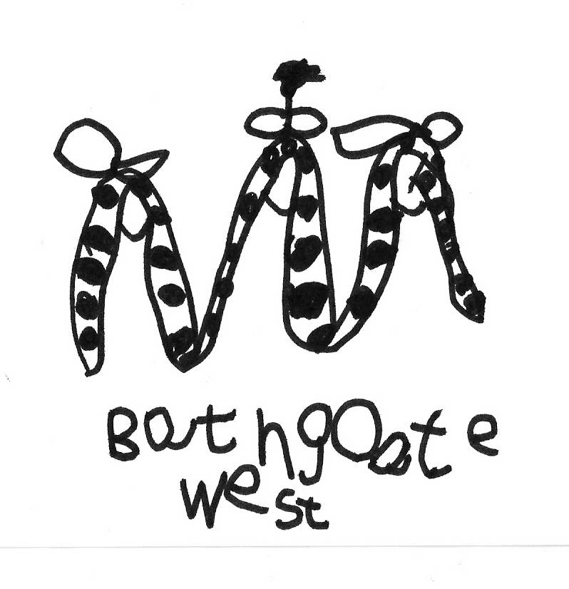
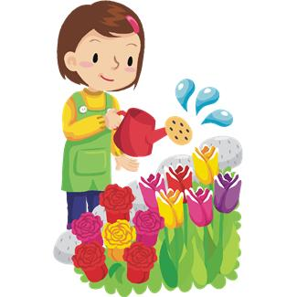
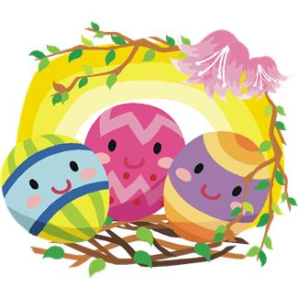

Our topic:
Spring and Easter

We will be busy making our own Easter bonnets and will parade them during our Easter egg hunt on the last day of term.
There might even be a surprise visitor!
We will begin to plant seeds to grow in our recently repaired green house. Over the next few weeks, we’re hoping to develop our garden to enable us to plant vegetables in our veggie patch in the garden.
Easter is an exciting time to talk about new life – we will be looking at baby animal names in the nursery and this is something that you can extend when you’re out and about!

This is just a taste of what we will be doing during this topic. There are many experiences on offer, as our children learn and grow in their knowledge and understanding of the world around them.

We are planning to make yummy Easter nests with the children – if you would like to be involved in this baking activity or any other activity , please have a look at our parent helper list on the front door and sign up!

