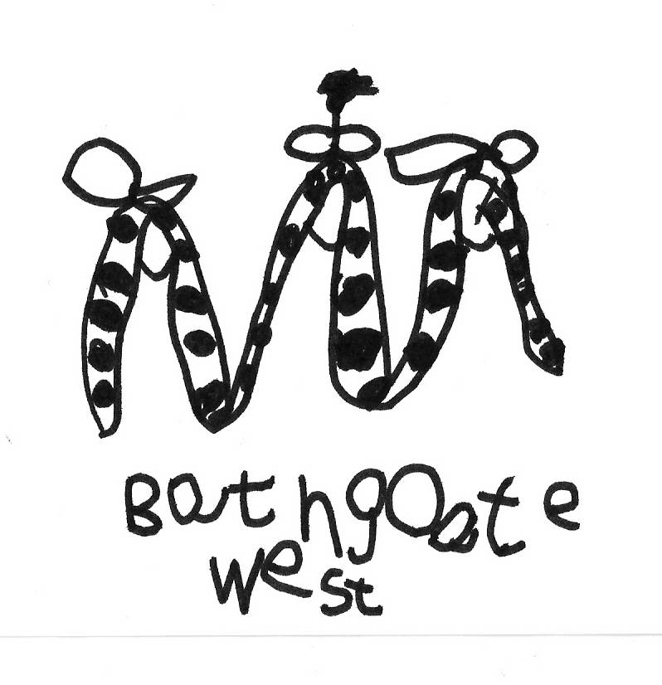
Our topic:
Fairytales
We will build on the children’s love for books and stories, by exploring a wide variety of fairytales. Children will be consulted in their groups on which stories they enjoy most, and we might even vote to see which fairytale comes out tops!
We will be having a Book Swap in the nursery, so both you and your child can bring in a pre-loved book and swap it for another book.
A chance to recycle and develop a love for books and reading for everyone!
We’re continuing to engage the children through Who?, Where?, When? and What happened? questions, as we read to them. This is great way to encourage higher order thinking as you tuck into a book together at home.

This is just a taste of what we will be doing during this topic. There are many experiences on offer, as our children learn and grow in their knowledge and understanding of the world around them.
We will be visiting the local Library on the week beginning the 29th February as an extension of this topic. We will need parent helpers, so please ask for more information of you are able to come along.
It is also World Book Day on Thursday 3rd March so celebrate with a story!

