

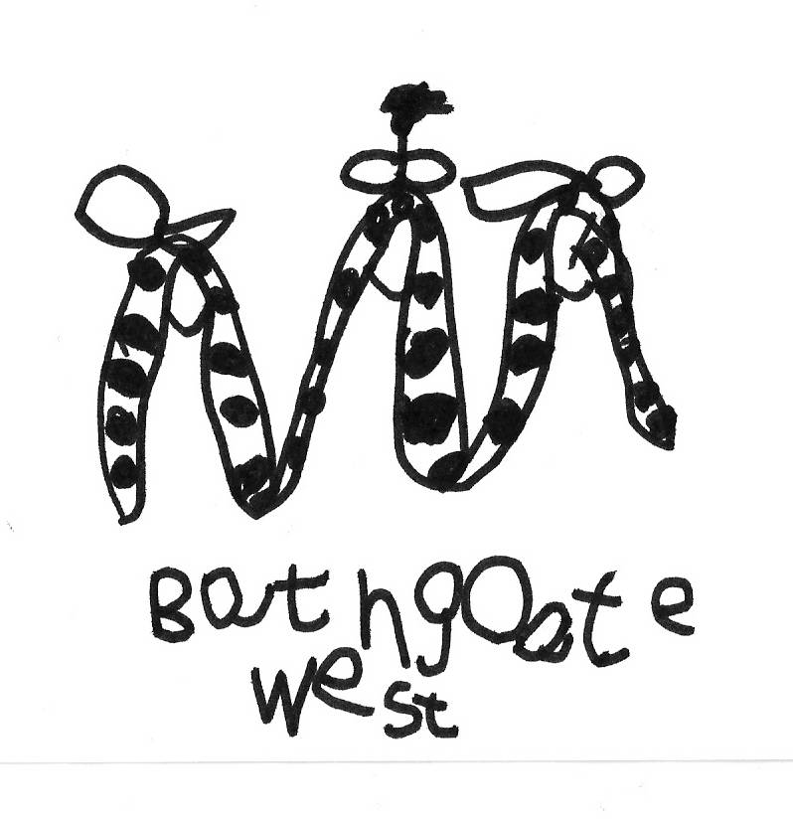
BATHGATE WEST NURSERY SCHOOL
63 MILLBURN ROAD
BATHGATE
West Lothian
EH48 2AF
Tel: 01506 652004

e-mail: wlbathgatewest.ns@westlothian.org.uk
Head Teacher: Mr Greg Welsh

Dear Parents/Carers,

In February the children took part in a ‘Nursery Natter’, the aim was to gain their thoughts and opinions on two questions, ‘What is good about nursery?’ and ‘What could be better about nursery?’ They all took part very enthusiastically and have given us ideas to shape future topics, planning and resources. The results are currently displayed in the entrance area, please take a moment to have a look.

Learning at Bathgate West
February has passed very quickly with lots going on. We have been scientists during our Discovery Lab topic and had lots of fun looking at different celebrations including Valentine’s Day, Chinese New Year, birthdays and the festival of colour, Holi.
You can keep up to date with what is happening in nursery at our blog; https://blogs.glowscotland.org.uk/wl/NurseryNatter
Please remember that you are very welcome to look through your own child’s Learner’s Journey at any time. The children enjoy showing off their work and the progress that they have made.

Parental Consultations
A reminder that Parental Consultations will take place on the 31st March and 1st April. Ten minute appointment schedules have been posted on the door in the entrance area.


World Book Day
We will be celebrating this day on Thursday 5th March, all children will receive a £1 World Book Day voucher. Your child can bring in a much-loved book that will be shared with their friends during group time. Please make sure that all items brought in from home on this day, are clearly labelled, to avoid tears and frantic searches at the end of the session.

Library Visits and Book Swap
As part of our World Book Day celebrations we will be taking the children to visit the library, please see Diary Dates for the day of your child’s visit. If you are able to help with the visits please speak to a member of the nursery team. Our Eco Team is also organising a book swap, week commencing 9th March. More information at the end of the newsletter.

Fundraising

This month we are holding our annual Pie, Peas and Bingo Evening at the British Legion on Thursday, 26th of March. Tickets are available at £2.50 each. We have been lucky to get some good prizes from local businesses too, so please come along, bring your friends and support this event. If you have any donations for raffle, etc, please hand them in to the nursery as soon as possible.

Red Nose Day
This year the nursery will be involved in raising money for Comic Relief by having a Fancy Dress Day, on Tuesday 10th March. Donations of £1 will be welcomed. We will also be having a mini Comic Relief Bake Off with cakes for sale at 20p.

Food Allergies and Intolerances

In the interest of the health and safety, please keep Nursery informed and up to date of any food allergies and intolerances that your child may have.

As always, we appreciate your continued support and involvement in the nursery. Please feel free to speak to a member of our nursery team if you have any concerns or suggestions.

Kind regards,

The Nursery Team

Dates for the Diary
Date | Time | Event
Wed, 4 March | Both sessions | Parent Group
Thurs, 5 March | Both sessions | World Book Day
Mon, 9 March | All week | Book swap
Tuesday, 10 March | Both sessions | Comic Relief Fancy Dress Day
Wed, 11 March | Both sessions | Parent Group
Wed, 11 March | Morning session | 9.45am Library visits
Wed, 11 March | Afternoon session | 1.15pm Library visits
Thurs, 12 March | Morning session | 9.45am Library visits
Thurs, 12 March | Afternoon session | 1.15pm Library visits
Wed, 18 March | Both sessions | Parent Group
Wed, 25 March | Both sessions | Parent Group
Thu, 26 March | 6.30pm for 7.30pm Pie, Peas and Bingo Night!
Tue, 31 March | Parental Consultations | 4.30pm – 6.30pm
Wed, 1 April | Parental Consultations | 4.30pm – 6.00pm
Thurs, 2 April | LAST DAY OF TERM | School Church service at the High Church
Mon, 20 April | CHILDREN RESUME

