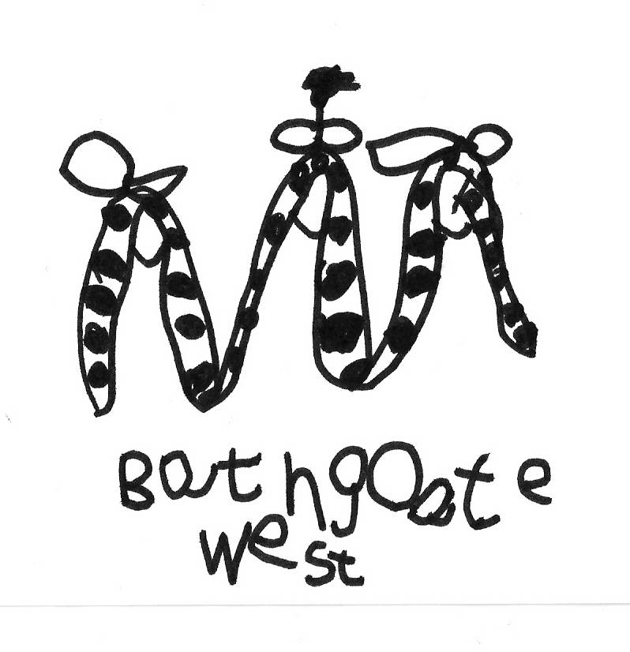

BATHGATE WEST NURSERY SCHOOL

23 June 2014
Dear Parents/Carers

Before we head off on the summer holidays, we have a few items of information to share with you:

Wednesday 25th June: Moving on Ceremony for pre-school parents
An invitation has already been issued – we hope you can make this special ceremony. Please take note of the time: 10.45am / 2.30pm.

Thursday, 26th June: End of Term Party and last day for all children
- Normal start times for morning and afternoon sessions.
- Let’s Party! – children can wear their party clothes on this day.

Staffing changes
Miss McAllister has secured a Principal Teacher post in Edinburgh Council, which will commence after the summer. Due to our nursery roll returning to 50/50 after the summer break, and the impact of this change on our staffing structure, we are also saying goodbye to Miss Prentice and Mrs Young at the end of this term. They have been wonderful additions to our nursery and we would like to thank them for their dedication to the team and enthusiasm for the children in the nursery. We wish them all the best in their future endeavours.
Mrs Waddell will join our team after the summer as the Nursery Teacher, and we’re also looking forward to welcoming Mrs Notman as Pupil Support Worker.

New model
A letter outlining the changes to the nursery day model has already been circulated. However, here is a reminder of the times:

Morning session:
8.25am – 9am Optional early learning & breakfast provision (breakfast will be served until 8.45am to allow for tidying and setting up for core provision)
9am – 11.30am Core nursery provision
Fridays: Optional early learning provision from 11.30am until 11.53am

Afternoon session:
12.25pm – 3.32pm Core nursery provision
3.32pm – 4.22pm Optional early learning and healthy snack provision

We would like to wish you all a lovely summer and we look forward to welcoming back our returning children on Tuesday, 19th August 2014.
We wish all those moving on to school the very best for the next step in their education.

Kind Regards,
Carene Hay ☺
Principal Teacher

