**THE DEANS ACTIVE SCHOOLS UPDATE**

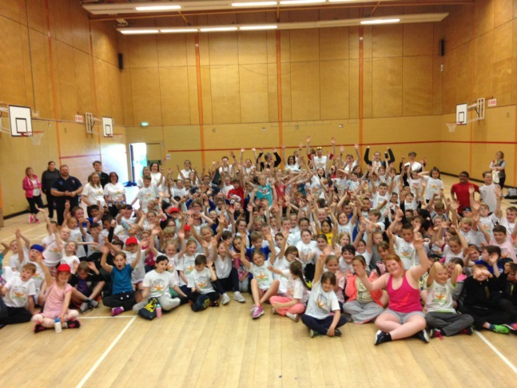Active Schools aims to provide more and higher quality opportunities for children to participate in school sport and to increase capacity through the recruitment of volunteers who deliver the activity sessions. This academic year has been extremely successful for the provision of sporting opportunities within the Deans Cluster.

**DEANS CLUSTER PRIMARY FESTIVALS**

# From Aug - Dec, there were 4 festivals available for the primary schools to attend:

### 200 pupils from P4/5 attended the World Cup rugby in partnership with Livingston Rugby Club. 5 out of 7 cluster primaries in attendance

### 170 pupils from P6/7 attended the Deans Cluster P6 Cross Country Festival (this includes the P7 athletes). This was delivered in partnership with Livingston Athletics Club & Lothian Running Club. 6 out of 7 cluster primaries in attendance

### 134 pupils from P7 attended the Deans Cluster P7 Sportshall in partnership with Sports Development, Livingston Athletics Club & Lothian Running Club. This festival promotes the sporting pathway for local, regional & national competition. 5 out of 7 cluster primaries in attendance

### 243 pupils from P4 attended the Deans Cluster Handball Festival in partnership with Livingston Handball Club. 6 out of 7 cluster primaries in attendance

After Christmas, there were 3 festivals available for schools to attend:

* 239 pupils from the P3 attended the cluster multisports festival run to develop the senior sports leaders at Deans CHS. All cluster primaries in attendance
* 192 pupils from the P6 classes attended the cluster rugby festival which was supported by senior pupils from DCHS and Livingston RC volunteer coaches
* 124 pupils from the P5 classes attended a multisports festival at the end of May. This event was sponsored by Whitherby Publishers and was delivered in partnership with a number of local sport clubs. Each participant received a water bottle, string bag and t-shirt

In addition to the above, a number of the cluster primary schools have competed in the West Lothian Primary netball, football, handball and basketball leagues. A number of schools also competed in one off championships in Athletics, Gymnastic & Netball.



**Sportscotland Schools Sport Award**

The **sport**scotland School Sport Award is a National Lottery funded initiative driven by sportscotland and is designed to encourage schools to continuously improve physical education (PE) and school sport opportunities.

Congratulations to Carmondean PS, Meldrum PS, Deans PS and Knightsridge PS who achieved their silver award and to Seafield PS for achieving a bronze in their School Sport Award Assessment.

**ACTIVE FUN, ACTIVE FEET – EASTER HOLIDAY PROGRAMME 2016**

63 children from across the cluster primaries participated in a 2 day Easter sports camp in the 2nd week of the holidays. Pupils took part in a variety of activities including athletics, basketball, new age kurling, parachute games, football, tag rugby, firstclubgolf to name but a few!  Sessions were delivered by sports leaders, community sports club volunteers and members of the West Lothian Active School team.

**Girls Handball Coaching**

Active Schools, in partnership with West Lothian Handball Development coordinated 3 weeks of girls only handball coaching for the P6 & P7 cluster classes. Allan Stokes, Handball Development coach, provided these sessions to promote the new girls team in the West Lothian Handball Club. Feedback from schools and the club was very positive.

**P6 TOUCH RUGBY**

Active Schools, in partnership with Livingston Rugby Club, coordinated 3 weeks of rugby coaching for the P6 Cluster classes. Gavin Paul, Rugby Development coach, also mentored teaching staff by team teaching and provided a 4 week touch rugby lesson plan.

**DESTINATION JUDO**

The Deans cluster had a 3 week allocation this year running from 9 – 27 May. As a community sports club partner, Destination Judo provide an unique and fun sporting opportunity with a pathway to a number of community clubs in West Lothian.

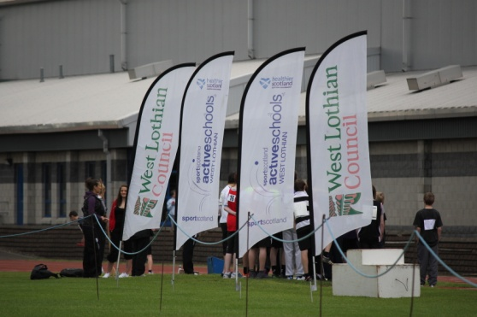**What is ahead? 2016 - 2017**

**ACTIVE FUN, ACTIVE FEET – SUMMER HOLIDAY PROGRAMME 2016**

The bookings for the West Lothian Active Fun Active Feet Summer Holiday Programme have now gone live. To book visit – [http://www.activewestlothian.com/active-schools/clubs#](http://www.activewestlothian.com/active-schools/clubs) The cost is £20 for 2 days and £12 for individual days and the programme will run from 09:00 until 15:00.

* **Deans CHS (July) Active Fun, Active Feet at DCHS - Tues 19th & Wed 20th July 2016.**
* **Deans CHS (August) Active Fun, Active Feet at DCHS - Tues 9th & Wed 10th August 2016.**

**CLUSTER GYMNASTICS**

Primary gymnastic classes will be available again on a Tuesday evening from Sept 2016. These introductory classes take place at Deans CHS with the purpose of getting young people more active through run, jump & gymnastics disciplines. For more information, please contact the reception at Deans CHS 01506 282155.

**The Cluster Volunteer Network**

The cluster primary after school clubs are mainly delivered by school staff and parents. Schools have always been successful to support their school sport, however, if you have a particular skill and/or you have any availability and interested in getting involved with coaching or assisting an after school club or assisting at cluster festivals then please get in touch with your school office.

In addition to this, Active Schools are co-ordinating a coach education week. This takes place in the October week 2016 and offers opportunities to gain governing body qualification such as UKCC Level 1 athletic, handball to improve the quality of the primary after school clubs.

Please get in touch if you have any questions or require further information on Active Schools.

[angela.coulter@westlothian.gov.uk](mailto:angela.coulter@westlothian.gov.uk)