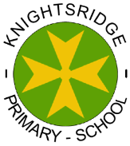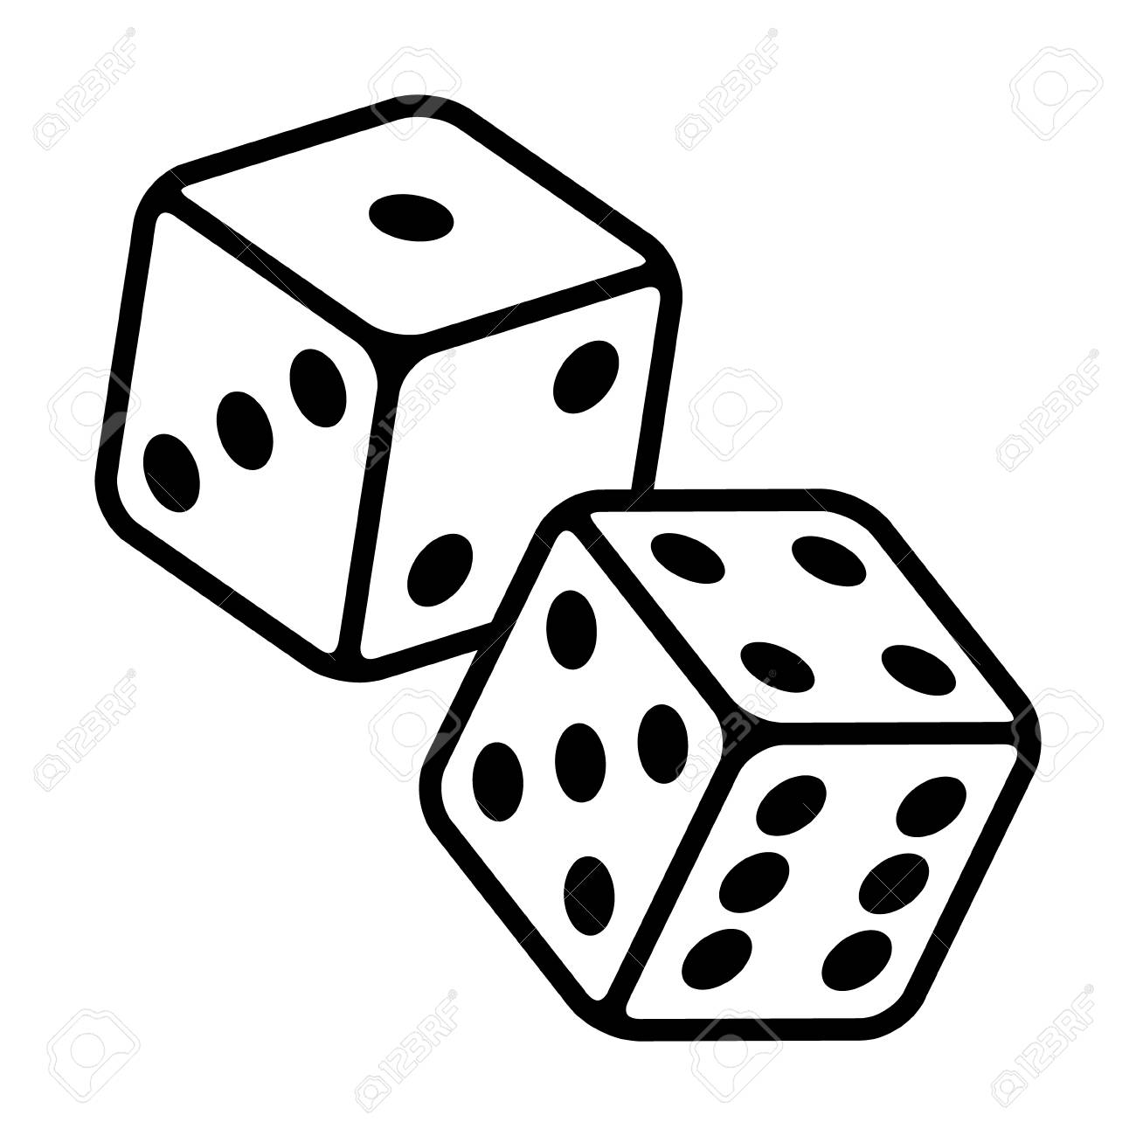vLISTEN

**Numeracy and Maths**

Complete **Rigour maths calendar** – there are 2 to try for December– see link on blog

Our maths focus is shape this month –try to create a picture of a Christmas tree with decorations using only squares triangles and circles!

**Literacy**

Use 2 strategies a week to practise your spelling keywords.

Take part in the **Christmas Reading Challenge** – see link

**Health and Wellbeing**

This is a busy time of year – try to help around the house.

Try out some of the ideas on the Kindness calendar – see link

**Digital Learning**

Try learning some songs and vocabulary in French – see files (**French songs online**) for web links.

**P6/5 Home Learning**

Please complete all tasks marked with a star you have throughout the month to complete the remaining boxes.

**December**

**Creativity**

Design a poster to show the 12 days of Christmas song.

**Skills for Learning, Life and Work**

**Make a sweet treat for family and friends – see link for recipe.**