Kindness to ourselves…
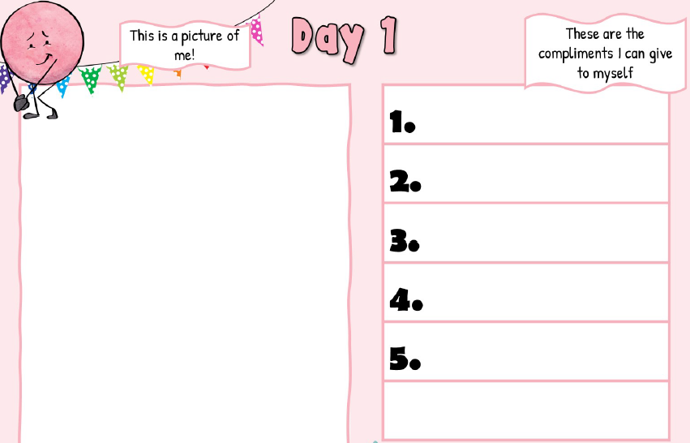
You can copy and complete this in your jotter, it doesn’t matter what this activity looks like. It is important that you take the time to think about yourself!

