 

**The theme for this week is the emotion JOY.**

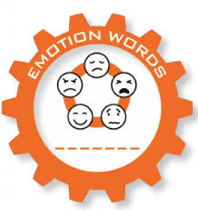 

Watch this again: <https://www.youtube.com/watch?v=CG8hrvVep8U&t=5s>

You’ll remember when we watched this altogether in Assembly. It is really lovely and a good example of giving and receiving JOY.

When you think of people or things, things that give you joy can make you feel full, you 'inflate' with joy! Helping others or being kind to someone else can bring you joy also.

**Design a hot air balloon**, decorate it with things that bring you joy, colours or symbols. Add people in the basket who make you feel joy. Here is an example of a hot air balloon:

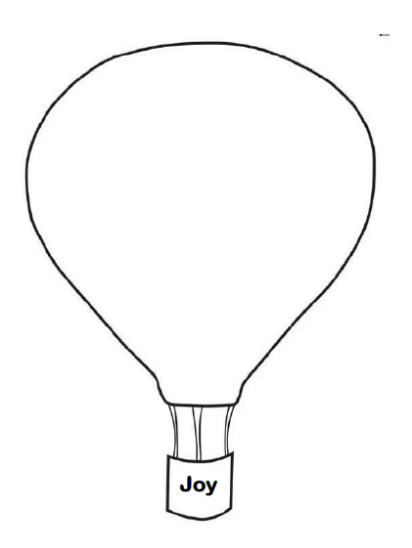

Remember to send us photos on Teams or by e-mail, we love to see your work.