14th October 2015
L.O. Investigate all options

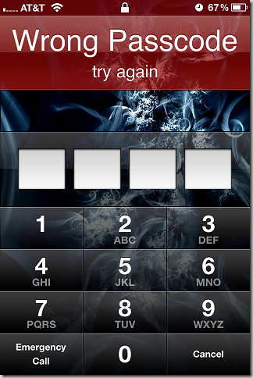

Oh dear! 6 careless people have forgotten the passcode to their phone. Can you find all possibilities for the 6 questions below? Clues are provided, please show working out and there may be more than one correct answer for each one…….
- The first two digits total 11, the first three total 17 and the last two total 8.
- The first two digits are a square number between 50 and 90 and the last two digits have a product of 40.
- First two digits are a prime number between 10 and 20 and the last two can be divided by 36.
- The product is 16.
- The first two digits are even numbers which total 8, the last two digits are the sum of 32 and 45.
- The first digit is a prime number between 6 and 10, the first 2 digits add up to 15, and the last 2 digits are multiples of 4.

