**Event - Usain Bolt vs Eddie Tolan**

L.I: I can use mental and written strategies to add and subtract numbers including decimals.

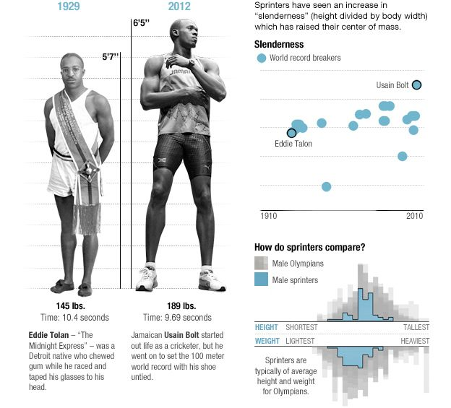

**1.95m**

**1.7m**

Complete the table:

|  |  |  |  |
| --- | --- | --- | --- |
|  | Eddie Tolan | Usain Bolt | Difference |
| Height |  |  |  |
| Weight |  |  |  |
| Speed over 100m |  |  |  |

**Extension Task 2:** Can you use your maths skills to find out any other facts about the two athletes?

**Extension Task 1:** If Usain Bolt Could keep the same pace over 200m, calculate how long it would take him to run this distance