How to Draw a Curve Using Straight Lines
First, you need to draw two lines at right angles (like the corner of a square). The lines should be the same length.
Then, mark intervals on the line – you can choose how big to make them. Mine are 5mm, but you could use 1cm. You will get different results depending on how big the intervals are.
You could number the intervals (this makes it easier to keep track of your drawing) but you don’t have to.
You should end up with something like the pictures below.

Next, you are going to start drawing in your lines. Draw a straight line (using a ruler!) from the furthest mark on the vertical line to the closest mark on the horizontal. In my first picture you would be drawing a line between 14 and 1, as shown in the picture below.
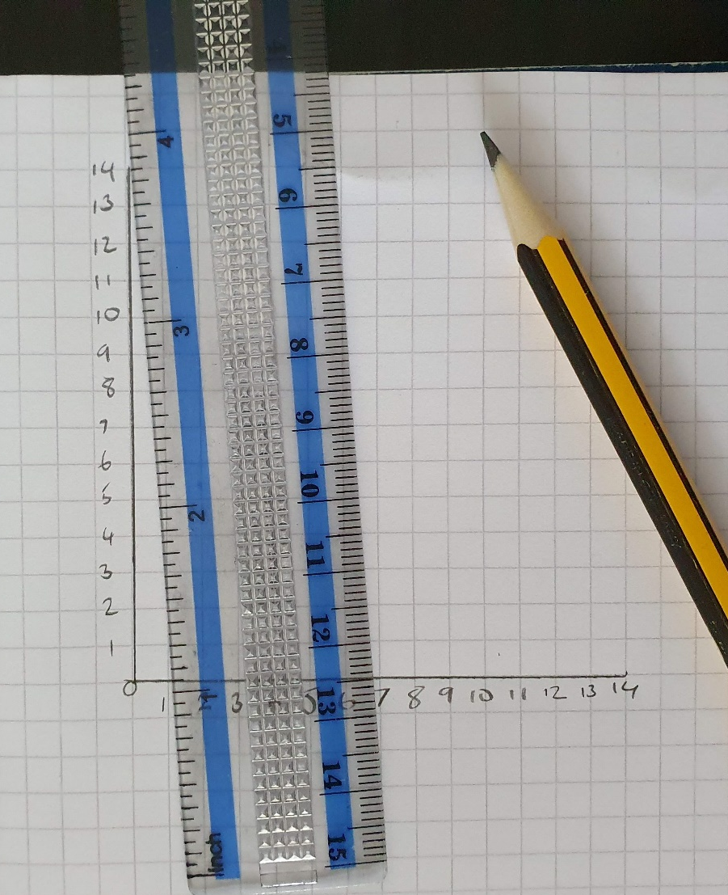
Then you join the second furthest mark to the second closest mark (13 to 2 in my drawing).
Then you join the third furthest mark to the third closest mark (12 to 3 in my drawing) and keep doing this until you are joining 1 on the vertical line to 14 on the horizontal line.
As you draw in the lines, you will start to see the curve appearing.
Once you have finished, you will end up with something like this:
As you should be able to see, the end result shows a curve between marks 14 and 14, but you will only have drawn straight lines to make it!

Once you have got the hang of the basic technique you can begin to experiment. I tried drawing on squared paper and on plain, and I changed the distance between my marks, going from 1mm to 1cm. I also changed the angle between the two lines I drew at the start. I drew my two lines at an acute angle (smaller than a right angle) and obtuse (bigger than a right angle). As you can see, changing these things gives different results.
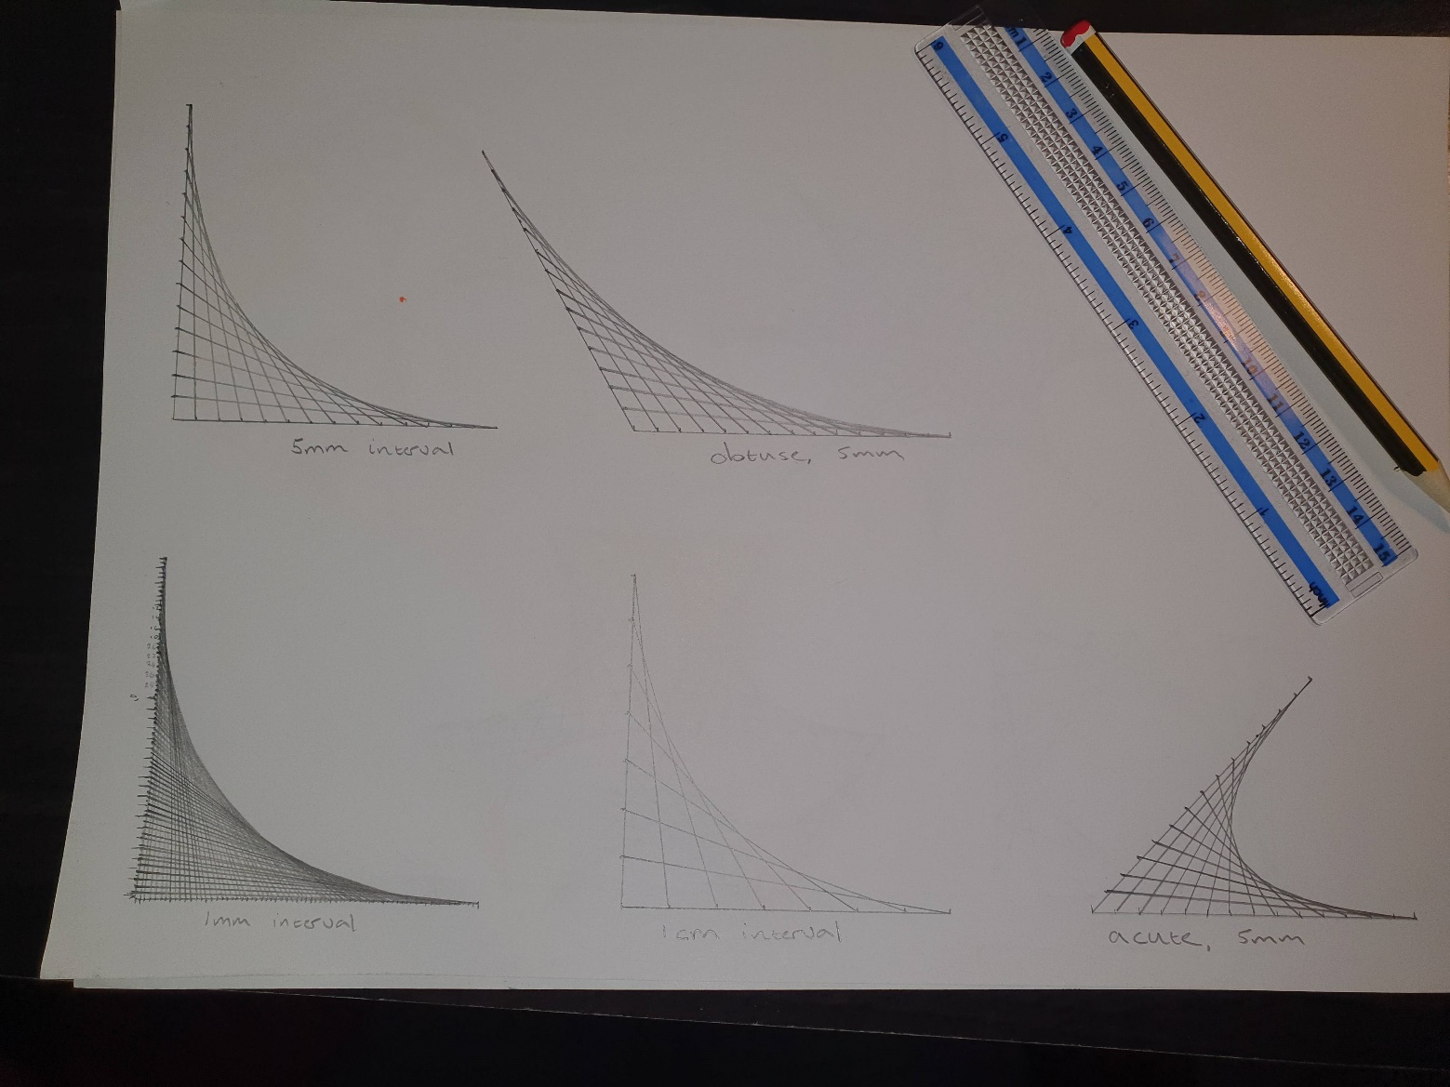
You can also use this technique to create patterns and pictures by using different colours, and by drawing your curves inside shapes. For example, you can draw inside a triangle (I found an equilateral triangle worked best, as all the sides are the same length), or a square. I also tried drawing a circle and splitting it into sections and drawing curves in each section. I’ve put my photos below. Please try experimenting and let me see any examples you have!
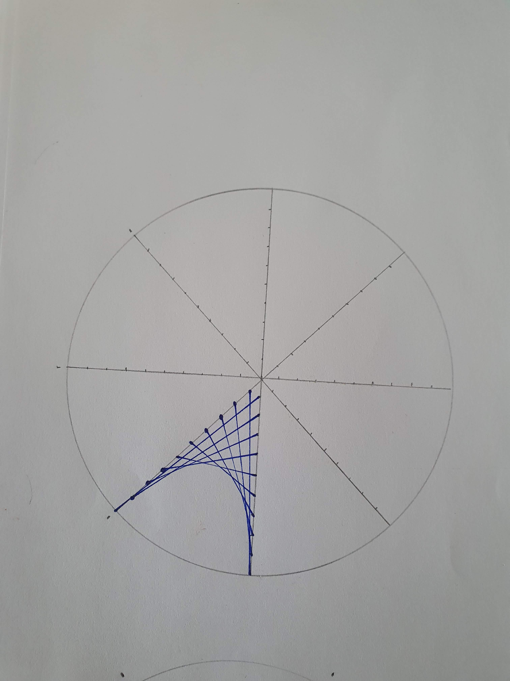
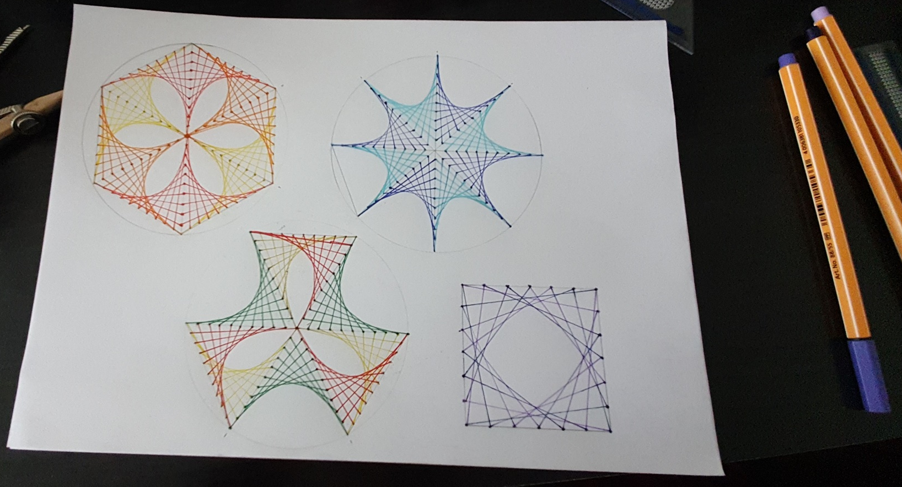

Top Tips
You can use squared or plain paper for this – if using squared, you can just count the squares to make sure your lines are the same length.
Use a ruler for all your lines.
Measure the first two you draw to make sure they are the same length. Remember to line up the 0cm on your ruler with the start of the line.
A sharp pencil works best because your lines will be more accurate.
The bigger the interval the easier it is to draw.
Number your intervals to make it easier to match the marks – if you do this lightly in pencil you can rub them out once you are done.
Sharp coloured pencils work well, or thin pens. If you want to use felt pens, make your design bigger and use a bigger interval.

This video is good at showing and explaining how to do this too (although he numbers his lines differently to me!)
https://youtu.be/xY2U28etO0A

