Sports Day Related Learning Activities for Tuesday 26th May

Design a New Sport
Amazing Fact
The sport of chess boxing combines two traditional sports, chess and boxing. The competitors fight in alternating rounds of chess and boxing and winning in either round means overall victory.
Challenge
Design your own sport that combines two different sports.
Give it a name and describe how it would work. Then, draw a picture to show your new sport.
You could also try to find out:
How popular chess boxing is
Where this idea originated from
Whether any other mixtures of sports exist
What other sports would go well together

Design a Sports Day Mascot
A Mascot is a person or thing that brings good luck. Design a Mascot that will bring you good luck on Sports Day. Write a detailed description too.

Jumbled up letters
Now for a bit of fun:
Unscramble these words (all to do with Sports Day):
rostp
geg dna onosp
askc ecar
ginkipps
serac
nirngun
lehrdus
gratet
owrth
yrlea
gonl pmuj
lnijeav

Design a Sports Day medal
What will it be awarded for? Winning? Taking part? Good sportsmanship?
You may have your own ideas, but you could use this kind of shape?
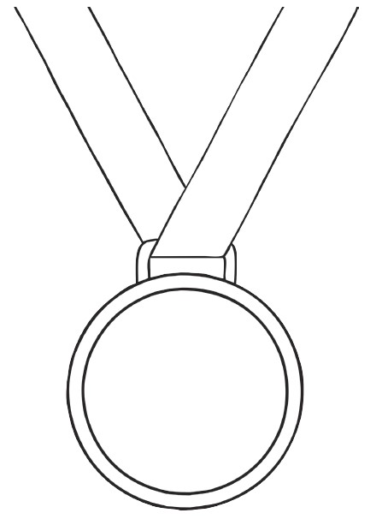

It would be great to see any of your work so please send to Mrs Gillespie or Mrs Ramsay by e-mail, or share on the Teams page. Thank you Primary 5. Have a fantastic day!

