**8 x Table search**

Find the calculations from the 8 times table. They may be horizontal, vertical or diagonal. Write the calculations you find in your jotter or on paper.

Example: 8 x 10 = 80. Can you find the other 9 calculations?

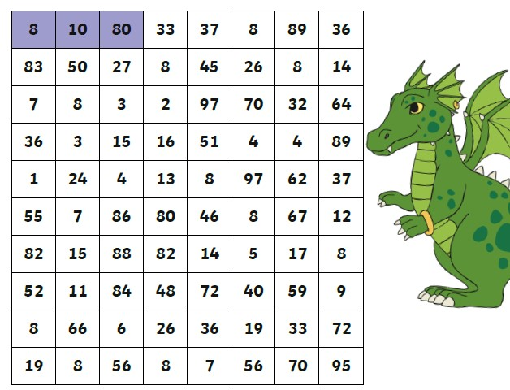

**9 x table search**

Find the calculations from the 9 times table. They may be horizontal, vertical or diagonal. Write the calculations you find in your jotter or on paper.

Example: 9 x 2 = 18.

Can you find the other 9 calculations?

